Post-operative management for Trans palpebral exenteration

* Place an ice pack on the surgical site until the patient wakes up or for no more than 10 to 15 minutes. Icing the site is typically not necessary throughout the postoperative recovery period.
* If the globe or periocular skin was infected or an orbital silicone prosthesis was placed, an oral broad-spectrum antibiotic should be prescribed for 10 to 14 days.
* For analgesia, an oral synthetic opioid (tramadol) or nonsteroidal anti-inflammatory drug is recommended for about two or three days, or longer if needed.
* Usually the first 24 to 48 hours after surgery is when patients exhibit the highest pain level. However, the patients were found to be more comfortable after surgery than before it because the source of pain has been removed.
* the patient can be discharged the same day, Unless the surgery and recovery were uneventful.
* An Elizabethan collar (dogs and cats) or a hard eye cup (horses) is recommended to prevent trauma or contamination to the surgical site. Skin sutures should be removed in 10 to 14 days.

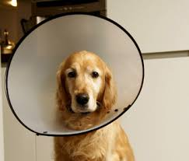 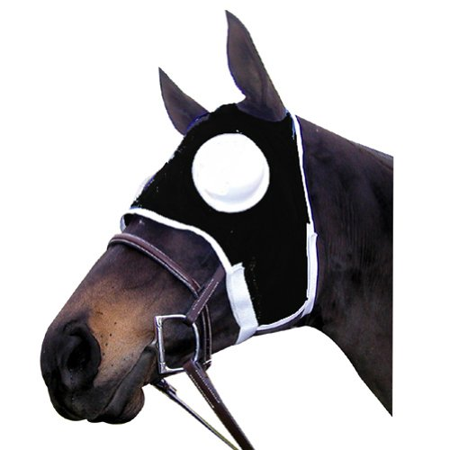

* No post-operative treatment is required. Antibiotics are usually placed in the orbit during surgery and are administered once. Administration of systemic antibiotics is only indicated if deemed necessary, e.g. in presence of marked sepsis.
* Considerable post-operative swelling, and deformity of the orbit are likely to occur with this trans palpebral exenteration method, but this can hardly be of any significance in production and food animals.
* 'Cancer eye' susceptibility in cattle is thought to be of moderate heritability, so perhaps such animals whose indications for the surgery were such, should not be used for breeding replacement stock.