**Peterson’s Nerve Block**

**Advantages**

* Safer than the Retrobulbar block Retrobulbar block as there is less risk of globe penetration and haemorrhage.
* Additionally, potential catastrophic injection of the meninges surrounding the optic nerve is minimized using this technique.
* More effective than alternative techniques if performed correctly.
* Less oedema and inflammation with this block than with infiltration of local anaesthetics into the eyelids and orbit.

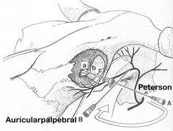

**Disadvantages**

* Technically more challenging to perform than other blocks anesthetizing the same or similar area.