Surgical instruments

* Scalpel handle and blades 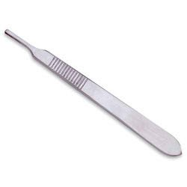
* Atraumatic forceps 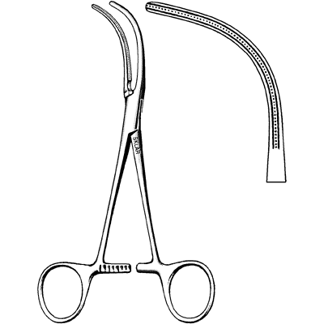
* Cutting needle, needle holder and monofilament suture 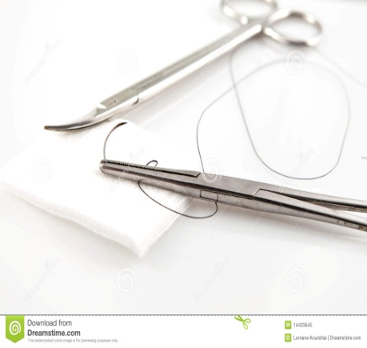
* Blunt dissecting scissors 