Intra-op for Third Eyelid Flap

Method:

* Direct needle through stent.
* Direct needle full-thickness through the skin and emerge in the superior-lateral conjunctival fornix.
* Direct the needle through the outer (palpebral) conjunctival surface of the 3rd eyelid midway between the base of the T-cartilage and the “crossbar”.
* Try to engage the cartilage, but be careful not to go full-thickness through the lid.
* Redirect needle through the superior-lateral fornix, exit the skin and stent

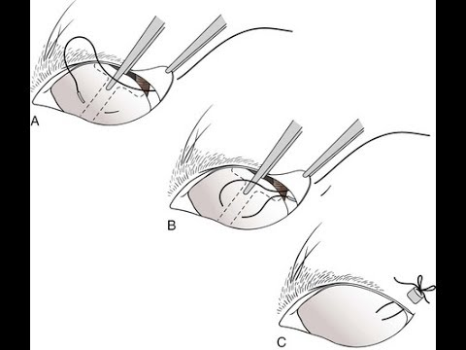

Post-operative care

Animals were kept in a confined area for several days after surgery to allow appropriate hemostasis and healing to occur. Daily observation of the surgical site and assessment of general well being was performed until suture removal. Sutures were removed in 14 to 21 days to allow for complete healing of the skin.

Additional Info:

Advantages

* Simple to perform.
* Gives good protection to cornea.
* Topical medication can still be administered and desired therapeutic drug concentrations readily achieved.

Disadvantages

* Cornea cannot be examined while flap is in place.
* Cannot be used with infected corneal ulceration