**Exenteration Technique**

There are 3 types of eye removal surgery:

1. **Evisceration** –removal the intraocular contents only, (the sclera and extraocular muscles are left attached). Indications: for the treatment of a painful, blind eye; for the presence of an inoperable intraocular neoplasm; performed when the condition is confined to the globe. The type of enucleation will depend on the presence or absence of infection.



1. **Enucleation**–removal of the eyeball (globe) only



3. **Exenteration**–removal of the globe and orbital contents



**Transpalpebral Approach- Exenteration**

Indications: Extrascleral extension of intraocular disease and intra-orbital neoplasia. Removes the globe, short piece of the optic nerve, lid margins, conjunctiva, third eyelid and gland of the third eyelid. Elected when there is an infected ocular surface or tumour that is not restricted to the globe. Reduces the risk of contaminating the orbit by confining disease within the conjunctival sac. **Exenteration includes the Transpalpebral enucleation plus removal of all orbital contents possible.**

* The lid margins are sutured closed with simple continuous monofilament suture or towel clamps. This reduces the risk of contamination of the orbit.
* Incise the skin approximately 5mm from the lid margin in an elliptical shape, subcutaneous tissues, and orbicularis oculi down to the conjunctiva (but not through it). Ensuring to incorporate both the lateral and the medial canthus and to avoid the agularis oculi vein at the medial canthus. Be careful to leave enough skin for closure after the globe is removed. Be sure to remove the third eyelid and gland.
* Dissect all the way around the globe until you are past the limbus (where the conjunctiva, and potential contaminants end).
* Once the limbus is reached, isolate the muscles and transect with scissors. Care show be taken to not to put too much traction on the globe to prevent oculo- cardiac reflex and potential binging of the fellow eye.
* Clamp the optic nerve with a curved forcep.
* Transect where ligation is optional.
* Pack orbit for 5 mins- then ligate any bleeders before closing.
* 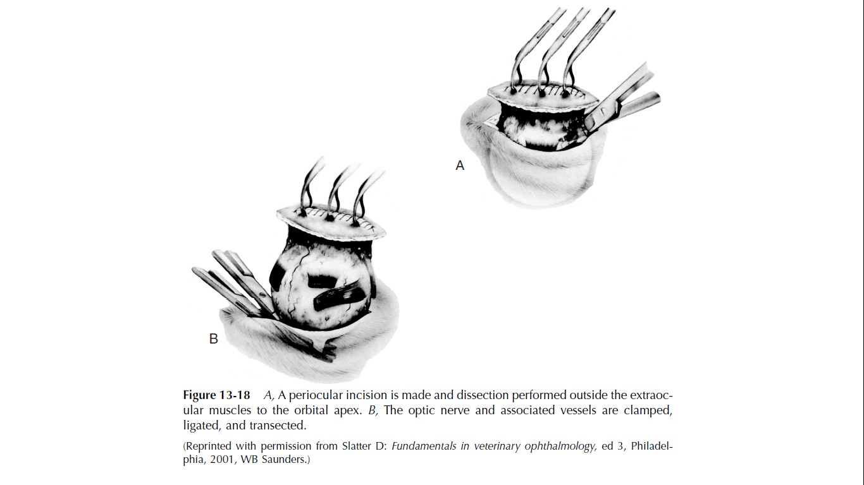Palpate the remaining orbital tissue and orbital bone for additional evidence of neoplasia.

