**Third Eyelid Removal Procedure**

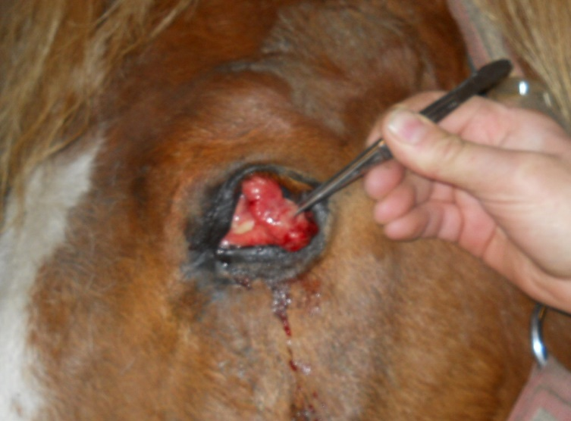Indication: Usually due to the suspect of a Squamous Cell Carcinoma or its presence.

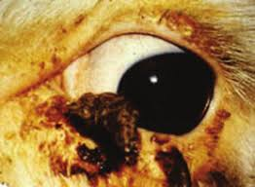

* Press on the globe dorsally through the upper eyelid to prolapse the third eyelid.
* Using a mosquito haemostat, grasp the third eyelid by the free margin. The haemostat should be clamped firmly.
* To inspect any foreign bodies under the third eyelid, go approximately 0.5cm off the edge and gasp a pinch of the conjunctiva.
* Bring the entire third eyelid out to observe its extent. Note the surgical landmarks of the thin conjunctiva dorsally and ventrally of the third eyelid. It is thicker in the middle due to the cartilage of the third eyelid (T shaped cartilage).
* Place a second haemostat in clear (or thin) dorsal conjunctiva from the free edge margin to the furthest of the medial canthus as possible, without clamping the cartilage. Ensure no lower eyelid conjunctiva is clamped.
* Another curved forceps, using the curved edge of the forceps placed against the lid and placed again, as far medially as possible on thin area of conjunctive. Ensure no upper eyelid conjunctiva is clamped.
* A scalpel blade is used (preferably a No. 15) to cut right along the forcep, removing conjunctiva as it is cut. Leave the forceps in place for fifteen minutes for haemostasis. After fifteen minutes, remove the forceps gently.
* Place the fourth forceps across the base of the third eyelid. Cut along this forcep.
* This removes the third eyelid.
* Ensure the patient’s head is elevated. If the patient’s head becomes depressed, it can cause swelling to the area and increase the likelihood of complications.
* When removing the forceps, observe for haemorrhage before the last forceps is removed and observe for fat around the edges. If fat is presence use 6-0 Vicryl suture and over sew the cut edges. Fat prolapse is a complication of this procedure.