Treatment: In some minor cases of entropion, correction can be made by injecting 1-2 mLs of a long-acting, slowly absorbed antibiotic (procaine penicillin) under the skin of the affected lid. This will help distend and roll the eyelid outward into a proper position and help alleviate some of the irritation. Sometimes staples, suture, or clips are applied to the skin surface of the problem eyelid. In these cases, the tension of the clip or staple alone may pull the lid into proper placement. In many of the younger animals, these procedures are often all that is needed to correct the problem.
In more complicated cases, this condition is corrected by surgically removing an elliptical portion of the skin under or over the problem eyelid (see figure 1) with a knife or curved tip surgical scissors. The wound is sometimes left open to heal and antibiotics are applied. As the wound heals, the increased tension pulls the lid into proper placement. Stainless steel surgery clips (see figure 3), staples, or stitches (suture) are also utilized to close the created skin defect and help correct the inversion.
These procedures are most effective if performed early in the life of the newborn, especially while the skin is softer and more pliable. Advanced cases that require surgery or cases where the eye is damaged, will need antibiotic eye ointment applied 3-4 times a day.
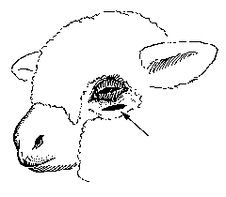 |  |  | Figure 1: Front view of a surgically removed elliptical portion of the skin under the lower lid.

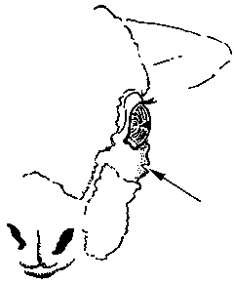 |  |  | Figure 2: Side view of a surgically removed elliptical portion of the skin under the lower lid.

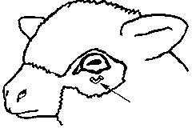 |  |  | Figure 3: Stainless steel clip.

