**Pre-op**

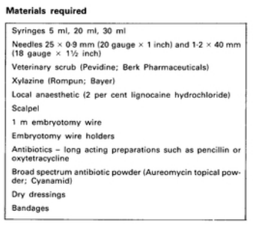

* Restraint using a stanchion and foot crush
* Sedation using xylazine
* A tourniquet can be applied to the metatarsus or metacarpus
* Anaesthesia- Local IV of lidocaine
* Ideally, the operation area should be washed, shaved and disinfected.

