**Examination of Colic in Horses**

After observing clinical signs, before rushing to decide on whether or not surgical intervention is needed, sufficient yet quick examinations of both the patient and the environment if possible. This would further enhance the understanding of the individual case and form a better foundation upon which the decision is made.

**Signs of previous colic episodes should be identified** and taken note of, as this could not only aid in the formulation of a diagnosis, but also a prognosis, since the patient under examination can potentially have another bout of colic in the future. These signs can include (but are not limited to) scrapes left in the flooring of stalls due to pawing, the absence/presence of faeces and if present, its characteristics, skin abrasions and swellings that may result from rolling, signs of trauma at the flank due to the horse kicking in response to pain and scrapes on the walls of the stall due to attempts to relieve discomfort.

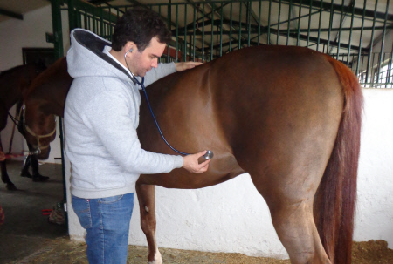Consequent to the examination of the environment, clinical examinations can then be conducted. Determination of normal physiological parameters (namely **temperature, respiration and pulse rate**) are crucial. An elevated temperature can point to the presence of a microorganism leading to the pathology. Increased respiration and pulse rate (heartbeat) indicate the presence of pain. However, this is a general deduction but still helpful, as elevated pulse rate can indicate shock while a higher than normal respiratory rate may point to the lungs’ compensatory mechanisms being activated as compression occurs due to enlarged abdominal organs applying pressure through the diaphragm into the thoracic cavity, decreasing the space available for lung expansion and thus, decreasing total lung volume. **Capillary refill time (CRT)** when evaluated in colicky horses may be more than 3 seconds and reveal discoloured mucous membranes (dark pink to purple).

Auscultation of the four quadrants of the abdomen is also highly recommended, as it may reveal abnormal gastrointestinal sounds as well as a gas cap in the event of build-up in the stomach (particularly in the upper left).

**Blood tests** – a complete blood count (CBC) and serum biochemistry should be done to assess the infectious and metabolic status of the patient.

**Ultrasound** – Used to identify the physical changes in the gross appearance of the gastrointestinal tract, as well as their locations which would not only aid in forming a diagnosis but could potentially help formulate a course of action in the event that the surgical route of colic management is chosen.

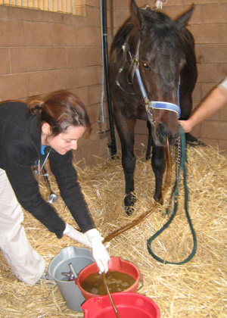**Nasogastric intubation** – This involves the use of a nasogastric tube for determining the presence of fluid in the digestive tract. This fluid would indicate the severity and potentially aid in determining the onset of the colic episode. In cases involving the blockage of intestines due to either strangulation or impaction, there would be build-up of fluid and food material over time due to its inability to flow out of the stomach. This is especially so since horses are incapable to vomition. The tube is inserted into one of the nostrils and directed downward through the ventral nasal concha. With the head flexed, it is guided down the oropharynx and into the oesophagus and into the stomach, where a siphon is created, drawing fluid (and possibly ingesta) out, the volume of which can give an idea as to the severity and stage of the colic.

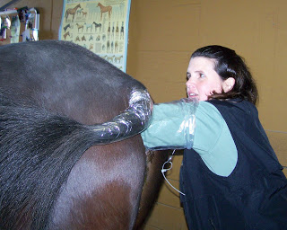**Rectal examination** – Only if possible and absolutely necessary, the attending clinician must palpate the gastrointestinal tract in order to detect any enlargement, twisting or displacement. It is important to understand where the landmarks for palpation are in order to properly examine the abdominal organs for any abnormalities. It is important to bear in mind that rectal examination is often very painful to the horse and must not be done for very long. Furthermore, since this is a blind procedure, it is best complement with the results of a visual medium e.g. ultrasound.

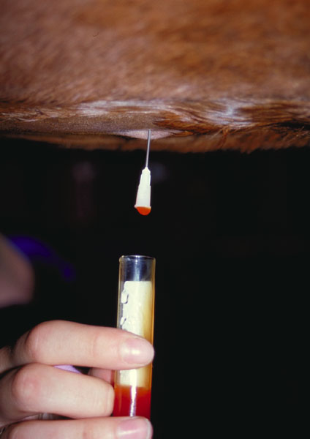**Abdominocentesis** – This is a test involving the use of a needle to obtain a sample that would be used for identification of infection/inflammation. Its composition can also give information that can help in determining a diagnosis e.g. presence of white blood cells, increase in plasma proteins. The fluid surrounding the intestines also changes in response to colic coming as a result of twists or strangulation.