Clinical signs of Colic

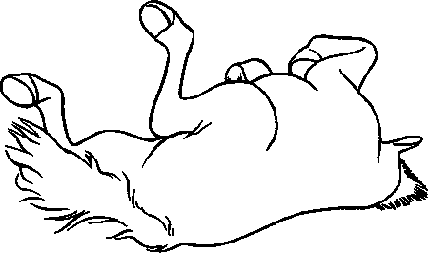

Knowing and recognising the signs of colic is very important for horse owners as this will allow early recognition of colic and therefore early veterinary intervention. Signs to look out for include:

1. Repeatedly getting up and lying down, tries to roll, repeatedly or sits on his haunches like a dog.
2. Curls his lip, grinds his teeth or shows other signs of mild distress.
3. Rolling or thrashing
4. Flank watching;
5. Pawing the ground;
6. Kicking or biting the abdomen;
7. Decreased faecal output or diarrhoea; doesn't pass manure in a normal time span such as overnight, for example.
8. passes hard, dry manure or has diarrhoea.
9. Sweating, anxiety, trembling;
10. Inappetence and depression; goes off his feed and shows little interest in grass.
11. Standing stretched out as if to urinate with his legs parked out in front and behind

