Diagnosis of Colic

Patient’s History: 1) How long he's shown signs of colic?

2) When did the patient last passed manure?

3) When and what he last ate?

4) Has the patient have colic before?

The severity and cause of the colic is then examined. Besides vital signs and gut sounds, those clues may come from:

1. Mucous membranes: Gums should be moist and healthy pink, not dry, dark or bright red or purple. Look for a toxic line which is a red line that appears above the teeth when toxic compounds build up in the blood.

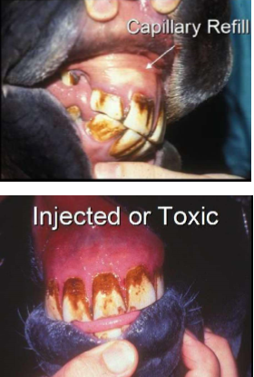

1. Prominent blood vessels in the gums or the sclera (whites of the eyes) are another sign.

The clinical examination may include some of the following;

1. Abnormal temperature. A rectal temperature over 102 °F may indicate infection or inflammation.
2. Heart Rate: A normal resting heart rate is around 24-44 beats per minute. An increased heart rate is usually a good indicator of pain and can often be an indicator of severity of colic. Move the stethoscope to its chest, beneath the left elbow, to check his heart rate. (Or, without a stethoscope, find the pulse at the facial artery where it runs across the jawbone.) Using a watch with a second hand, count beats for 10 seconds and multiply by six to get the rate. A resting rate above 50 beats per minute indicates distress.
3. Mucous Membranes and Capillary Refill Time: Normal gums should be salmon pink in colour, moist with a capillary refill time of less than 2 seconds. Mucous membrane colour, moistness and capillary refill time help to assess A horse's hydration status and are good indicators of blood perfusion. The colour of the gums can be an indicator of severity of colic



1. Gut Sounds: In a normal horse these sounds are heard in 4 quadrants of the abdomen. By listening to the gut sounds, A vet can get a good indication of how much activity is occurring inside the abdomen. an inexpensive stethoscope and being familiar with the horse’s normal gut sounds before they show signs of colic is key. Listen on each side by placing the stethoscope (or, in a pinch, an ear) at its flank, in front of and below the point of the horse hip. Normally, you'll hear several gurgles a minute with a louder rumble every minute or two. Silence is not good; neither is excessive noise.

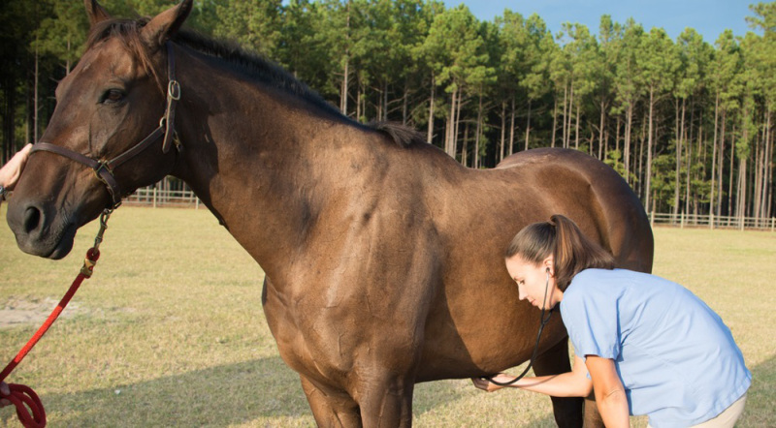

1. Skin Tent: A well hydrated horse's skin when pinched will spring back to its normal position as hydration is closely related to skin elasticity. A sluggish return to normal can be suggestive of dehydration.

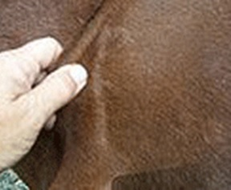

1. Rectal Examination: Internal examination of the abdomen via the rectum is a vital part of the colic diagnostic process. It allows the vet to feel what is occurring inside the abdomen to assess if there are any major abnormalities present such as an impaction or distended loops of bowel due to a twist or locate areas that are distended with gas or fluid, for example. Not all areas of the abdomen can be reached using this technique, but it is an invaluable examination. rectal examination.

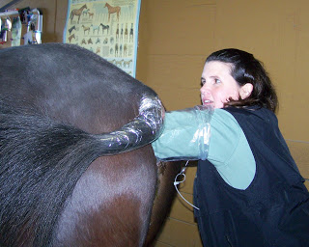

1. Passing a Nasogastric (Stomach) Tube: Passing a tube up the horse's nose and down into its stomach is both diagnostic and therapeutic. Firstly, this will allow the vet to determine if there is any excess fluid in the stomach, "Gastric reflux", which occurs when there is a blockage in the small intestine that causes the build-up of fluid in front of it. Unlike other species the horse cannot vomit, and the stomach can rupture due to build-up of fluid. The presence of gastric reflux is often a major indicator for surgery. Secondly, if gastric reflux is not present, the vet may decide to administer some fluids down the tube to help treat an impaction colic such as mineral oil and water to lubricate the gut.

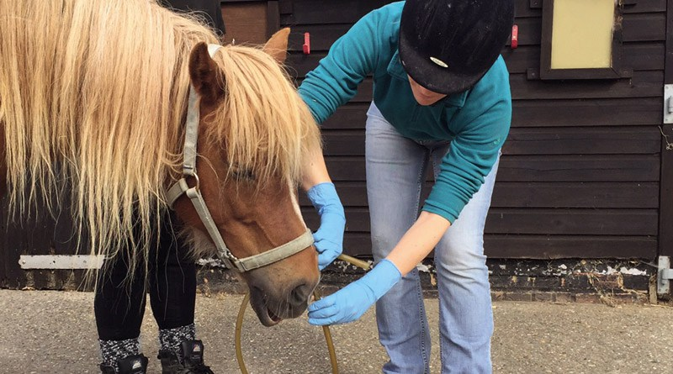

1. Ultrasound and lab tests can also provide information about the nature of the colic. For example, peritoneal fluid (the fluid that lubricates the abdominal cavity) can be drawn with a needle and analysed. That may be helpful in deciding the horse needs surgery, if the results can be obtained quickly and such tests are available.

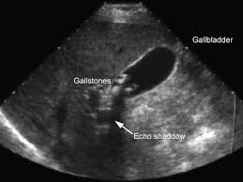

*Ultrasound of Bilary colic*