Pre-Op Considerations

- Perform a thorough pre-surgical evaluation on the patient prior to surgery. This includes a distance exam, a physical exam, assessing TPR, mucous membranes, rumen sounds, and capillary refill time. Auscultation for cardiac arrhythmia or abnormality and for abnormal lung sounds. An oral examination is important and often ofterlooked. Assess saliva production, mucous membranes, breath and tongue. Assessment of rumen is also essential and should have a contraction rate of 1-2/minute. Pre-surgical aboratory evaluation can provide information about the general health status of the patient and where possible must be carried out prior to anesthesia. Recording of this information is essential, shown by attached SVM Animal History Form.
- This sheep presented normally for all physical exam parameters prior to surgery.
- Attitude was BAR, with T 103.3 F, HR 92 and RR 36, adequate hydration status, pink mucous membranes, 2 rumen contractions/minute and a BCS of 3. All haematological parameters were within normal limits.
- It is essential that animals are fasted prior to surgery. Calves and small ruminants should be starved of food for 12 hours and of water for 8 hours. Ruminants are generally not good anaesthesia candidates due to risk of regurgitation and food consumption prior to GA can result in regurgitation and inhalation of ingesta – the risk is greatest in ruminants relative to other species. This can be mitigated by use of a rumen tube.
- Patient’s head should be positioned below the body to allow any regurgitated material to run downwards instead of into the throat.
- This patient was accidentally fed on the morning of the procedure so this is an even riskier complication. Animals should generally not be placed under GA once it has eaten, unless in an emergency. The complications we encountered associated with the patient having not been fasted are further expounded upon in the complications/risks and method section of this CMAP.
- Proper pre-op preparation of surgical, epidural & catheterization sites: to save time and reduce stress to the animal, surgical and epidural site were thoroughly clipped ahead of the surgery time.
- Both cephalic and jugular catheters are placed in order to have a ‘back up’ IV route. This was done successfully in our patient. Sites of catheter insertions are at risk for bacterial infection so ensure adequate cleaning with chlorhexidine and alcohol, and removal of dirt if animal is excessively filthy.
- Proper draping and assessment of environment is essential - aseptic vs clean, adequate space, equipment, cover, control of flies.
- position of animal
- Choosing whether to operate on a standing or lying animal is determined only for adult horses and cows.
- Smaller animals (dog, cat, foals) are almost always operated while in dorsal recumbency, and under general anaesthesia.
- Small ruminants (calf, sheep and goat) are often operated in lateral recumbency under local anaesthesia.
- Laparotomy on a standing animal vs recumbent animal has advantages and disadvantages, which should be considered pre-operatively given the environment, resources, skill of surgeon, etc.
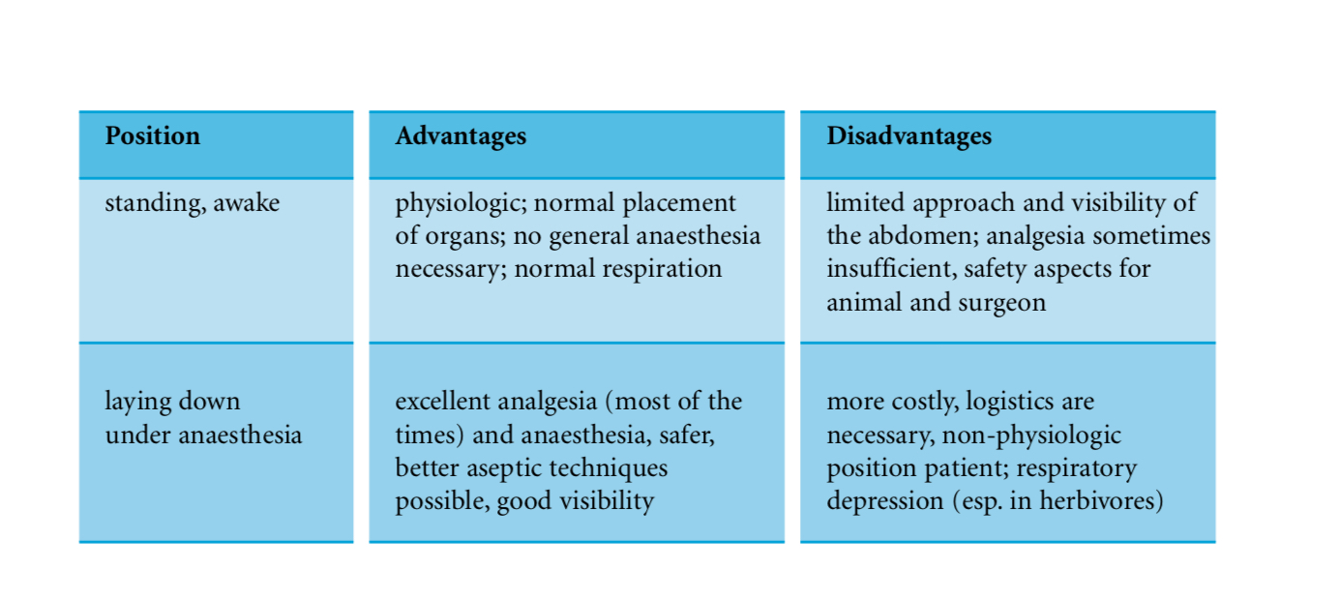
- The consequence of the above mentioned advantages and disadvantages is that usually is performed on a recumbent animal, and in adult cows mostly on the standing animal. Advantages and disadvantages:
- A good preanesthetic sedation facilitates smooth induction and has anesthetic sparing effect during maintenance. Sheep was administered the Ketamine Stun prior to entry into the OR to minimize excitement and allow time for drugs to take effect.
- Allow one week acclimation for newly arrived animals before surgery, minimum 72 hours. This stabilization period is not required for animals used acutely (anesthetized and euthanized at the end of the procedure), although it is recommended. This provision allows animals to acclimate to the facility and reduces the chance of preventable stress-induced disease and compilations such as anesthetic death.
- Proper padding and positioning of ruminants during surgery is vital. Whenever possible, standing surgeries with local anesthetic blocks are preferred. If recumbency is required, place ruminants on a flat surface with sufficient padding. A minimum of one- to two-inch thickness is recommended for calves, sheep, and goats. Because of their size, ruminants often require mechanical ventilation during anesthetic procedures.
- Proper surgical site preparation with chlorhexidine in a concentric motion
- Proper predation of surgeon, assistants and instruments.
- administration of CRI and fluid therapy as soon as induction doses have been given.

