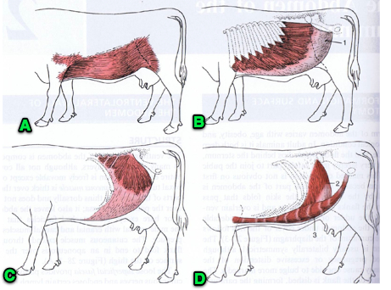

A: cutaneous trunk line m. B: external oblique m.  
     - loosely arranged through fat tissue  
     - thicker in ruminant and horses  
     - can 'flick' to get flies off  
  
  
  
C: internal oblique m. D: transverse abdominus m.and rectus abdominus m