**Recommendations:**

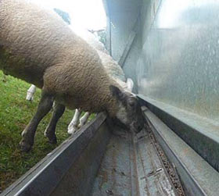**Fasting:**

As with the vast majority of the surgical procedures for ruminants, they must be fasted in order to eliminate the complications of rumen activity that can lead to bloat, asphyxiation, among other issues. Since the case we were presented with was fed on the day of the procedure, problems arose, making the procedure more difficult. Therefore, it is highly recommended that the fasting of animals is properly communicated to the staff in order to prevent situations than that lead to detrimental risks for the patient.

Furthermore, an **endotracheal tube** should be placed in the patient’s oesophagus at the beginning of the surgery in the event of a patient having been fed prior to surgery. This would ensure gas build-up is prevented as it would have a point of exit. While it is known that in almost every case, surgery would not be conducted on a non-fasted animal, in situations where it must be done, an endotracheal tube should be passed.

**Proper placement of the laparotomy incision:**

The area should be better examined in order to properly estimate where the incision for the exploratory laparotomy be done. Ideally, it should always be done a few centimetres caudal to the last rib. This would give better ability to reach and palpate the organs in the abdominal cavity.

**Preparation for hypothermia**:

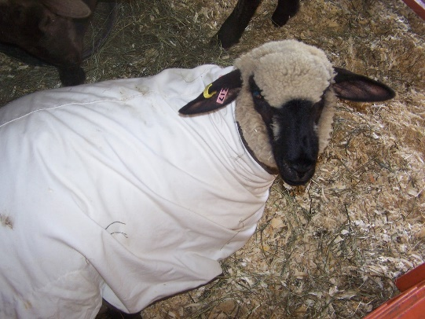Blankets – after surgery, clean, warm blankets should be readily available to the patient in order to immediately begin to progressively eliminate the effects of hypothermia.

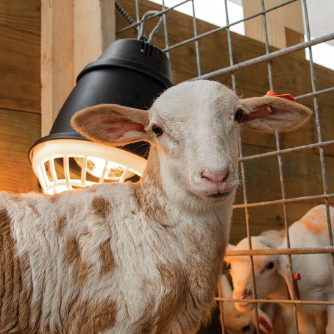Heat lamps – infrared lamps should be held in the recovery pen for a few days after the procedure as a means of temporarily providing heat until the patient’s thermoregulatory mechanisms re-stabilize.

Insulating materials on the operating table – to minimize the degree of conductive heat loss from the patient to the operating table, a clean material e.g. cloths, paper sheets, can be place on the table before placing the patient on it. This would decrease the degree at which heat is transferred, potentially preventing the onset of hypothermia.

Heating pads – heating can be placed in a safe location in the recovery for the patient to lay on in the event severe hypothermia occur. This would provide the patient with heat via conduction. It is important that bedding must be placed on the heating pad in order to prevent the patient suffering from burns as a result of laying on the pad for a period of time as it fully recovers from anaesthesia.