Exploratory Laparotomy in Small Ruminants Procedure

- The animal is placed in left lateral recumbency, making the right flank accessible. Drapes are placed along the areas of the lumbar vertebrae, tubercoxae, last rib and ventral abdomen

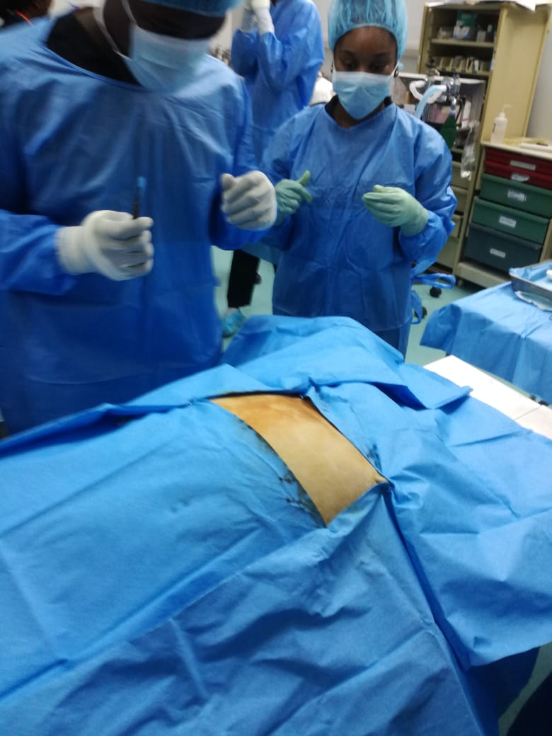

- A dorsoventral skin incision is made more cranially on the flank, exposing the cutaneous trunci muscle, which is also incised following the line of the skin incision

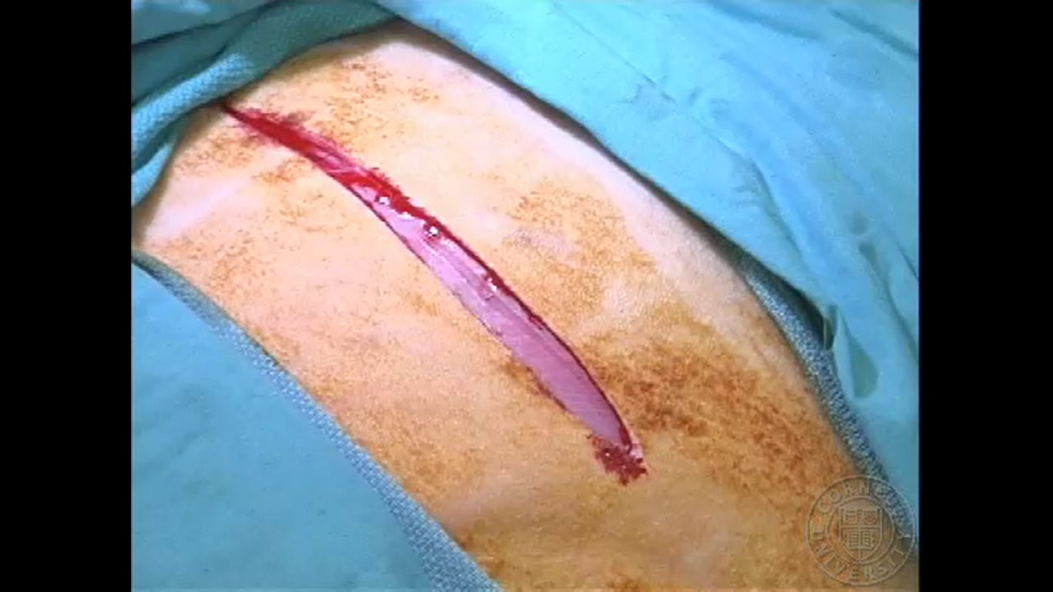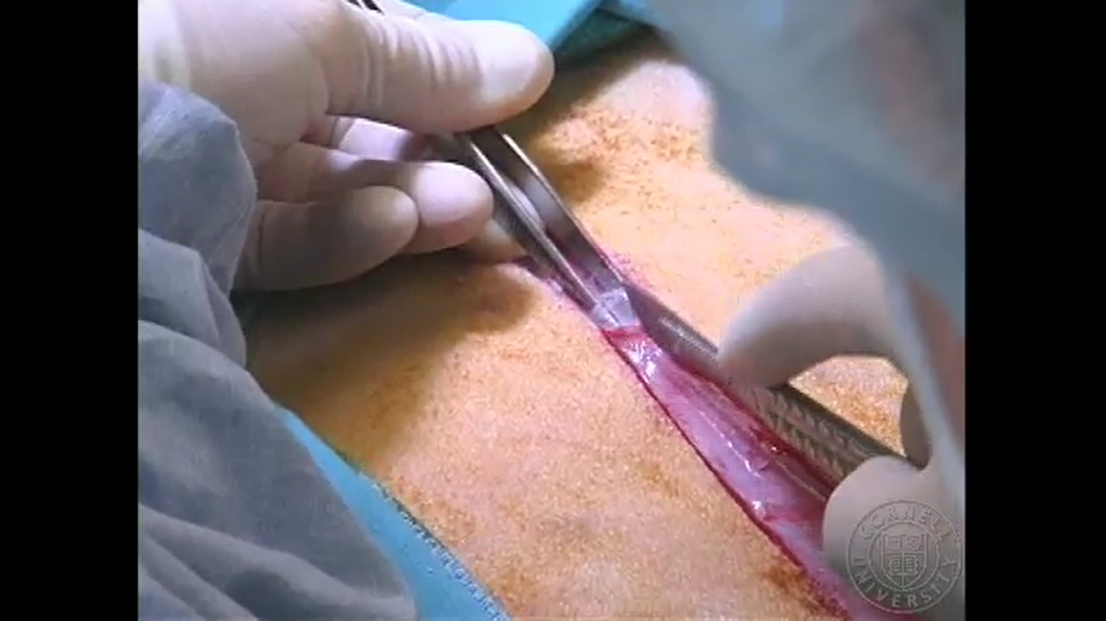

- The next layer is the external abdominal oblique muscle, which runs caudoventrally,

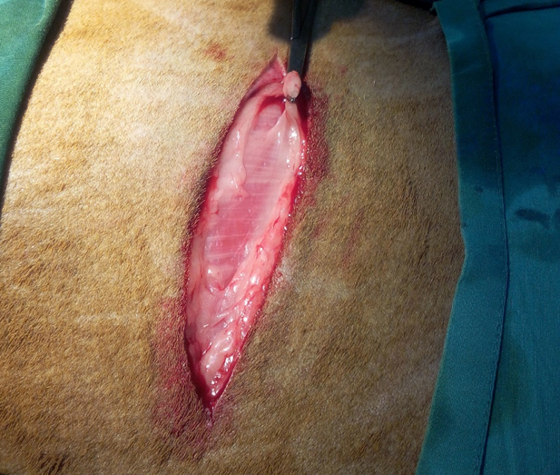

followed by the internal abdominal oblique muscle which runs cranioventrally. When incising, cut blood vessels can be ligated using haemostats or suture materials. These muscle layers are incised using Mayo scissors instead of a scalpel blade.
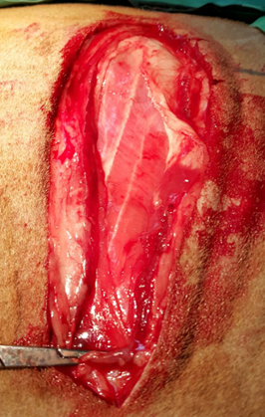

- Using scissors, the next layer is incised- the transversus abdominis, along with the peritoneum. This is done carefully by tenting the muscle to prevent and using a mayo scissors to avoid damage to abdominal organs.

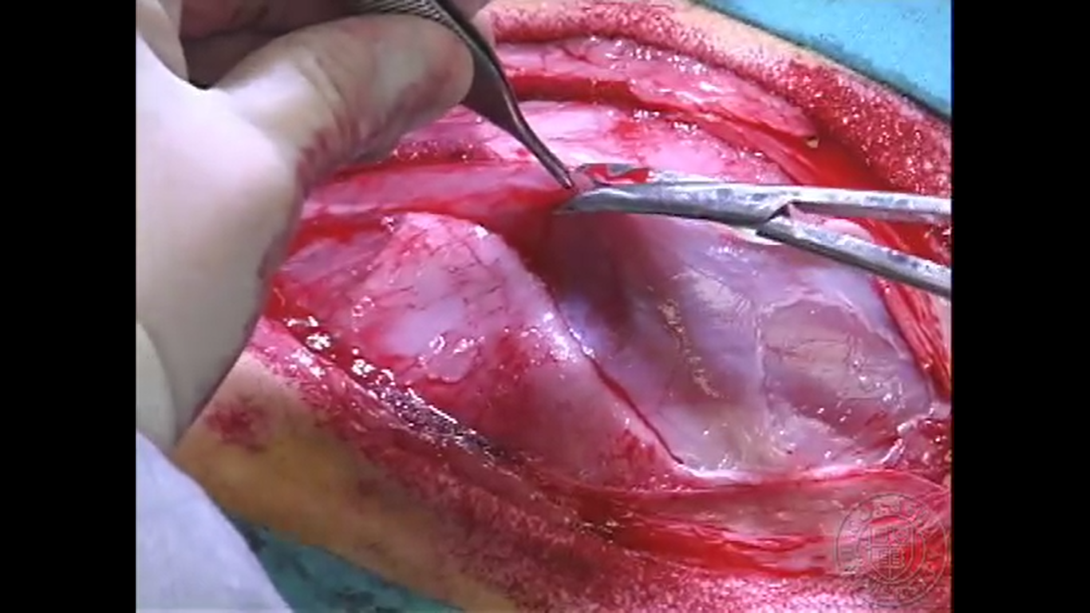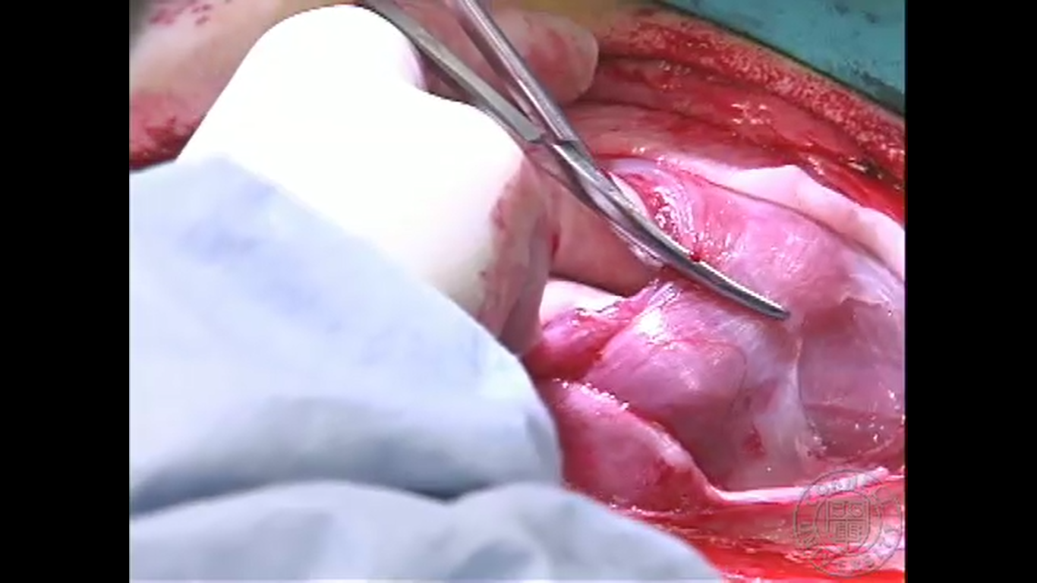

- Once the peritoneum is opened, the pylorus is exteriorized and the greater and lesser omentum identified. Gloves are washed with saline to prevent dry glove trauma and splash block for added nerve block and other abdominal organs are palpated, such as the kidneys and liver. The diaphragm is swept, and the heartbeat felt near the middle of the diaphragm.

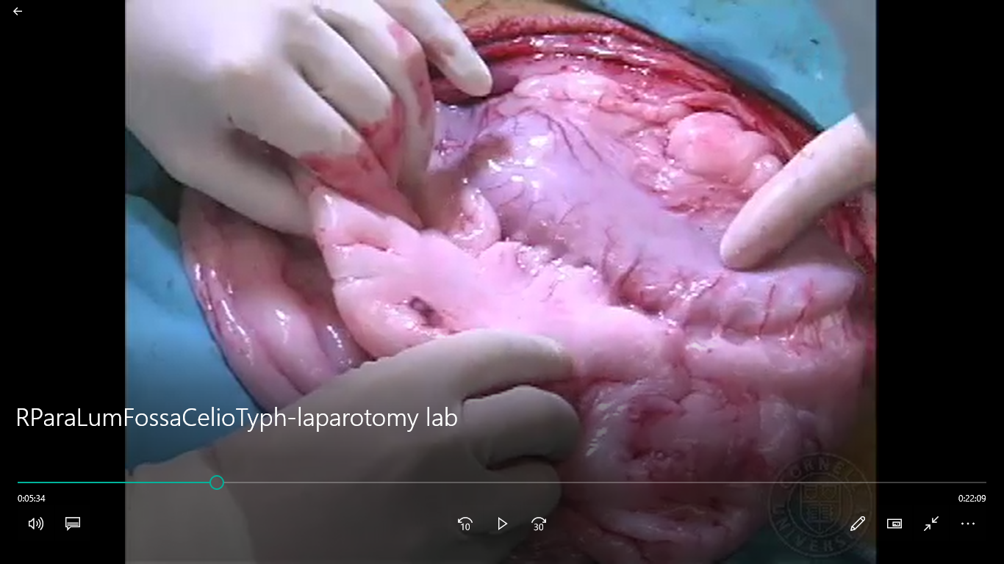

- The caecum is exteriorized, and the blind end located.

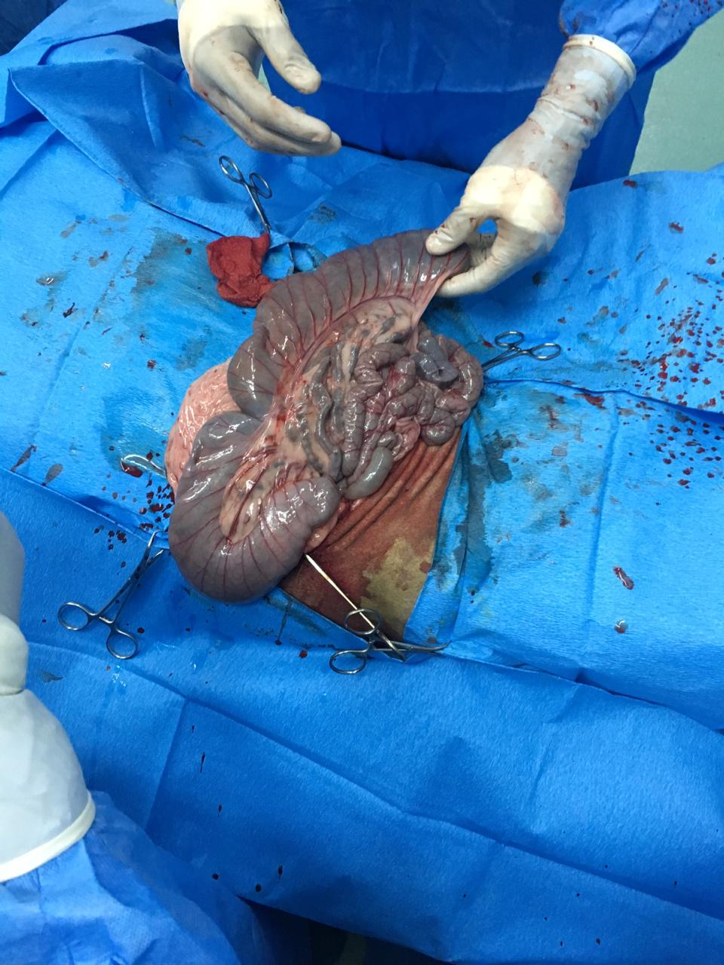

- The ileum is traced forward to the ileocecal junction, and the intestinal mass is flipped, exposing the spiral colon.

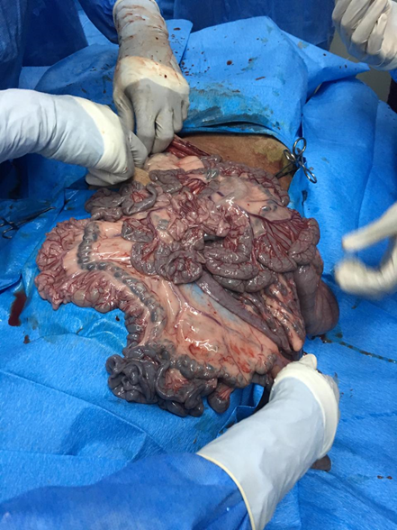

- After the length of the intestine is checked, more splash bock was added (as it is a highly sensitive organ) and it is put back into the abdomen, first by the proximal small intestine, then the distal jejunum and ileum, and then the caecum is replaced.

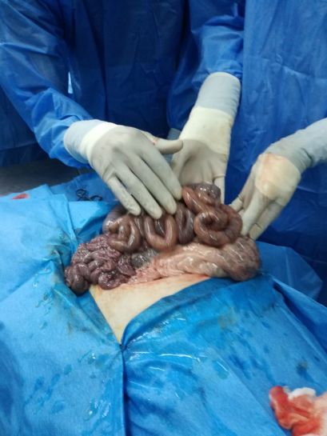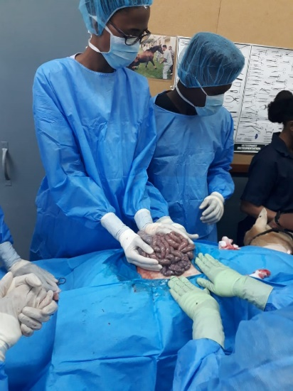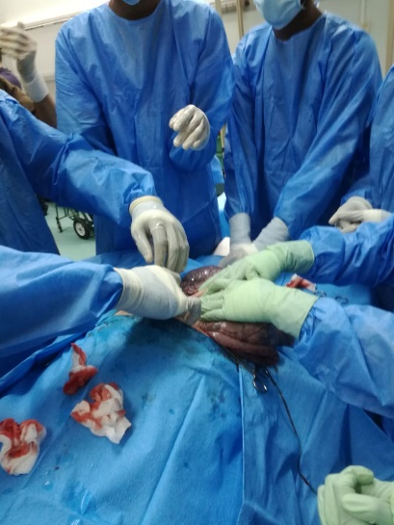

- The peritoneum and transversus abdominis external and internal oblique muscles are sutured closed with a simple continuous pattern.

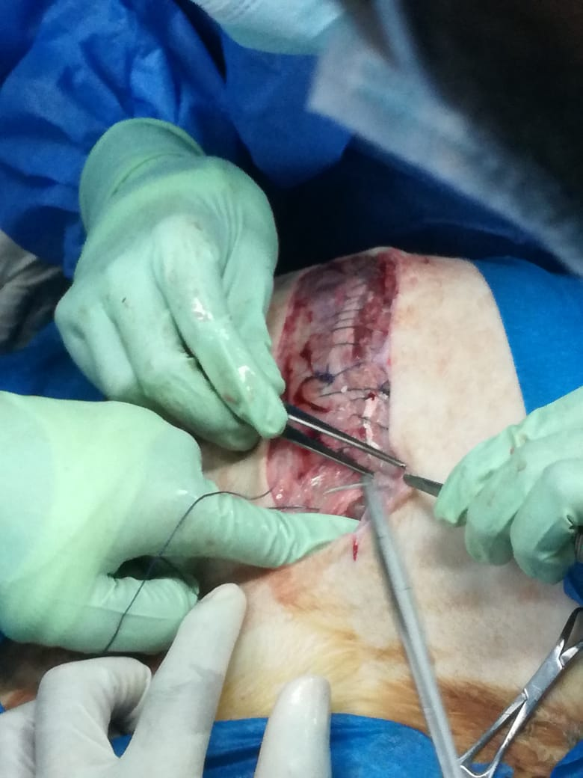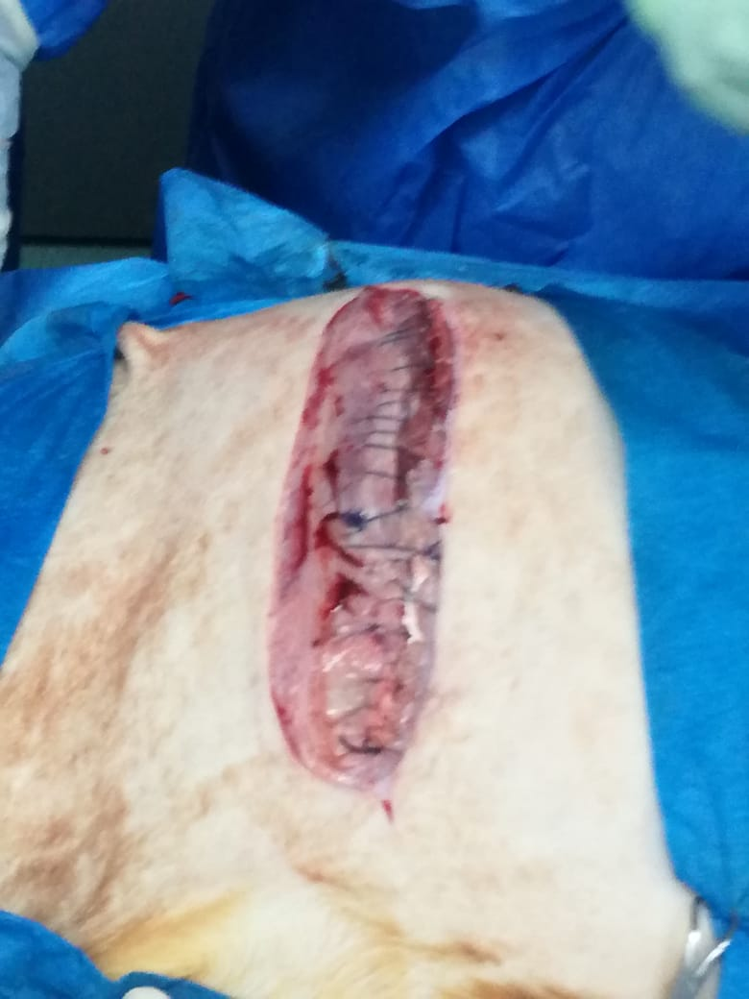

Suture used:
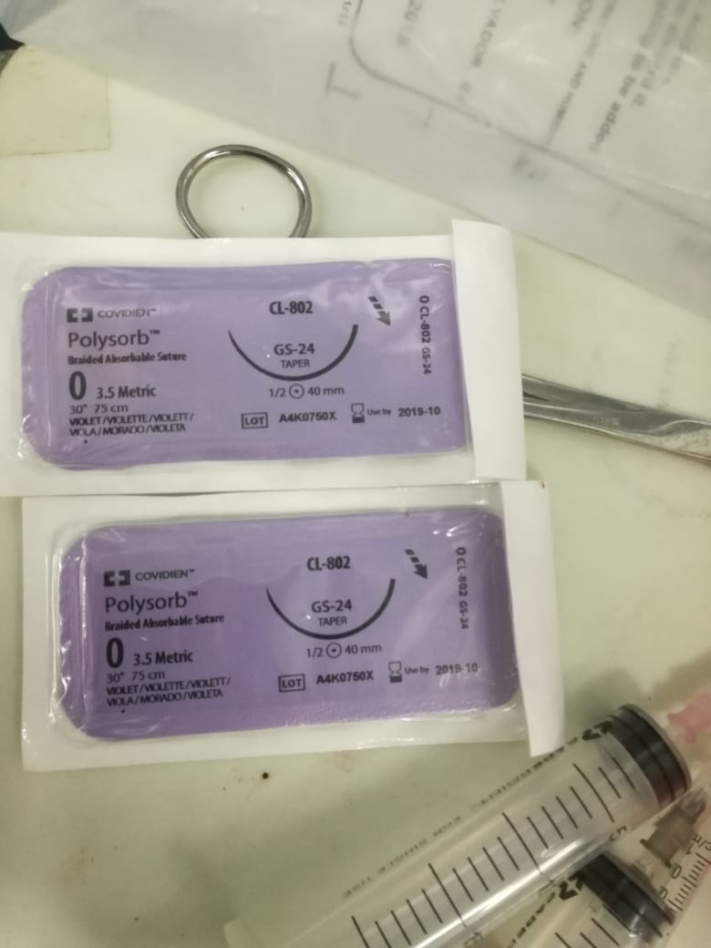

- The cutaneous trunci and skin are closed as one layer using ford interlocking suture pattern beginning from the dorsal part of the incision.

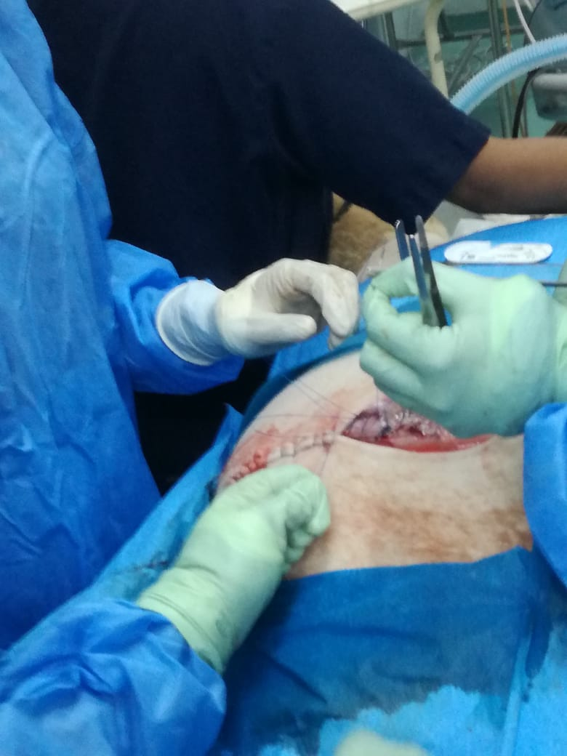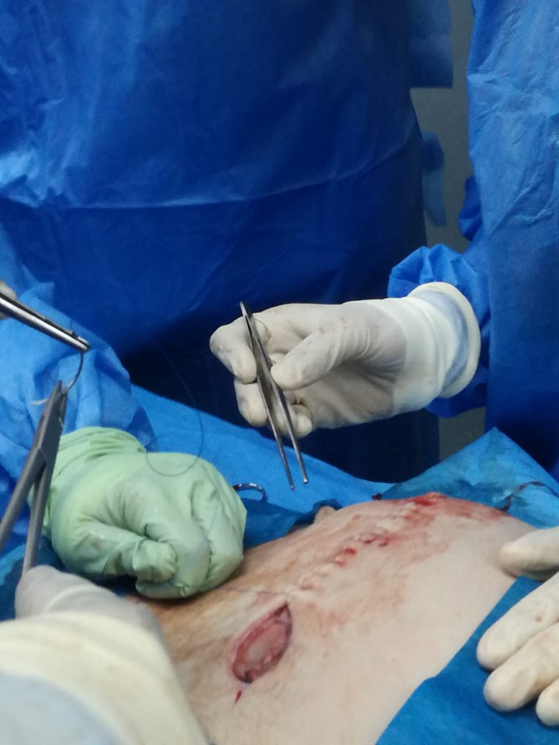

Suture used:

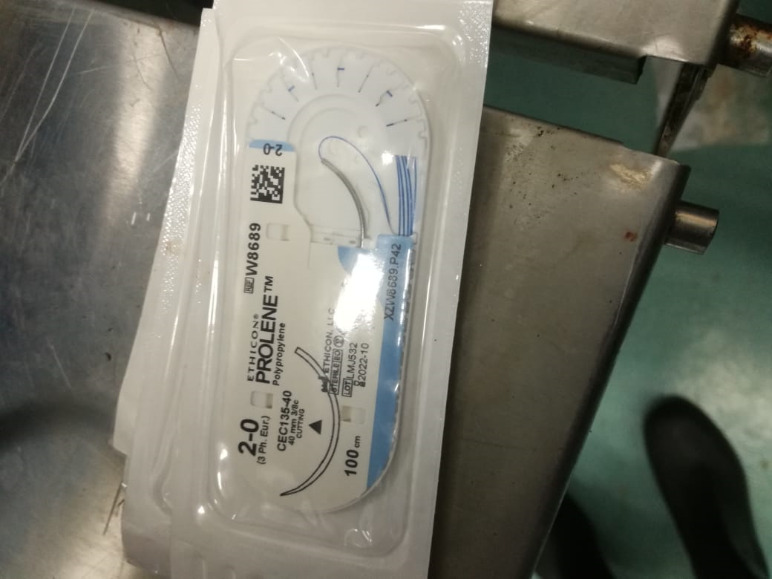

- At the ventral aspect of the incision 4 simple interrupted sutures were done to ensure proper drainage

