Recurrent Laryngeal Neuropathy aka laryngeal hemiplegia is a common disease of horses. It is due to the progressive destruction or weakening of the recurrent laryngeal nerve that supplies the larynx. As nerve function decreases, the muscles that innervate the larynx progressively weaken resulting in the larynx blocking the airway/a smaller than normal airway. The animal may emit a roaring or whistling noise as a result and show significant exercise intolerance.

In all species the larynx is closed during eating but opens during breathing. Normal appearance of the larynx is roughly diamond shaped.

* Studies of nerves from RLN horses show continual or intermittent damage to the nerve with attempts at repair - thought to be the reason for variation in progression in horses with the disease
* Laryngeal paralysis is a commonly used term but is not accurate as both sides of the larynx are not usually paralyzed.
* Left side is more commonly affected as it is longer. This condition is also more common in larger horses.
* There is no definitive cause but the following are predisposing factors to this condition:

1. Stretching or squashing of the recurrent laryngeal nerve (that supplies nerves to the larynx) as it has a very long, tortuous pathway to the larynx
2. Injury to the recurrent laryngeal nerve
3. Inherited condition: studies have shown that offspring of RLN-affected stallions are more likely to be affected with RLN than offspring of unaffected stallions
4. <https://www.ed.ac.uk/files/imports/fileManager/rln.pdf>

Diagnosis

* Clinical history - especially reduced exercise tolerance/history of poor performance
* Clinical signs: roaring/whistling/gasping during heavy work. - due to turbulent air flow across vocal cords
* Physical exam: palpation of larynx for loss of musculature
* Confirmation with endoscopy [fibreoptic camera inserted into nostril to view larynx and upper + lower respiratory tracts] to assess symmetry of arytenoids and synchrony of movement. Can be done by blocking nostrils to increase effort of breathing to assess full laryngeal function
* Exercise tests

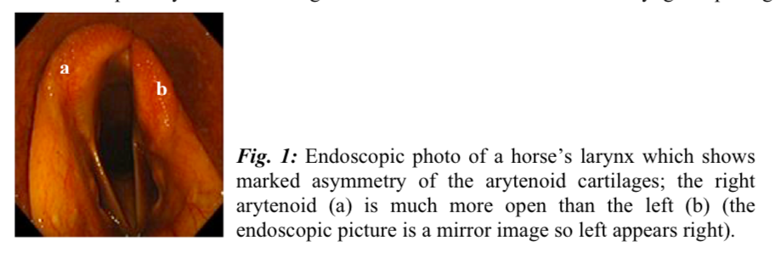

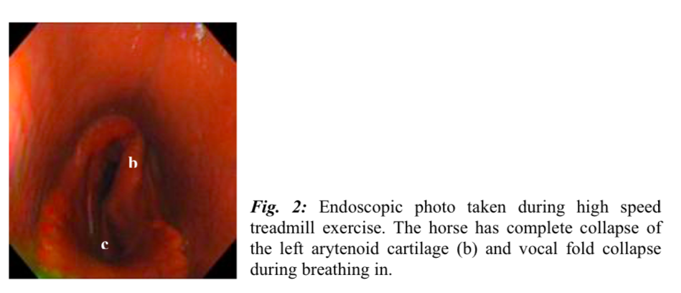

The degree of laryngeal opening is graded:

Grade 1: normal larynx. Opens fully during inspiration at rest and post exercise

Grade 2: larynx opens fully but there is some degree moment, such as a flutter seen in muscles on the left side

Grade 3: larynx does not open fully. Movement of left side is evident when horse inspires and expires

Grade 4: At rest, obvious weakness in left laryngeal muscle, does not open at all.

* Grades 1 & 2 are considered normal. Grade 3 may require treatment if horse is performing poorly.  Grade 4 - horse will produce abnormal noise

<https://www.xlvets.co.uk/sites/default/files/factsheet-files/XLVets-Equine-Rebranded-086-Tieback-and-Hobday-Factsheet.pdf>

Treatment

The most commonly used treatment is a prosthetic laryngoplasty or a tie-back procedure, which may or may not be done with a ventriculocordectomy. Selection of the appropriate treatment is dependent on the clinical signs, use of the horse and owner’s goals/desires from treatment.