Splint Bone Removal

What? & Why (Anatomy, Condition and Indications)

What?
- Splint bone fractures are fairly common, particularly in horses two years and older
- They occur more commonly in the forelimb than the hindlimb
- In horses over two years old the elastic interosseous ligament that joins the medial and lateral splint bones to the palmar or plantar aspect of MC/MT III becomes ossified. At around 5-7 years there is less flexibility in the splint bone
- Fractures are most common in the distal third of the splint bone
- Can occur due to:
—> cyclic bending of the suspensory ligament causing what is known as a ‘fatigue fracture’ from the pulling of the splint bone buttons by the suspensory ligament
—> following repeated overload of the suspensory ligament
—> hindlimbs kicking forelimbs due to conformation such as knocked knees or unbalanced feet

[— i.e. excessive weight-bearing load can cause excessive movement between the bones resulting in increased pull from the interosseous ligament and this increased ligament tension can fracture the splint bone. In most of these cases the splint bone breaks at it thinnest-most aspect, which is approximately 1-2 inches above the "button" (located at the distal aspect/ bottom of the bone). This type of fracture is more commonly associated with the medial (inside) splint bones and is usually "closed" (i.e. it is not associated with an open wound)].
- Also occurs with exostosis (I.e. splints, usually younger animals, forelimbs) - splint bone periosteal proliferation due to overload or external trauma, healed trauma/fracture
- Splint bone fractures are commonly associated with suspensory ligament desmitis and suspensory strain may be involved in causing splint bone fractures as the enlarged suspensory ligament pushes the splint bones outwards during flexion of the fetlock. One study found that 61% of affected thoroughbred patients also had associated suspensory ligament desmitis.

Why?: Splint bone removal is indicated by fracture due to the risk of excessive callus formation as well as secondary pseudoarthritis that may interfere with the suspensory ligament causing pain and lameness that may progress.

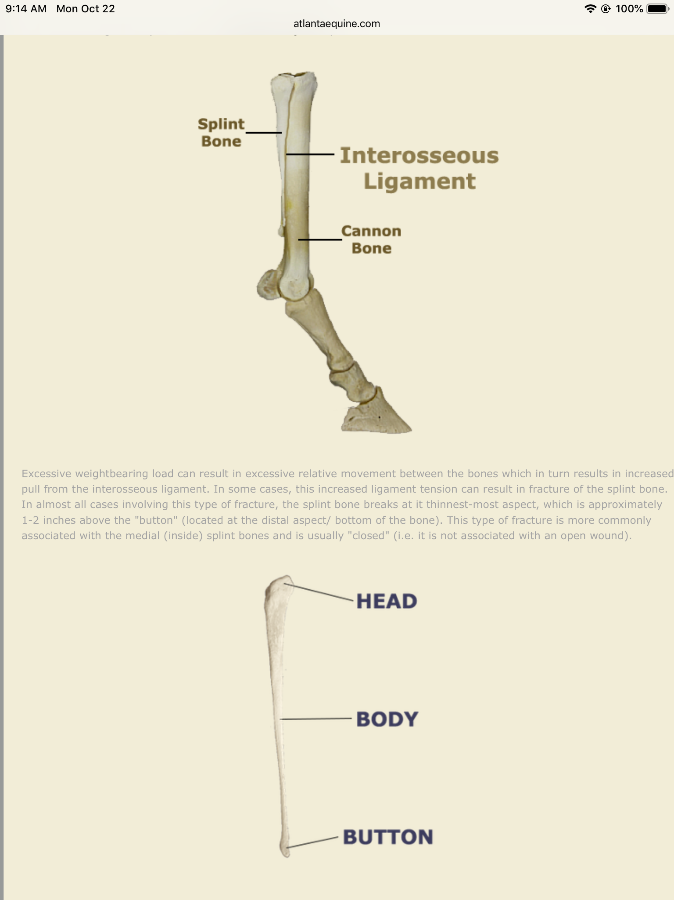
Normal anatomy of equine splint bones

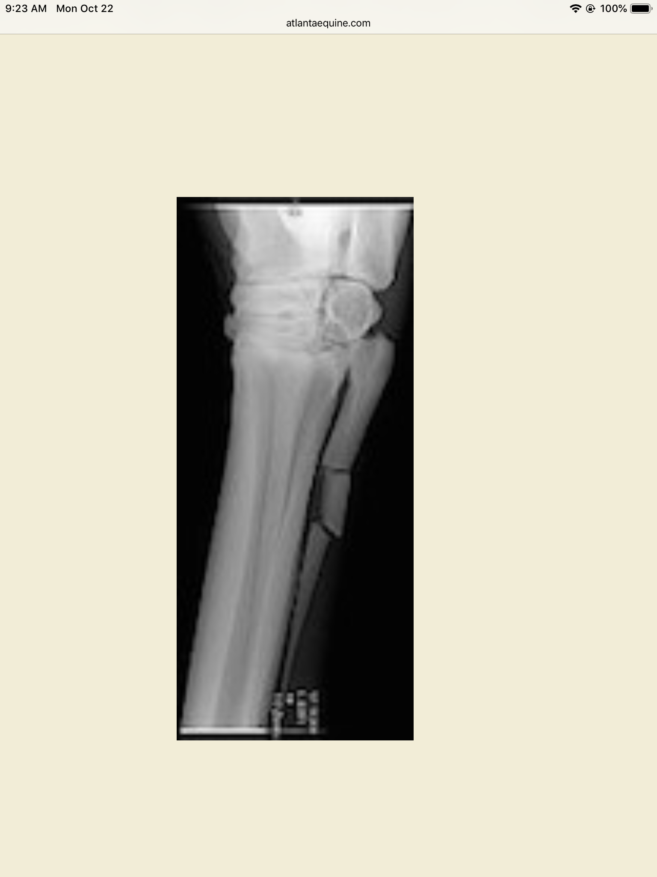
Radiograph of splint bone fracture

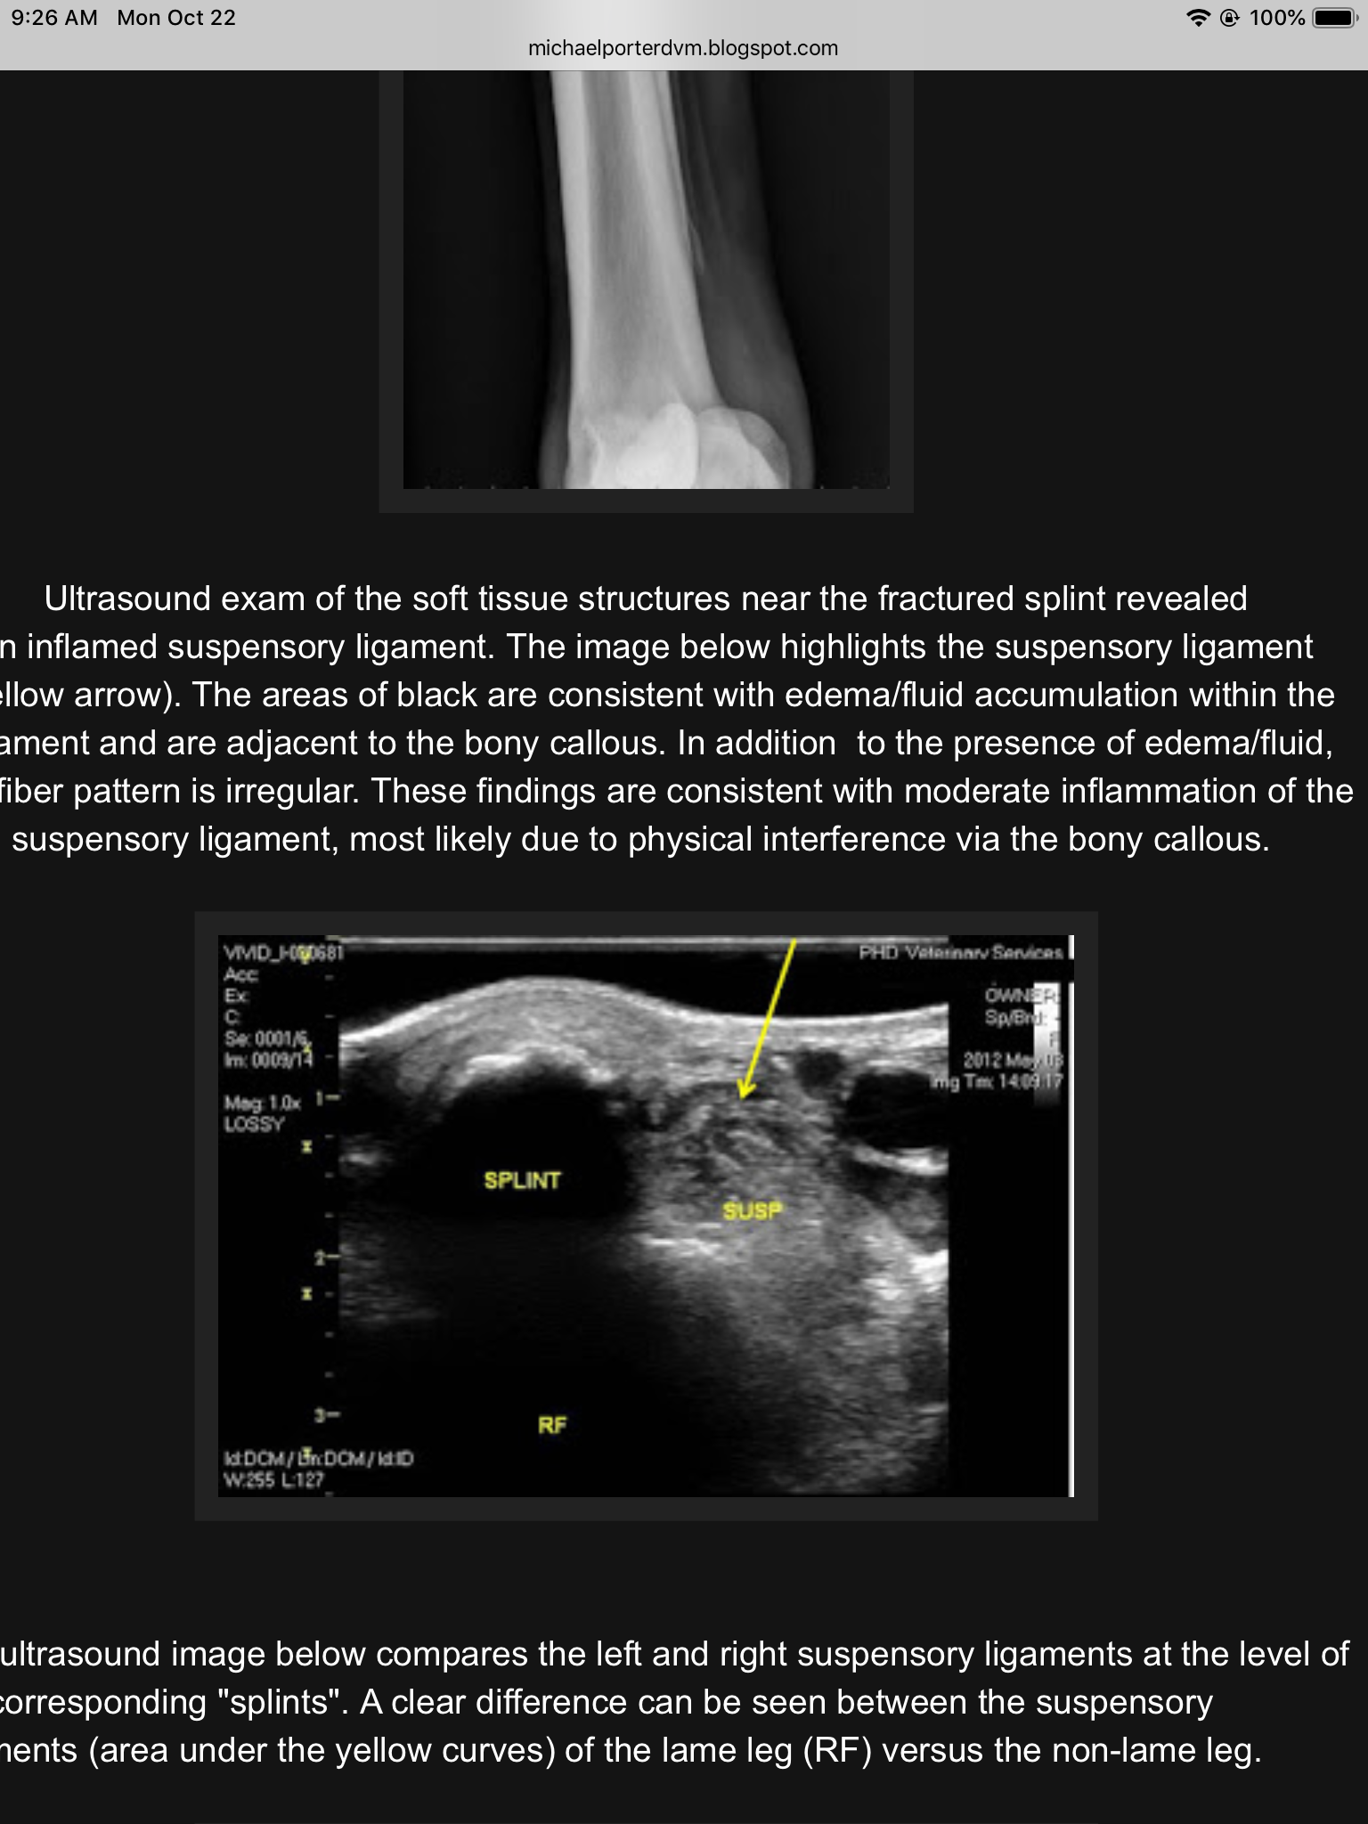
Ultrasound showing callous formation on splint bone and inflamed suspensory ligament

(http://michaelporterdvm.blogspot.com/2012/10/not-all-splints-are-created-equal.html)

Diagnosis

- Physical exam - will notice swelling over cannon bone, heat, pain and lameness that is usually not evident at the trot in a straight line but will present once the horse is lunged on a circle (Grade 2 lameness). An open wound is possible which can lead to infection
- Radiograph is used to confirm diagnosis
- Ultrasound is also important in order to assess the commonly affected suspensory ligament for desmitis or strain

General Surgical Procedure
- a tourniquet is optional as it may lead to post op hematoma
- Take intraoperative radiographs
- make an incision dorsal to the affected splint bone extending distally past the button
- Dissect skin from subcutaneous tissue and incise fascia
- Handle periosteum very gently
- Detach ligament, start at location distal to button
- Avoid vessels and nerves
- Transect bone proximal to fracture using an osteotome or chisel, sharply excise soft tissue attachments
- Oscillating saw is another option and has been shown to cause less micro fractures
- Use a rasp to smooth the end
- Wipe and lavage wound to remove all bone fragments
- Routine closure in layers using absorbable sutures

https://courses.cit.cornell.edu/vet644/splintBoneRemoval.html

Ostectomy is done for a complicated fracture with multiple small fragments. Completely remove distal fragment if not attached to cannon bone.

Complications
- Proximal segment may dislocate causing lameness and degenerative joint disease
- removal of attachment of collateral ligament and carpometacarpal or tarsometatarsal joint can cause joint instability resulting in luxation of joint.
- New bone formation at distal end of proximal fragment, ostetitis, infection
for mid body fracture removal
- dorsal MT artery runs between lateral splint and cannon bone. Carefully avoid!

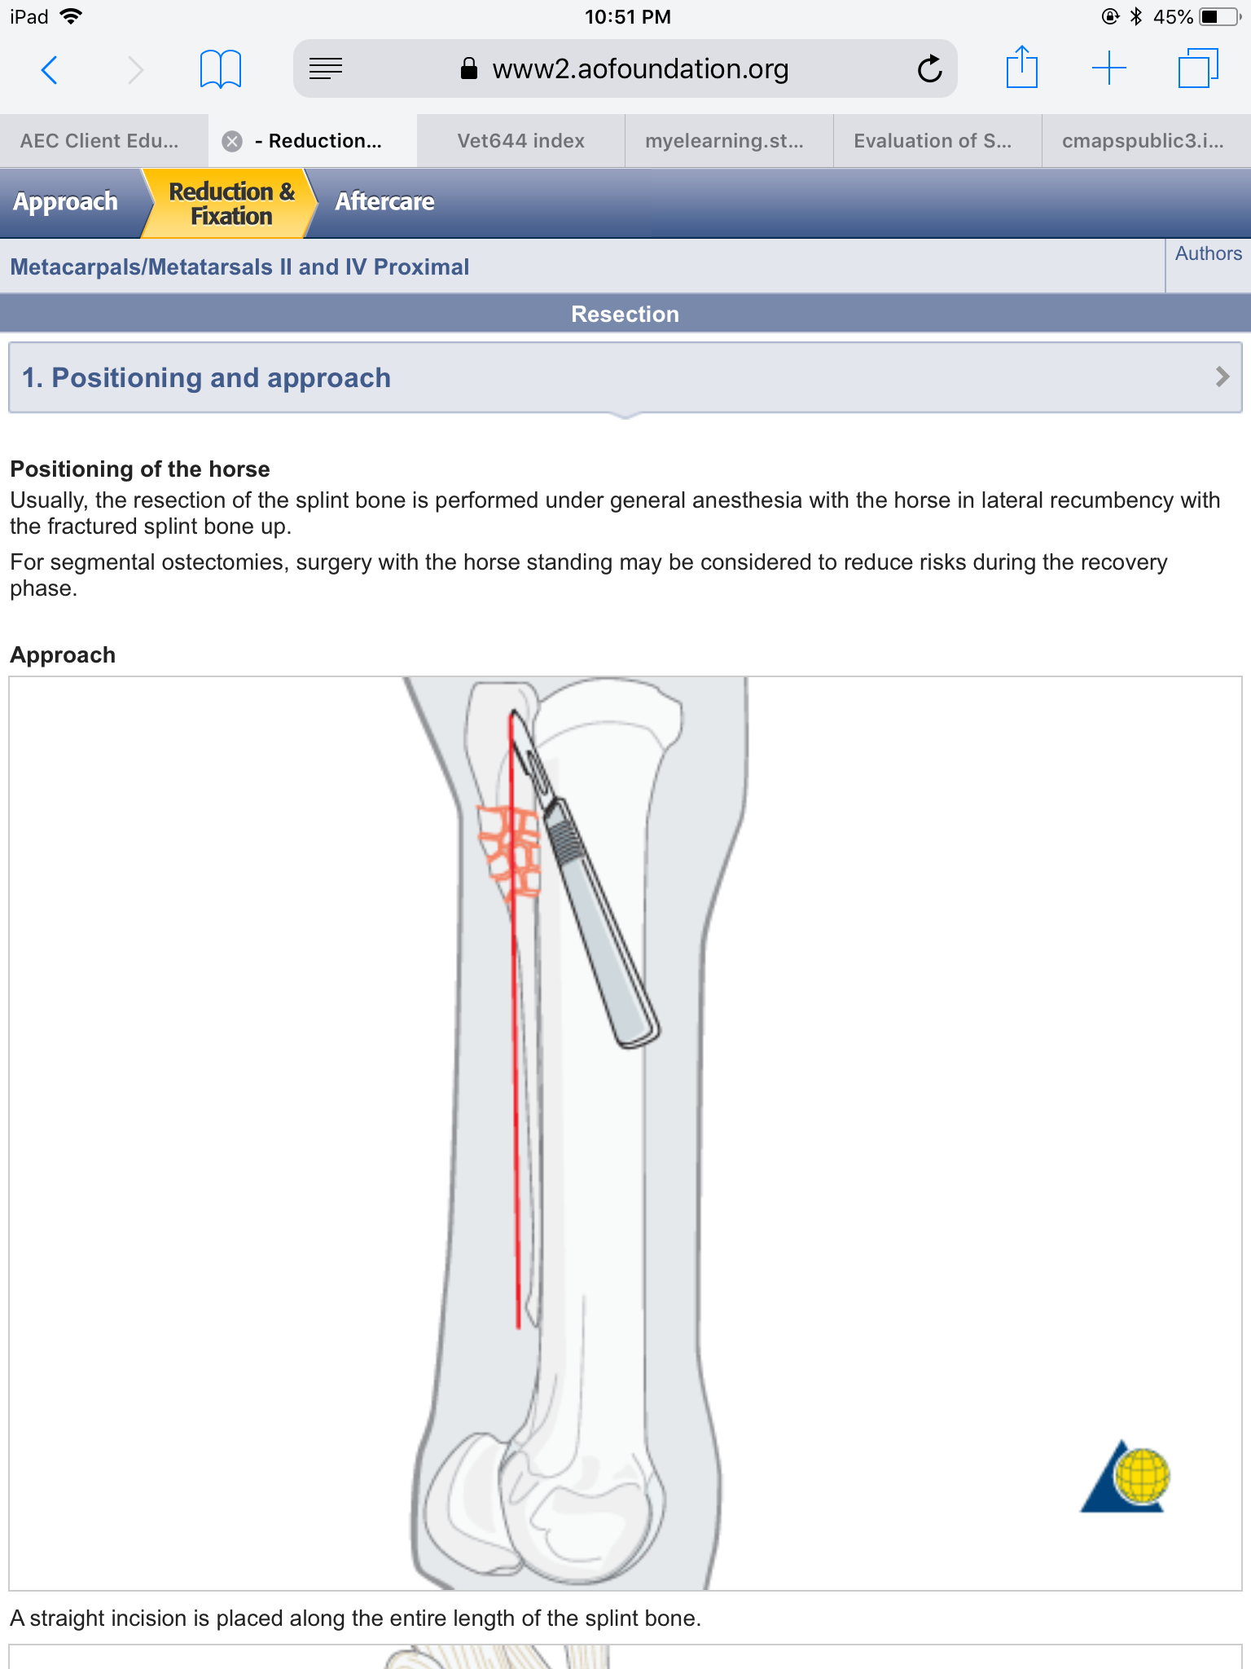
Incision

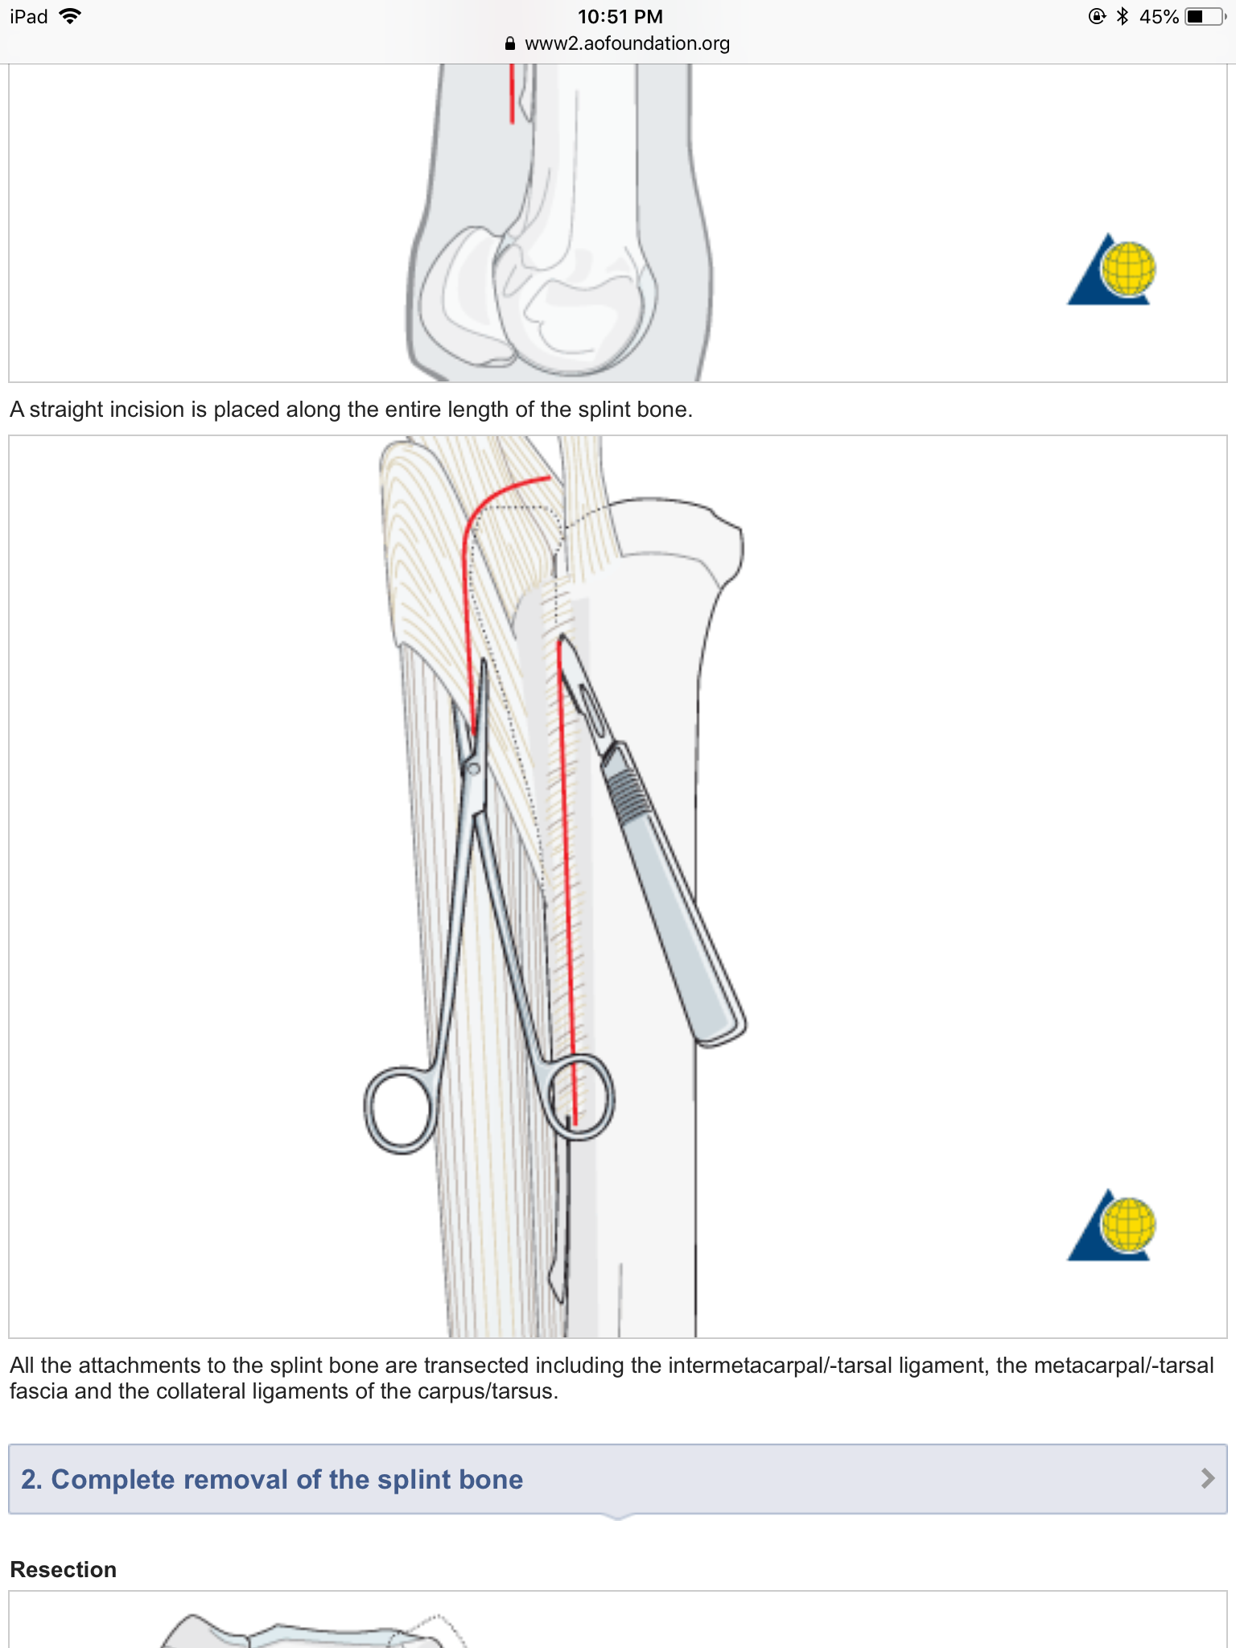
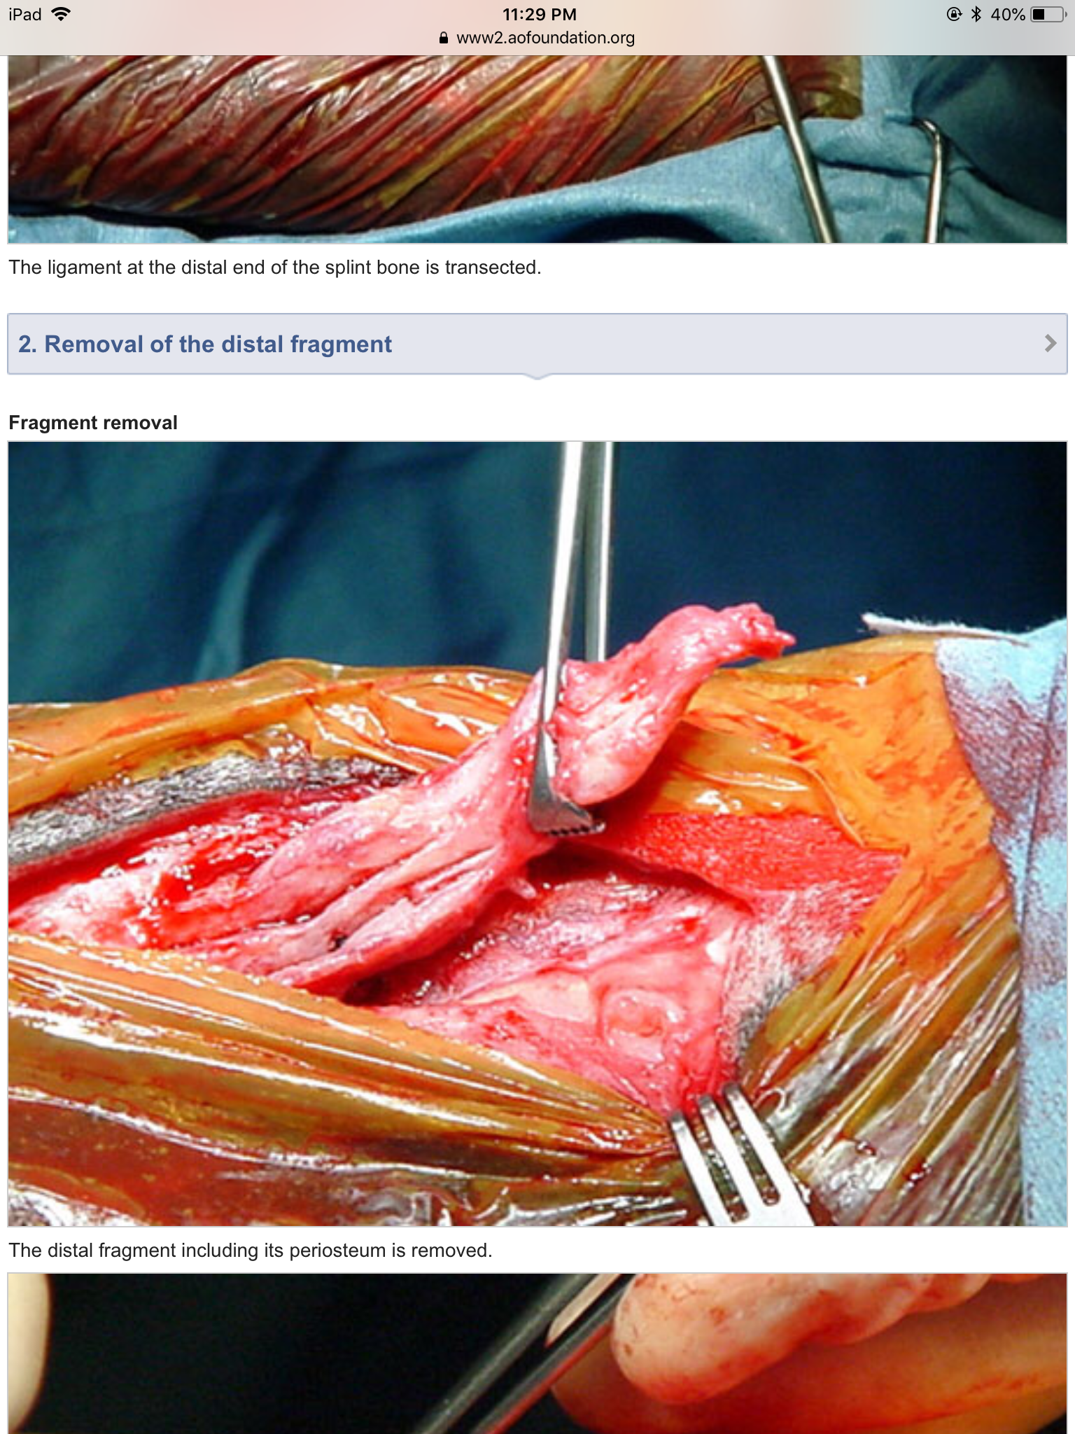

- approaches and complications may slightly vary dependent on location of the fracture - proximal, mid body and distal. Listed below are the surgical approaches with photos and more specific complications

PROXIMAL FRACTURES

Wound debridement

https://www2.aofoundation.org/wps/portal/!ut/p/a1/04_Sj9CPykssy0xPLMnMz0vMAfGjzOKN_A0M3D2DDbz9_UMMDRyDXQ3dw9wMDAzMjYEKIvEocDQnTr8BDuBoQEh_QW5oKAD4ENaS/dl5/d5/L2dJQSEvUUt3QS80SmlFL1o2XzJPMDBHSVMwS09PVDEwQVNFMUdWRjAwMDcz/?showPage=redfix&bone=HorseFoot&segment=Metatarsals&classification=h87-Metacarpals/-tarsals%20II%20and%20IV,%20Proximal&treatment=&method=Wound%20debridement&implantstype=&approach=&redfix_url=1412782886722

Resection

https://www2.aofoundation.org/wps/portal/!ut/p/a1/04_Sj9CPykssy0xPLMnMz0vMAfGjzOKN_A0M3D2DDbz9_UMMDRyDXQ3dw9wMDAzMjYEKIvEocDQnTr8BDuBoQEh_QW5oKAD4ENaS/dl5/d5/L2dJQSEvUUt3QS80SmlFL1o2XzJPMDBHSVMwS09PVDEwQVNFMUdWRjAwMDcz/?showPage=redfix&bone=HorseFoot&segment=Metatarsals&classification=h87-Metacarpals/-tarsals%20II%20and%20IV,%20Proximal&treatment=&method=Resection&implantstype=&approach=&redfix_url=1412782958316

Plate Fixation

https://www2.aofoundation.org/wps/portal/!ut/p/a1/04_Sj9CPykssy0xPLMnMz0vMAfGjzOKN_A0M3D2DDbz9_UMMDRyDXQ3dw9wMDAzMjYEKIvEocDQnTr8BDuBoQEh_QW5oKAD4ENaS/dl5/d5/L2dJQSEvUUt3QS80SmlFL1o2XzJPMDBHSVMwS09PVDEwQVNFMUdWRjAwMDcz/?showPage=redfix&bone=HorseFoot&segment=Metatarsals&classification=h87-Metacarpals/-tarsals%20II%20and%20IV,%20Proximal&treatment=&method=Plate%20fixation&implantstype=&approach=&redfix_url=1412783021558

MID BODY FRACTURES

https://www2.aofoundation.org/wps/portal/!ut/p/a1/04_Sj9CPykssy0xPLMnMz0vMAfGjzOKN_A0M3D2DDbz9_UMMDRyDXQ3dw9wMDAzMjYEKIvEocDQnTr8BDuBoQEh_QW5oKAD4ENaS/dl5/d5/L2dJQSEvUUt3QS80SmlFL1o2XzJPMDBHSVMwS09PVDEwQVNFMUdWRjAwMDcz/?showPage=redfix&bone=HorseFoot&segment=Metatarsals&classification=h87-Metacarpals/-tarsals%20II%20and%20IV,%20Midbody&treatment=&method=Resection&implantstype=&approach=&redfix_url=1412783213380

DISTAL FRACTURES

https://www2.aofoundation.org/wps/portal/!ut/p/a1/04_Sj9CPykssy0xPLMnMz0vMAfGjzOKN_A0M3D2DDbz9_UMMDRyDXQ3dw9wMDAzMjYEKIvEocDQnTr8BDuBoQEh_QW5oKAD4ENaS/dl5/d5/L2dJQSEvUUt3QS80SmlFL1o2XzJPMDBHSVMwS09PVDEwQVNFMUdWRjAwMDcz/?showPage=redfix&bone=HorseFoot&segment=Metatarsals&classification=h87-Metacarpals/-tarsals%20II%20and%20IV,%20Distal&treatment=&method=Resection&implantstype=&approach=&redfix_url=1412783282886

Differential diagnoses

- Splints result from an injury to the periosteum or interosseus ligament due to trauma or other factors (such as injury, concussion, strain from training, excess nutrition, poor conformation or poor shoeing) and is seen mostly in younger horses. Splints primarily involves the interosseous ligament between the large (third) and small (second) metacarpal and, less commonly, the metatarsal bones. It is a periostitis with formation of exostoses along the involved splint bone.

