* Skin grafts not only cover granulation tissue and result in a more cosmetic end result, but they have also been shown to encourage wound contraction and epithelialization while decreasing exuberant granulation tissue.
* In most instances, wound healing can proceed effectively using the principles of second intention healing. However, there are times when second intention healing will not provide a cosmetic end result. In this instances, skin grafting should be considered.
* The indications for skin grafting are: wounds that don’t heal by contraction and epithelialization, wounds where the cosmetic outcome is very important an wounds where the client does not want to spend the time necessary for second intention healing.
* Skin grafts can be placed immediately after excision of skin masses or after appropriate wound care and second intention wound healing has occurred.
* The types of grafts are; autografts where the donor and recipient are the same animal, allografts where the donor and recipient are different animals but are of the same species and xenografts where the donor and recipient are form different species.
* The healing stages of skin grafts is shown below:

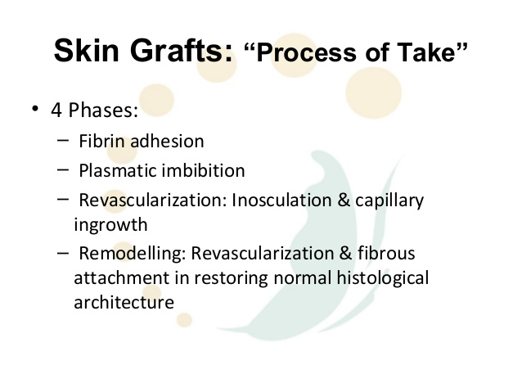

* The following are the different types of grafts that can be done in horses:
* Pinch grafting:

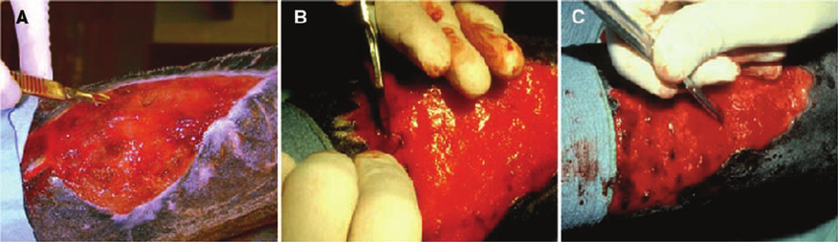

Steps involved in preparing the recipient site for pinch grafting. (A) Creating a pocket in the granulation bed that opens dorsally using a scalpel blade. (B) Sliding a graft into a pocket. (C) Partially completed graft procedure showing evenly spaced pinch grafts placed in pockets.

* Punch grafting:

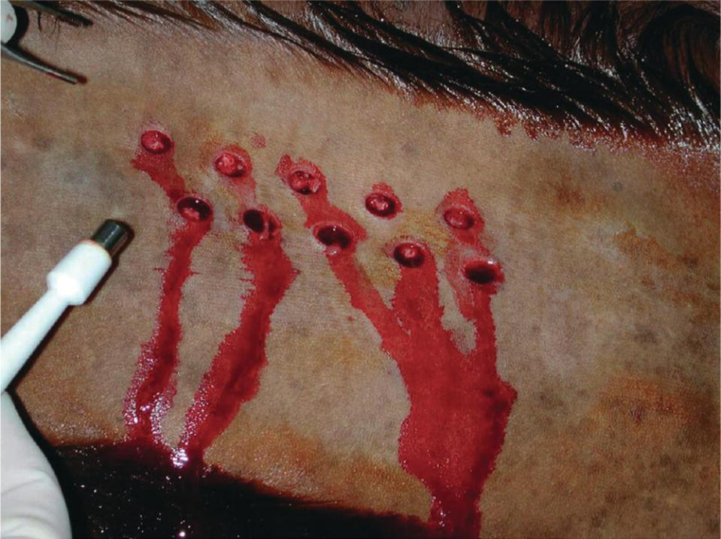

Punch grafts are full‐thickness plugs of skin that are harvested and implanted into granulation tissue using skin biopsy punches. Punch grafts are harvested directly from the horse or from a full‐thickness piece of skin, usually excised from the cranial pectoral region. Punch grafts harvested directly from the horse should be collected at a relatively inconspicuous site, such as the ventrolateral aspect of the abdomen, the perineum, or the portion of the neck that lies beneath the mane, because wounds created at the donor site heal with small scars.

* Tunnel grafting:
* Tunnel grafting requires removing long narrow strips of skin from the donor site. A long forceps is tunneled under the granulation tissue and used to grasp the skin graft. The skin is pulled (taking care to maintain normal orientation) though the granulation tissue, and the ends are sutured to the surrounding skin. The wound is dressed as described above. Approximately 6 to 10 days later, the granulation tissue is surgically removed over the skin grafts. More skin is

placed into the wound than with pinch or punch grafts, but less specialized equipment is necessary when compared to sheet grafting. This technique generally requires general anesthesia.

* Mesh grafting:

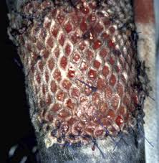

One way to reduce the problems with graft movement is to “mesh” the graft. Graft meshing is beneficial for two main reasons. It allows evacuation of exudate from between the graft and the wound bed, and it allows coverage of a larger area without having to remove as large of graft from the donor site.

The harvested graft can then be placed through a mesher to “mesh” the graft for the reasons previously described. The graft is sutured into place around the periphery of the wound and then dressed.