**Post-operative Management of Annular ligament Desmotomy**

* A sterile dressing is placed over the incision, and a pressure bandage is applied

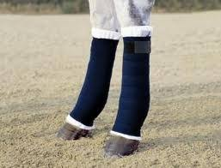

* Antibiotics are not used routinely
* Hand- walking is begun in 3 days and is maintained on an increasing plane to preclude the formation of the adhesions.

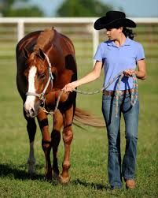

* The sutures are removed at 14 days and bandaging is maintained for 3 weeks
* With uneventful healing the main criterion for returning the horse to work is the time necessary for healing of the tendinitis in the superficial flexor tendon

