**Anatomy of the Annular Ligament**

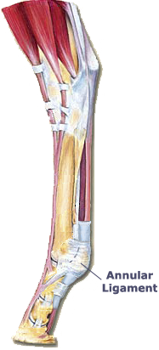

There are three annular ligaments of the fetlock:

* The palmar
* The proximal digital
* The distal digital
* The annular ligaments hold the flexor tendons in place
* They are formed from localized thickened fascia
* The palmar annular ligament attaches the abaxial borders of the sesamoids to the superficial digital flexor tendons
* The proximal digital annular ligament is X-shaped when seen in a palmar view
* The distal digital annular ligament is U-shaped when seen in a palmar view.
* It arises from the proximal phalanx and covers the collateral navicular ligament.
* It also separates the deep digital flexor tendon from the digital cushion

