**Indications for annular ligament desmotomy**

* This surgery is indicated for the treatment of constriction of or by the palmar or plantar annular ligament, tendinitis in the digital sheath or posttraumatic adhesions of the digital sheath.

The problem is associated with injury or infection, and the condition may develop in several ways;

* Direct injury to the annular ligament with subsequent inflammation may cause fibrosis, scarring and a primary constriction of the ligament.
* the constricted ligament, in turn exerts pressure on the superficial and /or deep flexor tendon with subsequent tendinitis (bowed tendon) can have the same result because it is associated with swelling of the SDF tendon against the inelastic annular ligament.
* In some situations, both types of injury may be involved.
* The restriction of free tendon movement and tenosynovitis result in pain and persistent lameness. prolonged permanent damage to the tendon may result.

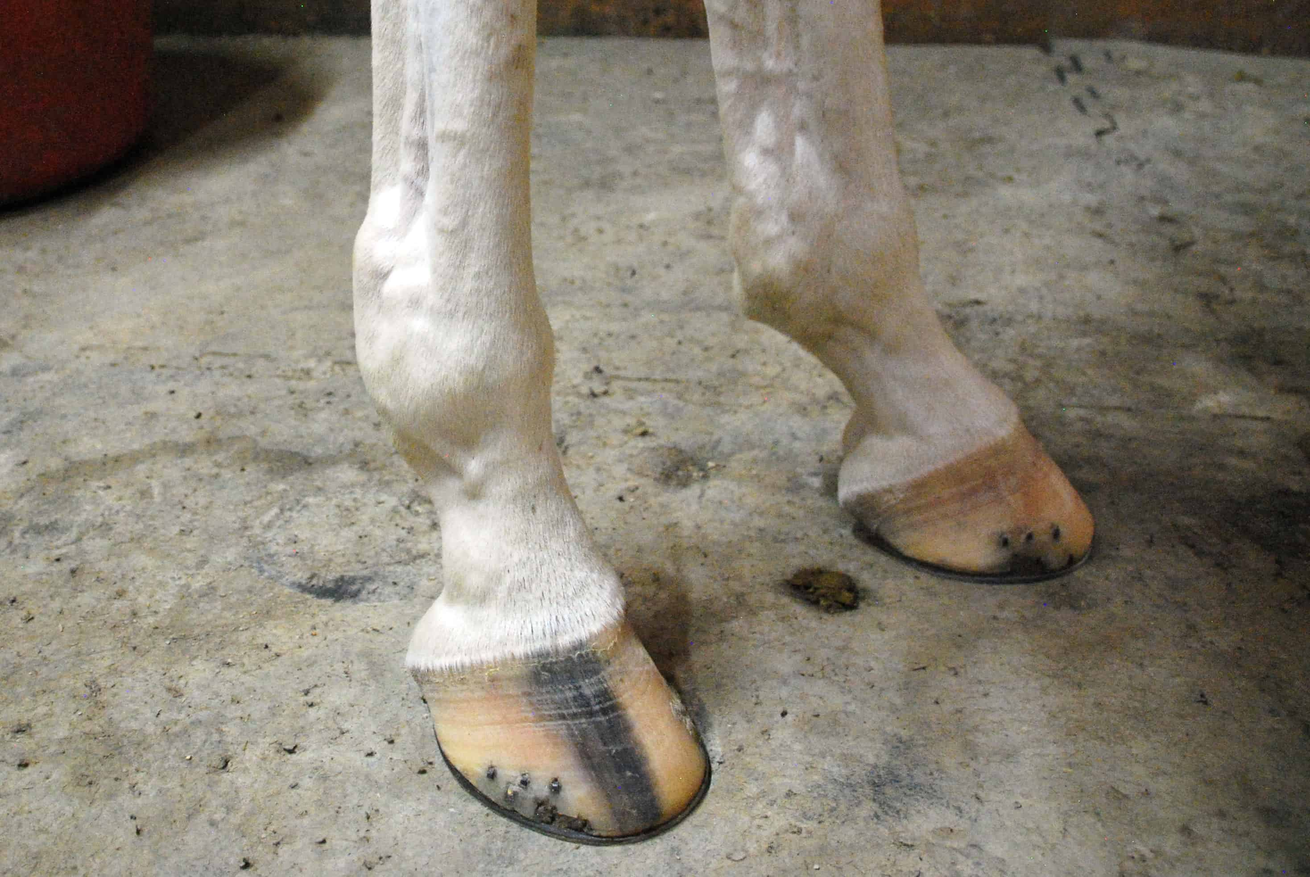

* The syndrome can also arise as a primary chronic digital sheath synovitis of unknown cause, with excess production of synovial fluid and fibrous tissue deposition at the proximal reflection of the synovial sheath onto the flexor tendons
* It has been considered this pathogenesis to be the most common (the cause of the synovitis remains obscure) fluid distention of the digital flexor tendon sheath above and below the constricted annular ligament causes the characteristic “notched” appearance on the palmar or plantar aspect of the fetlock

