**Location of A Wound**

A location of a wound can greatly affect the treatment strategy and the prognosis.

Wounds on the Head and Face:

A horse can injure any spot on their head and face, but certain areas tend to be the most frequent.  Curious exploration of their environment can lead to cuts and punctures on the lips and around the mouth.  Lots of facial wounds are caused by the horse rubbing his head on an object to get a nice scratch.  It is all too common for a horse to find a seemingly harmless object and catch a corner of his eye on the object – which results in half of their eyelid being torn off.

The eyes are probably the most injured structure on the horses’ head.  Second to that would be the bridge of the nose and frontal sinus area.

[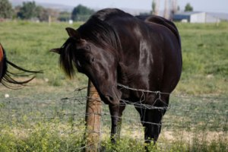](https://horsehealthsimplified.files.wordpress.com/2014/11/horse-scratching-on-post-viim-org.jpg)  
Figure 1: Scratching the face can lead to injuries.

What to do for Head and Eye Injuries:

* These injuries look horrible and will terrify you, but luckily the face and head are places on the horse that heal quickly and usually without much scarring. These injuries, while nasty to look at initially, healed up beautifully (as shown below).

[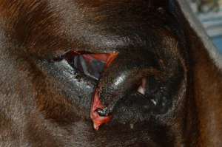](https://horsehealthsimplified.files.wordpress.com/2014/11/eyelid-laceration-1-pre-op-the-horse.jpg)[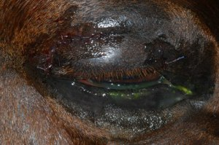](https://horsehealthsimplified.files.wordpress.com/2014/11/eyelid-laceration-1-post-op-the-horse.jpg)

Figure 2: Common eyelid laceration seen in horses and the same wound healed

[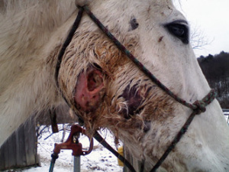](https://horsehealthsimplified.files.wordpress.com/2014/11/zima-facial-injury-dec-24-banixx.jpg)  
Figure 3: Wound infected and needs to be left open to drain.

* Fresh wounds can be cleaned and stitched easily, which decreases the chance of scarring.  Wounds that are swollen and infected can be difficult to sew up completely and the vet may need to leave some portion of the wound open to help it drain.  Lots of wounds leave a flap of skin attached, which would be nice to put back in place and suture, but if left long enough the flap loses blood supply and the tissue dies off.  There is no point in suturing dead skin, so then you must deal with an open wound.  This can mean cleaning and flushing the wound – horses typically don’t appreciate that.
* Get your horse in an area with very good lighting.  It should be protected from the elements if possible.

**Treatment Options**

The treatment will always depend on multiple factors:

1. How long the wound has been present and if infected or not
2. Involvement of other facial structures/organs (eyes, mouth, ears, etc.)
3. Depth of the wound

Most of the time treatment will begin with cleaning the wound and removing dead or infected tissue.  Your vet will then decide if and how they will suture the wound.  Some vets like to use staples instead of stitches.  If the wound can’t be sutured, then your vet will determine how the open wound will be treated and give you instructions on how to do so.  Usually horses are given antibiotics when they have wounds.   As opposed to humans, horses are always in an outside or barn environment.  We can’t control their actions and must assume that they will rub their sutures and roll in mud and get the wound dirty.  Antibiotics help treat any infection already present as well as prevent future infection.

**Prevention**

Severity and frequency of injuries can be lessened by regularly checking the barn, paddocks, and sheds.  Nail heads, wires, and sharp edges make excellent scratching posts and often contribute to eye injuries.  Any wood that is splintered or chewed on can also be places for your horse to injure themselves.  Examining your horse’s environment at least monthly can help catch these problem areas early.  Finally, some injuries (especially puncture wounds) can be small and easy to miss by just glancing at the horses as you throw hay over the fence.  It is important to give horses a decent look-over at least once a day to check for injuries and abnormal behaviour.

Wounds on the Trunk and Chest:

Wounds to the trunk and chest can be very odd.  Trunk and chest wounds can arise from:

* Bad bite wounds (from other horses)
* Kick wounds
* Punctures by fences

Many times, the owners cannot find what caused the wound and spend hours scouring the pastures for evidence.  Other times you have a clear answer when you find a fence post sticking out of a horse’s chest

[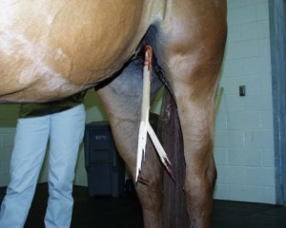](https://horsehealthsimplified.files.wordpress.com/2014/12/penetrating-wound-stick-protruding.jpg)   
Figure 4: Stick penetrating up into the abdomen

What do for Trunk and Chest Injuries:

The vet will examine the wound closely and try and determine what structures might be damaged.  The area will be cleaned, and the debris flushed out.  It may be necessary to take x-rays or ultrasound the affected areas to see if any foreign material is still in the horse or if any bones have been fractured.

 Sometimes contrast material will be injected into the wound to better visualize its tract.  Again, many of these wounds are deep, which means that fluid and inflammatory material can built up in the pocket of the wound.  This build-up can delay healing and promote infection.  To effectively get the fluid out of the wound your vet may place a drain around the wound.  Work the drain back and forth and flush out the drainage sites daily.  The wound would be sutured but leave a couple of gaps for drainage, other times the wound will be left open.  Almost all horses will get antibiotics and anti-inflammatories, and any horse with a wound should be up to date on their tetanus shot.

[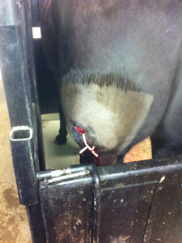](https://horsehealthsimplified.files.wordpress.com/2014/12/img_1753.jpg)

Figure 5: Penetrating wood fence injury with a drain place through the wound.

At Home Treatment and Healing:

Some of these large and deep wounds will take a long time to heal- upwards of a year for full healing to take place.  The time to heal depends of several things:

1) infection

2) inflammation

3) foreign material

4) size of wound.

Sometimes the foreign material goes undetected, especially if it does not show up on x-rays or ultrasound.  This can cause a constant source of infection and inflammation and will prolong the healing until the foreign material is removed.  A common sign of foreign material is when the wound heals up when the horse is on antibiotics, but as soon as they stop taking the meds the wound begins draining again.  Eventually the body will end up attacking the foreign material until it is “pushed” outwards.  There are cases where years later a piece of wood will exit a chronic wound.

[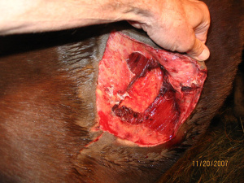](https://horsehealthsimplified.files.wordpress.com/2014/12/evsequinevetservicechestwound.jpg)  
Figure 6: Chest wound may require topical treatments for weeks to months.

If the wound is particularly large an unable to be stitched, you may have to deal with an open wound for quite some time. Lavage the wound, hose it, apply topical treatments, and more for months on end. It is best to attempt to treat the horse in a safe area with his horse buddies near.  If applicable, give the horse some grain or treats while applying medication or lavage the wound.

Wounds on the Limbs:

Wounds to the upper portion of the limb heal differently than those to the lower portion.  Some vets like to divide the limb into two areas – 1) above or proximal to the hock or knee, and 2) below or distal to the hock or knee.

The wounds of the upper limb area often heal better and with less complications than those of the lower limb.  The lower limb tends to rapidly form granulation tissue – which is a kind of scar tissue.  It is pink and spongy and has no nerve endings.  Granulation tissue formation is good when it covers a wound and protects the underlying structures from contamination.  Wounds on the lower limb tend to form excessive granulation tissue – known as “proud flesh”.

Location further has importance on the prognosis of a wound in that very important structures are located on the limb.  If these structures are damaged because of a wound, the prognosis can go from good to grave.  Examples of structures in the limb that you don’t want wounds to affect are joints, tendons, ligaments, and bones.

*Contamination of Wound*

[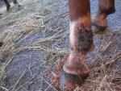](https://horsehealthsimplified.files.wordpress.com/2014/12/lakesidelivery-co-uk-muddy-wound.jpg)

Figure 7: Wound that may be contaminated  
Wounds on the limbs are often contaminated quickly because they are near the ground.

Contamination refers to the presence of foreign material (dirt, hair, etc) or infectious agents (bacteria, fungi, etc) on the surface of the body or wound.  Most of the wounds to the lower limb are contaminated within seconds of the injury due to proximity to the ground and other structures.  This is another reason why lower limb wounds tend to be more problematic than upper limb wounds.  The earlier you find the wound and clean it out – the better.  If you can clean out the dirt and hair quickly, the body will have less time to react to the foreign material, meaning the inflammation will be decreased.  Also, cleaning bacteria and infectious agents out can prevent colonization (infectious agents reproducing).  In terms of prognosis, the more contaminated the wound, the worse the initial prognosis.

*Size and Depth of the Wound*

The size of the wound greatly impacts the length of time to heal but does not necessarily greatly impact the overall prognosis for healing.  For complete healing and scarring epithelial (skin) cells must migrate to cover the wound.  They begin migrating 8-10 hours after the injury and continue at a rate of 0.2 mm (0.007 in) per day for upper wounds and 0.09 mm (0.004 in) per day for lower wounds.  This means that in a perfect situation a 5 cm (~ 2 in) wound will heal in 10 days on an upper limb and in about 16 days for a lower limb wound.  Factors that cause slower epithelial migration are infection, proud flesh, hypothermia, and drying out.  The depth of the wound affects the likelihood of vital structures being injured.  Additionally, deep wounds provide a nice home for bacteria and foreign material in which to hide.

[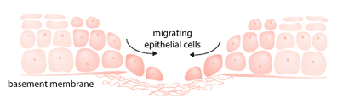](https://horsehealthsimplified.files.wordpress.com/2014/12/woundclosure.gif)  
Figure 8: Skin (epithelial) cells migrate from the outside to the inside of a wound when it is healing.

*Duration of Time from Injury to Treatment*

[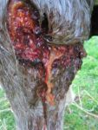](https://horsehealthsimplified.files.wordpress.com/2014/12/pintresthorsewound.jpg)  
Figure 9: Wound is that is several hours old and contaminated.

The longer that bacteria and foreign material hang out in a wound, the more damage they can inflict.  Bacteria can begin multiplying which causes the body to respond with a massive inflammatory response.  The inflammation causes heat, swelling, and pain.  Furthermore, portions of the wound may lose blood supply and die off.  This is commonplace when the wound leaves a flap of skin attached to the limb.  Once the tissue is dead it must be removed, which leaves an open wound to heal.

**What Your Vet Will Do**

[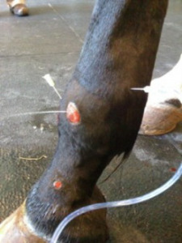](https://horsehealthsimplified.files.wordpress.com/2014/12/willamettevalleyequinejointlavage.jpg)  
Figure 10:Sterile saline is injected into the joint and coming out of the wound, indicating that the wound has compromised the joint.

After examining and cleaning the wound your vet will determine if any vital underlying structures are involved.  This may require x-rays, ultrasound, and/or joint lavage.  X-rays can show injuries to bone and the presence of foreign material.  Ultrasound will help determine the extent of injury to soft tissue, like tendons and ligaments, as well as find any foreign material present.  Joint lavage is performed when the vet does not know if the wound penetrated the joint.  A needle or catheter is inserted into the joint in question from a location that is not wounded.  Sterile saline is then injected into the joint.  If the saline leaks out of the wound, then you know the joint was damaged by the wound.