**Patient Preparation**

**Clipping the Patient:**

* The surgery site is clipped with adequate margins for the procedure to be performed as well as the areas where the IV catheters would be placed. The clipping of the surgical site is usually performed after anaesthesia has been induced however in some cases (such as C-sections or hernia repair), the clipping of the surgery site is performed before anaesthesia to reduce the anaesthesia time as much as possible.

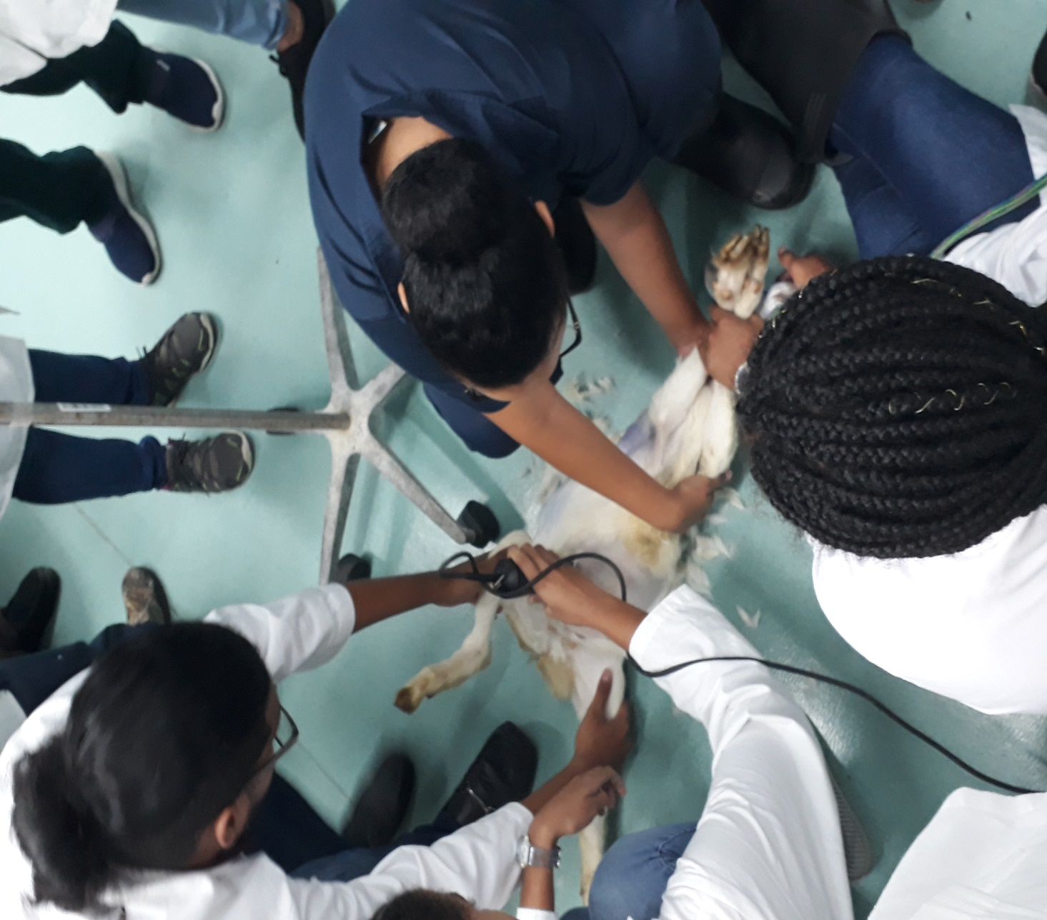

* For abdominal surgeries, the clip should extend a few centimetres cranial to the xiphoid, caudal to the pubis, and lateral to the nipples.
* If the surgery area includes open wounds, a sterile water-soluble lubricant should be applied to them so that hair from the clipping does not contaminate and stick to the inside of the wound. The clean areas should be clipped first, and then the infected areas should be clipped.
* A vacuum cleaner is recommended for suctioning up the loose hair that has collected on and around the pet prior to scrubbing.

**Applying the catheters**

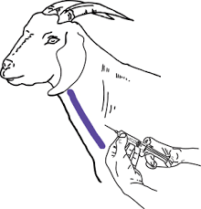 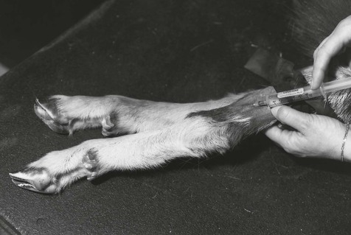

* Aseptic technique must be maintained throughout all IV therapy procedures, including initiation of IV therapy, preparing and maintaining equipment, and discontinuing an IV system.
* Always [perform hand hygiene](http://opentextbc.ca/clinicalskills/chapter/1-6-hand-hygiene/) before handling all IV equipment.
* If an administration set or solution becomes contaminated with a non-sterile surface, it should be replaced with a new one to prevent introducing bacteria or other contaminants into the system
* 20 or 22G 1” is required for the Patient :4mth kid
* To provide safe anaesthesia, when using all injectable or injectables combined with inhalant, an indwelling venous catheter should be placed.
* The catheter provides for the injection of both tissue irritating drugs and adjunct drugs throughout the aesthetic event as well as avoiding having to place a catheter in the event of an emergency occurring.

* The anaesthetist must determine the most convenient place for the catheter based on preference and procedure.
* With restraint and clipping both the forelimb cephalic or hind limb saphenous veins are good choices.
* The jugular vein can also be used in goats
* Because it is large and superficial and easily accessed, the ear vein is good for blood collection and IV injection. Small catheters can also be put in the ear of the small ruminant.
* In our case two catheters were placed in both cephalic veins of the left and right hind limb; one for normal CRI and the other for emergency purposes

**Epidural**

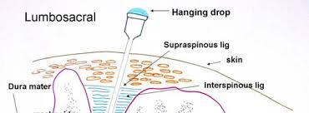

Lumbosacral region was clipped cleaned and a lumbosacral epidural was administered

**Scrubbing the Patient:**

* The initial scrub is done after the clipping in the preparation area to remove gross

contamination. Then the patient is moved into the surgery room for final scrubbing.

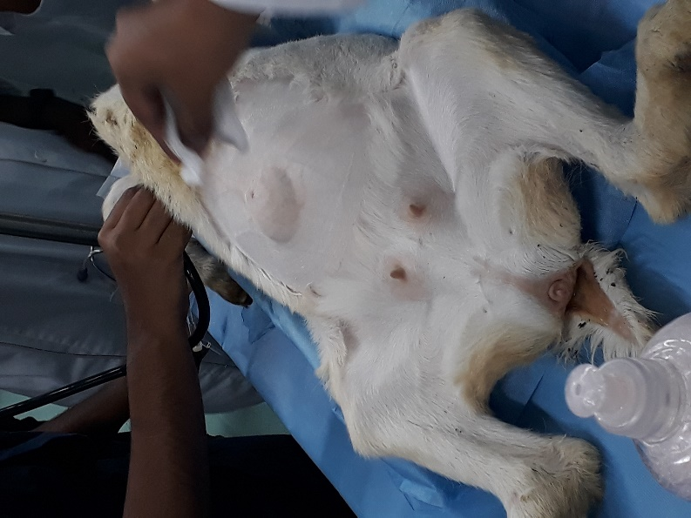 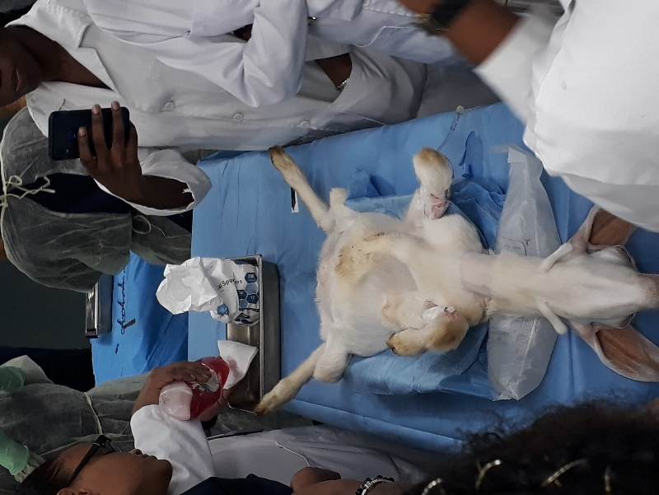

* Sterile gloves are worn during the surgical scrub in the operating room to decrease contamination to the surgery area from the hands.

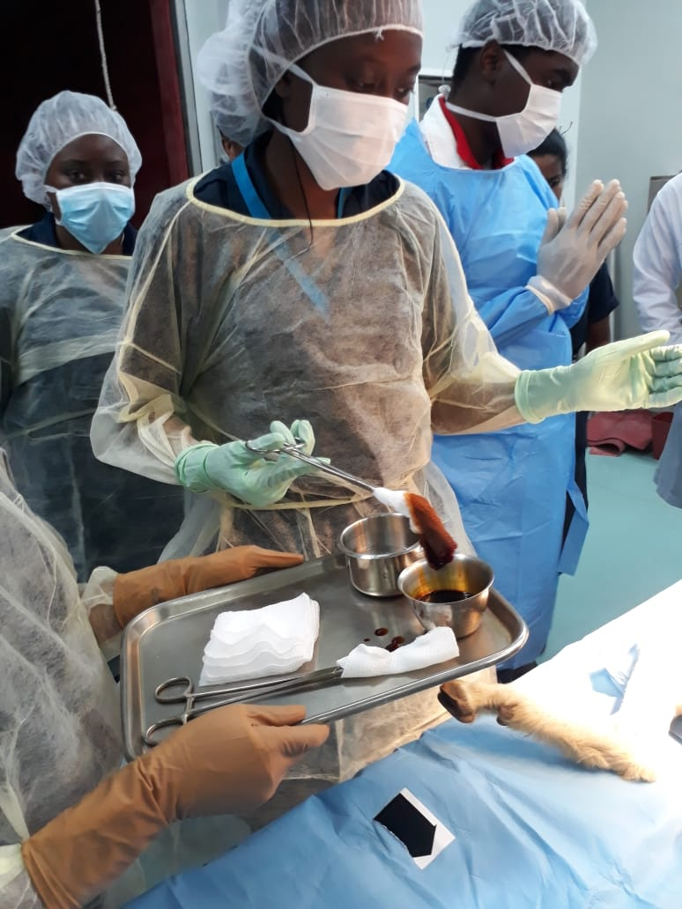

* The most common antiseptic scrubs used for preparation are povidone-iodine (Betadine) or 2% chlorhexidine The scrub is alternated with alcohol or saline. Contact time should be at least 5 minutes at the end of the 3 series of povidone-iodine scrubs.
* A minimum of three antiseptic scrubs should be performed at the proposed surgery sites (a scrub and a rinse three times). It should begin at the surgery site itself and extend or progress in an outward fashion, never returning to the centre or proposed surgery site with the same scrub gauze. Positioning for Surgery
* Abdominal surgeries are usually placed in dorsal recumbency (patient is on its back).