Instruments / equipment

Instruments/ Equipment | Uses
Towel holding clamps  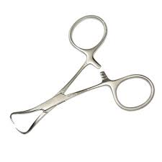 | - These are introduced through the ground drapes (at a corner where two drapes meet) and through the patient's skin to securely hold the surgical drape during a surgical procedure.  - Towel clamps can also be used to secure suction lines, electrocautery cables, and power equipment lines to drapes but this is less desirable because it creates a hole in the drape in an area that may not have been surgically prepared
Needle holders  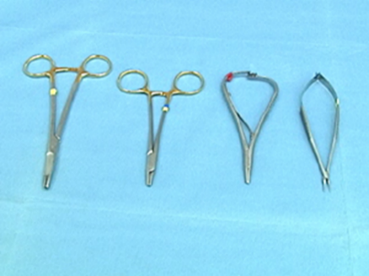 | - This instrument is used to hold and manipulate curved needles during surgical procedures
Sponge holding clamp  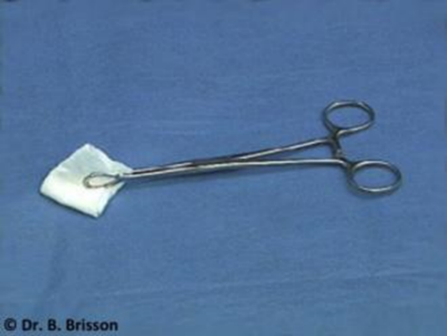 | - Holds sponges, gauzes or sensitive medical supplies as well as antiseptic cotton swabs and gauze before the surgery
Scalpel blade #10  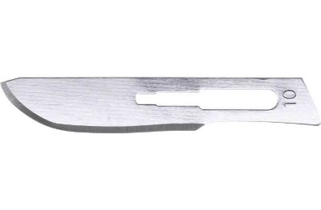 | - Used for large skin incisions and incising soft tissue
Scalpel holder #3  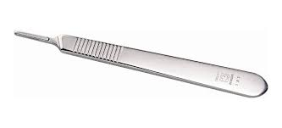 | - For holding the scalpel blades #10,11,12,15 disposable blades and used for dissection
Straight mayo scissors  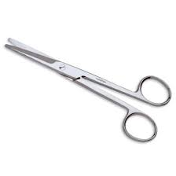 | - For cutting sutures and ligatures or trimming the skin around a wound  - Known as the “suture scissors”
Curved mayo Scissors  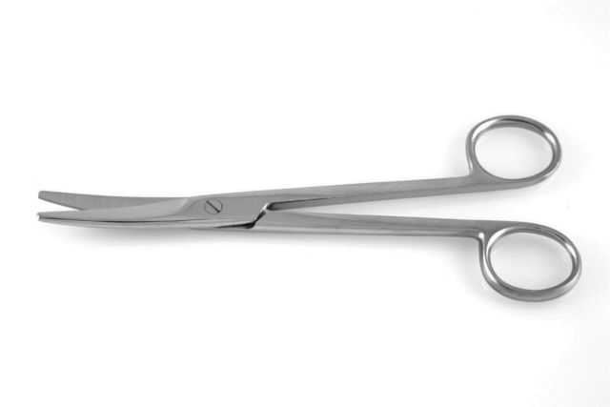 | - Allows deeper penetration into the wound and used to cut thick tissues like fascia, tendons and ligaments
Bandage scissors  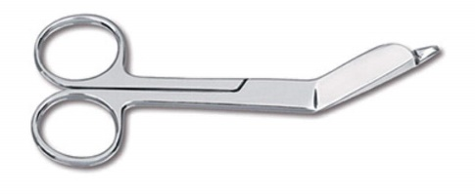 | - Used for sizing dressing and removing circumferential bandages  - Also used to cut plaster, fabric and occasionally umbilical chord
Thumb forceps  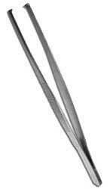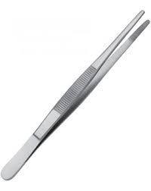 | - Used for the manipulation and grasping of tissues during surgery. They are non-locking, they contain a grasping surface and may or may not have teeth. Forceps without teeth are thought to cause less tissue trauma
Surgical drapes  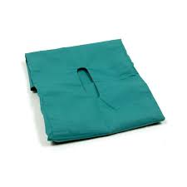 | - Used to maintain a sterile surgical field and reduce the risk of transmission of pathogens to both patient and surgeon
PDS II  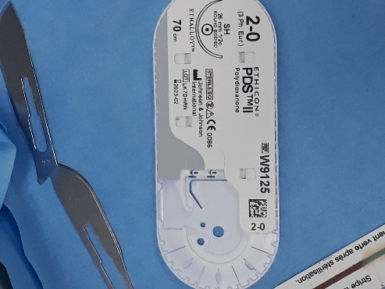 | - Acceptable to use for abdominal or thoracic wall closure
Polypropylene  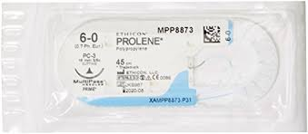 | - In repairing of the posterior inguinal wall in hernia operations  - Closure of skin incisions
Sterile gauze  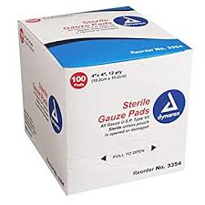 | - Used for absorbing fluids as well as dressing and protecting wounds  - It acts as a barrier to prevent contaminants from entering any wound area that it covers and absorbs any blood or fluid that seeps out of the wound
IV Solution set  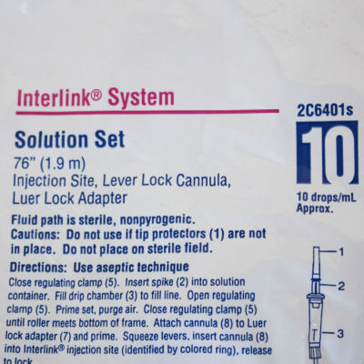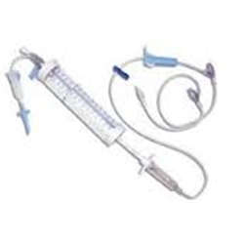 | - Used for intravenous therapy that delivers liquid substances directly into the vein
Lactated ringers’ solution  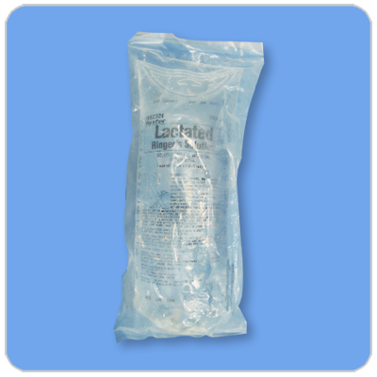 | - IV fluid therapy  - It is the most physiologically adaptable fluid because it’s electrolyte content is mostly closely related to the composition of the body’s blood serum and plasma
Catheter needle (20-22 gauge 1”)  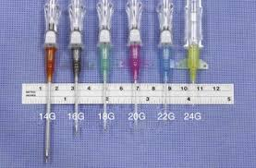 | - Placed into a peripheral vein for intravenous therapy such ad medication and anaesthetic fluids can also be used to draw blood
Endotracheal tube ( Size 4mm)  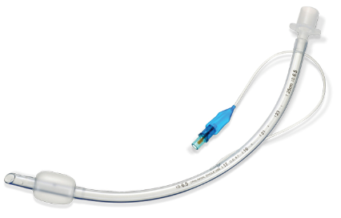 | - Inserted into the trachea for the primary purpose of establishing and maintaining a patent airway and to ensure the adequate exchange of oxygen and carbon dioxide
2% chlorhexidine  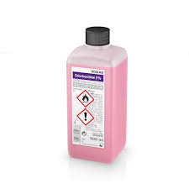 | - Used widely for skin antisepsis in veterinary medicine
Povidone Iodine  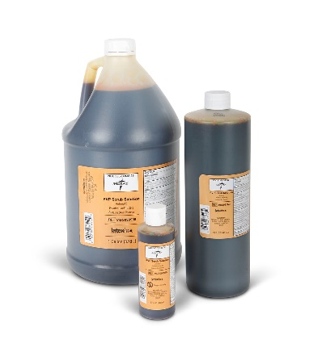 | - Broad spectrum antiseptic for topical application in the treatment and prevention of wound infection
Anaesthesia machine  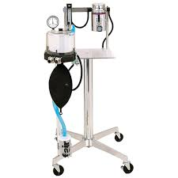 | - (in our scenario) To maintain the patient’s oxygen and accurate tidal volumes to patients with very poor lung compliance and to very small patients

