Drugs

Equations used:

- Loading dose: $\frac{D×W}{C}=V$

- CRI: $\frac{D}{FR}=FB$

- Drip Rate: $\frac{W×FR×60drops/ml}{60mins/hr×60secs/min}=drops /sec$

- Dilution: V₁ x C₁ = V₂ x C₂
Drugs | Characteristics | Contraindications | Dose | Loading dose  Calculation | CRI  Calculation (IR =5ml/kg/hr) | CRI calculation (IR= 10ml/kg/hr)
Ketamine  10%  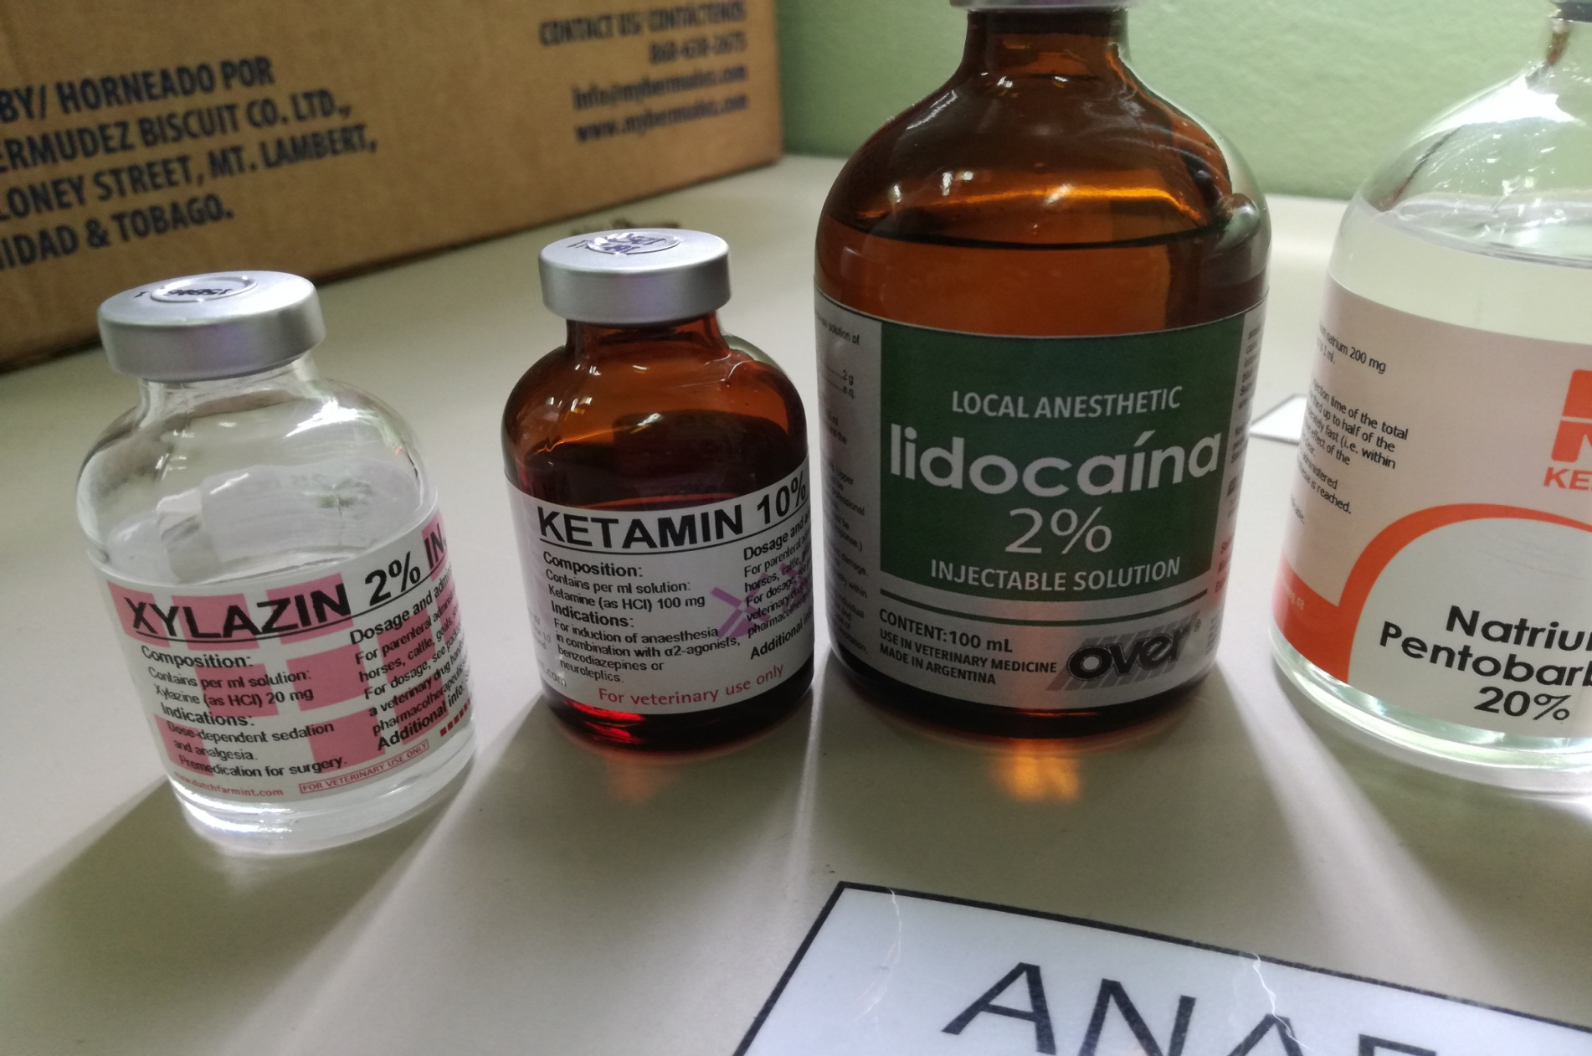 | - Ketamine is an NMDA receptor antagonist with a potent anaesthetic effect | - Ketamine is contraindicated in patients who have exhibited  prior hypersensitivity reactions to it and in animals to be used for human consumption  - Because of its supposed epileptogenic potential, it  should generally not be used (unless very cautiously) in animals with pre-existing seizure | 5mg/kg | $$\frac{5×8.4}{100}$$  = 0.42mls | $$\frac{5}{5}×1000$$  =1000/100  =10 mls | $$\frac{5}{10}×1000$$  =5mls
Xylazine  2%  (Concentration given: 1mg/ml )  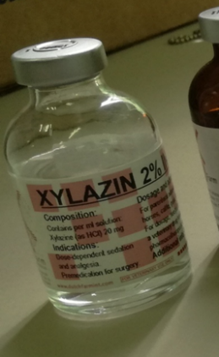 | - A tranquilizing agent,  - good to excellent sedation, excellent analgesia of15 to 30 minutes duration and a smooth recovery | - Animals receiving epinephrine or those with ventricular arrhythmias.  - It should be used with caution in animals with heart disease, hypotension, shock, respiratory dysfunction, severe hepatic or renal disease, a history of seizure activity, or those severely debilitated. | 0.05mg/kg | $$\frac{0.05×8.4}{1}$$  =0.42mls  *Dilution of xylazine to be added into saline (stock solution):  V₁(20) = 10(1)  V₁= 10(1)/20  =0.5ml | $$\frac{0.05}{5}×1000$$  =10/20  =0.5mls | $$\frac{0.05}{10}×1000$$  = 5/20  0.25mls
Lidocaine  2%  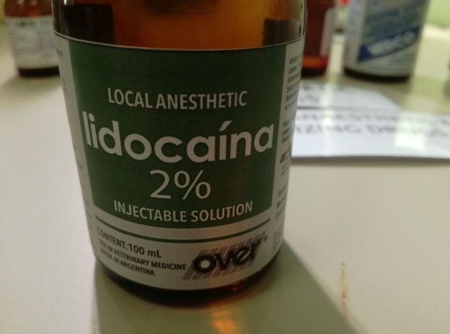 | - A local anaesthetic and cardiac depressant used as an anti-arrhythmia agent.  - Lidocaine mixtures may also be applied directly to the skin or mucous membranes to numb the area | - Lidocaine should be used with caution in patients with liver disease, congestive heart failure,  shock, hypovolemia, severe respiratory depression, or marked hypoxia.  - Common side effects with intravenous use include sleepiness, muscle twitching, confusion, changes in vision, numbness, tingling, and vomiting It can cause low blood pressure and an irregular heart rate | 1mg/kg | $$\frac{1×8.4}{20}$$  =0.42mls | $$\frac{1 }{5}×1000$$  =200/20  =10mls | $$\frac{1}{10}×1000$$  =100/20  =5mls

*To administer: 0.5ml + 9.5ml of saline =10ml
-In the addition of drugs to saline bag and the accuracy of calculations for CRI: remove the volume of saline that would be equal to the volume of drugs being added to ensure 1000ml value remains valid for calculation as well as preventing further dilution of the drugs.

- Lidocaine splash block:$\frac{1×8.4}{20}=0.42mls$

- Paediatric Drip rate:$\frac{8.4×\frac{5ml}{kg}/hr×60drops/ml}{60mins/hr×60sec/min}=0.7 ≈1 drop/2secs$

- Lumbosacral epidural: dose: 1mg/kg, conc:2% $\frac{1×8.4}{20}=0.42mls$

Emergency drugs
Drugs | Characteristics | Dose | Concentration | Calculated dosage
Tolazoline  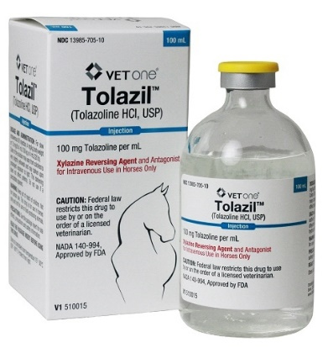 | - A vasodilator that apparently has direct actions on blood vessels and increases cardiac output.  - Tolazoline can interact to some degree with histamine, adrenergic, and cholinergic receptors, but the mechanisms of its therapeutic effects are not clear. | 0.05 | 100 | Mildly depressed (x2)  $$\frac{2\left(0.05\right)×8.4}{100}$$  =0.0084mls*  Severely depressed (x4)  $$\frac{4\left(0.05\right)×8.4}{100}$$  =0.0164 mls*  *pull up in 1ml syringe with saline to 0.5ml and shake
Epinephrine  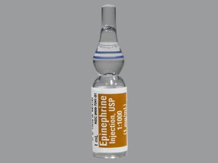 | - Epinephrine injection is used along with emergency medical treatment to treat life-threatening allergic reactions caused by insect bites or stings, foods, medications, latex, and other causes.  - Epinephrine is in a class of medications called alpha- and beta-adrenergic agonists (sympathomimetic agents). It works by relaxing the muscles in the airways and tightening the blood vessels. | 0.02 | 1 | $$\frac{0.02×8.4}{1}$$  =0.168mls
Atropine | - For the treatment of poisoning by susceptible organophosphorus nerve agents having anti-cholinesterase activity (cholinesterase inhibitors) as well as organophosphorus or carbamate insecticides. | 0.04 | 0.54 | $$\frac{0.04×8.4}{0.54}$$  =0.62mls
Tetanus antitoxin  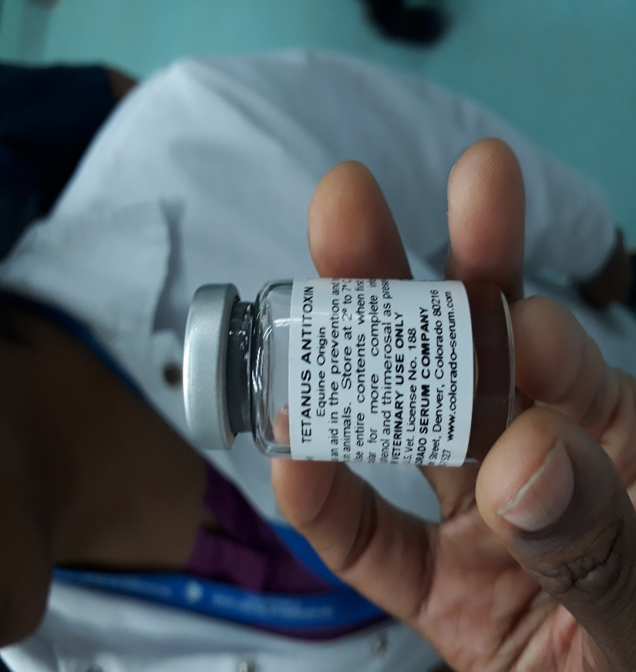 | - Tetanus Antitoxin is prepared from the blood of healthy horses that have been specifically hyperimmunized. It is recommended for use as an aid in the prevention and treatment of tetanus in animals. | 5ml | 1500IU | 1ml was advised

Question: Why Use tetanus anti-toxin?
Tetanus is a neurological disease caused by a toxin which is produced by the bacterium Clostridium tetani. This organism is very common in soil and in the manure of animals. Bacterial spores enter the body through wounds following castration, ear tagging, disbudding, kidding, etc., resulting in signs of the disease 4 to 21 days later. The toxin affects the central nervous system.

