**Anatomy of the umbilicus**

* The umbilicus is **the remnant of the foetal- maternal connection** and contains paired umbilical arteries, a single umbilical vein and the urachus

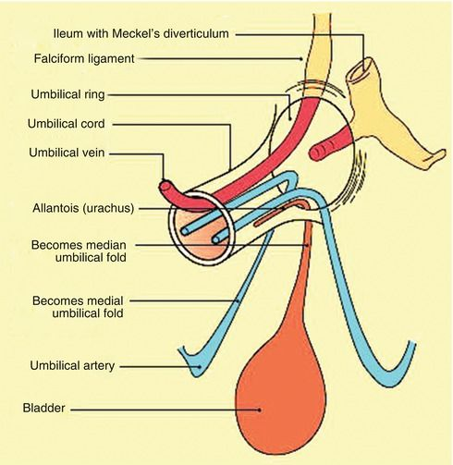

**Prior to birth:**

* The **umbilical veins** bring the nutrient and oxygen-rich blood from the placental villi via the umbilical cord to the embryo.
* The **umbilical arteries** are branches of the internal iliac artery and carries the waste materials and unoxygenated blood to the placenta
* The **urachus** connects the foetal bladder to the allantoic sac

**After Birth:**

* The smooth muscles surrounding the umbilicus contracts in response to the stretching during parturition
* The umbilical artery and urachus retracts into the abdomen and the umbilical and amniotic membrane remnants remain outside the body wall but rapidly collapses with smooth muscle contractions
* By 3-4 days post-delivery, the umbilical stalk dries and thins out and is eliminated
* The umbilical vein then regresses to form the round ligament of the liver
* The umbilical arteries also regress to form the round ligament of the bladder and the urachus undergoes atrophy
* The umbilicus also represents a relatively weak point in the anterior abdominal wall that is prone to herniation or bulging because of increased intra-abdominal pressure.

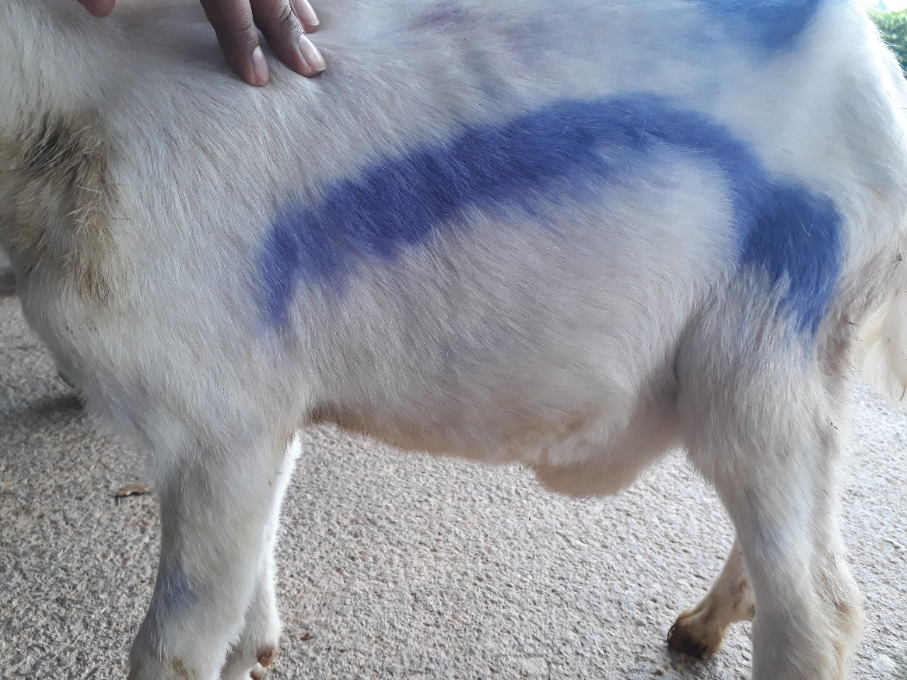

* Moreover, most abnormal conditions observed at the umbilicus are attributed to developmental disorders. Thus, focusing on the development of the umbilicus and its congenital anomalies and correlating these conditions with clinical findings are necessary;