Equipment Used in Closed Castration

* **Burdizzo (Emasculatome)** – Has a special clamping head designed to crush the spermatic cord and blood vessels. This instrument should be checked regulary for rusting and sharpening of the edges so that no cut to the skin is made.

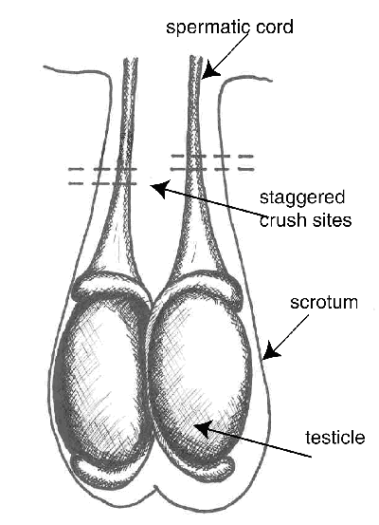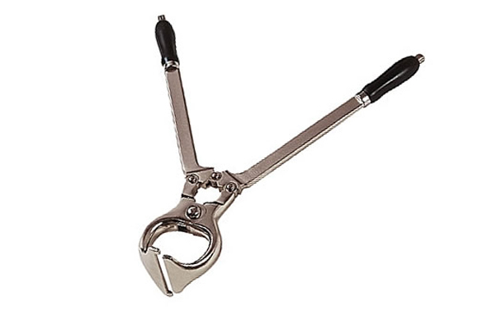

* **Elastic Banding:** Elastrator - Special elastrator pliers are used to place a tight [latex](https://en.wikipedia.org/wiki/Latex) rubber elastrator ring gently around the base of the [scrotum](https://en.wikipedia.org/wiki/Scrotum) with the testicles below it.This cuts the blood supply to the scrotum and testicles, which will totally decay and slough off within a few weeks. Used in animals <10 days old.

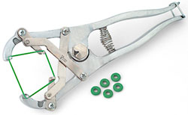

* Callicrate Bander – Placed above the testes for strangulation of vasculature which leads to atrophy and necrosis. Takes approximately 3 weeks and only for use in adult animals.

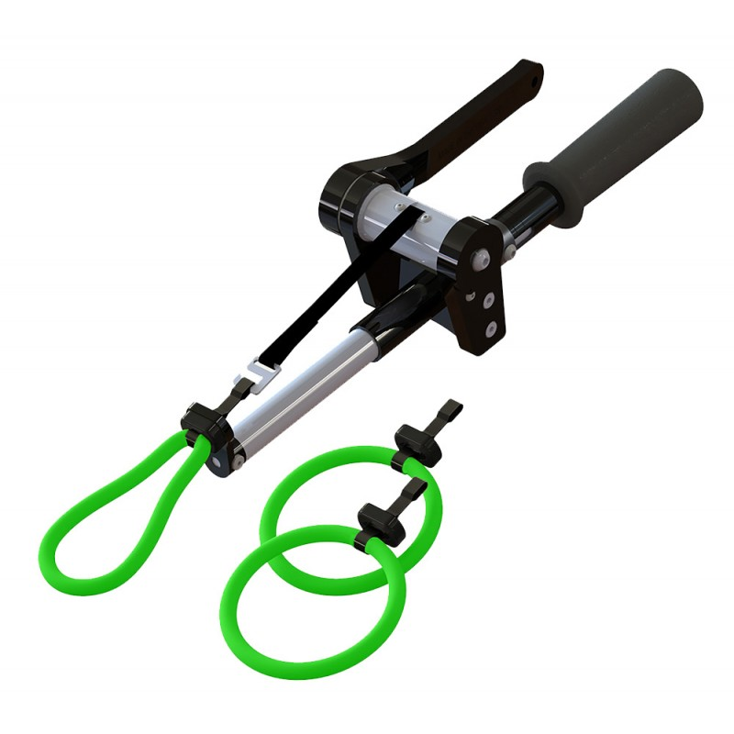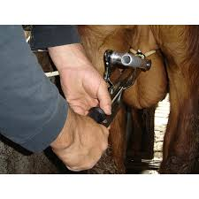

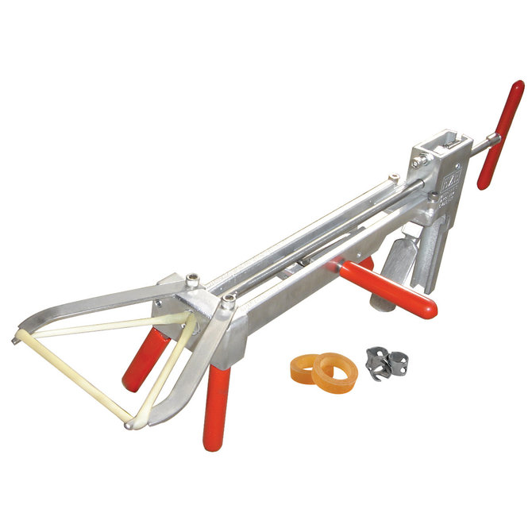

* EZE Bander -
* Short Scrotum Method (Cryptorchid Procedure) – the rubber ring is placed around the scrotum with the testicles above it. This causes the testicles to be pushed up against the body wall and attain body temperature leading to infertility.