**Castration of pot-bellied (pet) pig:**

**Procedure:**

1. Patient is given General anaesthesia, Injectable, or Inhalation

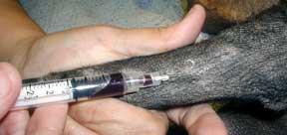

1. Surgical approach same as canine yet different as Pigs need to be monitored carefully for overheating during anaesthesia, which is the opposite of most anesthetized animals. They produce more body heat relative to other animals because of their large muscle mass. Pigs do not sweat or pant, they need to be in contact with something cool to rid of excess body heat. Because of this one must constantly monitor their temperature during and after the surgery.

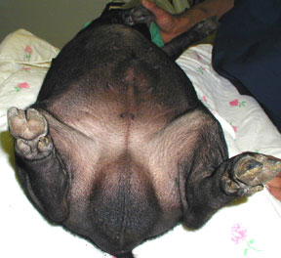

1. Push testicles cranially & make a single midline incision
2. A skin incision just in front of the scrotum. Using either a scalpel or a laser to make the incision – benefits of laser: no bleeding from the skin incision compare to scalpel

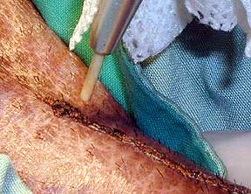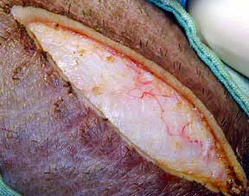

1. The testicle bulges out of the incision cover by its internal layers called tunics

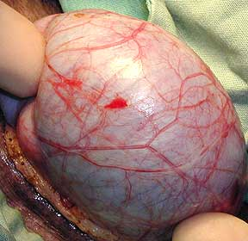

1. Testicle is carefully exteriorized giving access to the base where the blood vessels reside

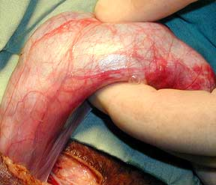

1. A Ligate suture is used to tie off the blood supply before removal of the testicle

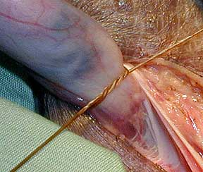

1. As the blood supply is extensive, more than one strong suture is used. These sutures will dissolve over the next several months.

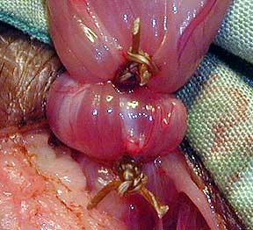

1. Remove tunics with testicles (closed castration), ligate cords & tunics
2. A Subcuticular closure is done

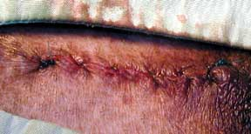

**The Aftermath**

After the Procedure:

* Administer pain medication
* Spray with an antiseptic/wound spray to prevent infection
* Watch for a couple days to way for any unusual bleeding, swelling, etc

