**Open castration:**

**Procedure:**

1. Grab the piglet by the back legs
2. Hold the piglet in an upside-down position

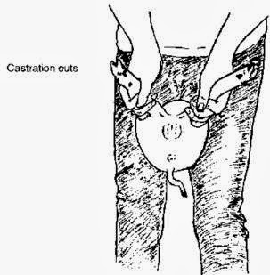

1. Push the testicles into the scrotum with your thumb and keep them there
2. Determine if both testicles are in the scrotum
3. Look at the scrotum to see if 2 pecan-sized structures are seen
4. Feel the structures and decide if they are the same size and firmness
5. Make sure that both testicles are freely moveable within the scrotum
6. Make an incision (cut) into the scrotum over each testicle (see picture)
7. Apply pressure behind each testicle with your fingers or instrument and push each testicle out of the hole made with the blade
8. Grasp each testicle with your hand or instrument and pull it
9. Each testicle should be removed with its attached cord and tunics and discarded for prevention of scirrhous cord or abscess formation
10. The incisions are left open to heal and sprayed with iodine or with suitable disinfectant

