**Body Condition Scoring (5 point)**

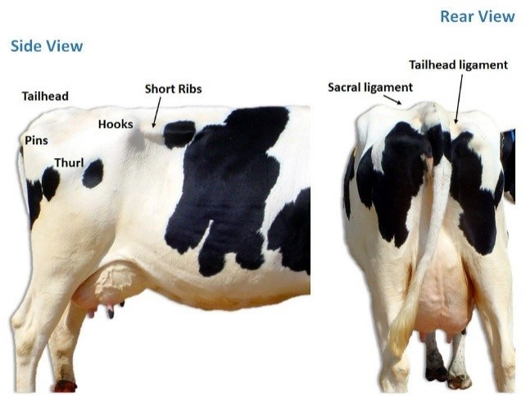

Table 1: Body condition scores and indicators

|  |  |  |
| --- | --- | --- |
| **Score** | **Indicator** |  |
| <2 | The line from the hooks to the thurl and pins creates a ‘V’ shape Hooks are relatively angular Corrugations on the short ribs are visible ¾ of the way between the tip of the short ribs and the spine assign Sawtooth spine and ribs are severely under-conditioned |  |
| 2.25 | The line from the hooks to the thurl and pins creates a ‘V’ shape Hooks are relatively angular Corrugations on the short ribs are visible ½ way between the tip of the short ribs and the spine assign |  |
| 2.5 | The line from the hooks to the thurl and pins creates a ‘V’ shape Hooks are relatively angular Pins are angular with a palpable fat pad |  |
| 2.75 | The line from the hooks to the thurl and pins creates a ‘V’ shape Hooks are relatively angular Pins are padded |  |
| 3 | The line from the hooks to the thurl and pins creates a ‘V’ shape Hooks are rounded |  |
| 3.25 | The line from the hooks to the thurl and pins creates a ‘U’ shape Hooks are rounded Sacral and tailhead ligaments are visible and easily seen |  |
| 3.5 | The line from the hooks to the thurl and pins creates a ‘U’ shape Sacral ligament is visible Tailhead ligament barely visible – partly covered in fat |  |
| 3.75 | The line from the hooks to the thurl and pins creates a ‘U’ shape Sacral ligament barely visible Tailhead ligament not visible |  |
| 4 | The line from the hooks to the thurl and pins creates a ‘U’ shape Sacral ligament not visible Tailhead ligament not visible Thurl is flat |  |
| 4.25 | The line from the hooks to the thurl and pins creates a ‘U’ shape Sacral ligament not visible Tailhead ligament not visible When looking at thurl, tip of short ribs is barely visible |  |
| 4.5 | The line from the hooks to the thurl and pins creates a ‘U’ shape Sacral ligament not visible Tailhead ligament not visible Pins are buried in fat |  |
| 4.75 | The line from the hooks to the thurl and pins creates a ‘U’ shape Sacral ligament not visible Tailhead ligament not visible Hooks are barely visible |  |

Reference

1. <http://wynnstaydairy.uk/body-condition-scoring/>