**Elastic banding**

**Technique:**

1. First put the band on the elastrator instrument and press the handles several times to stretch the band

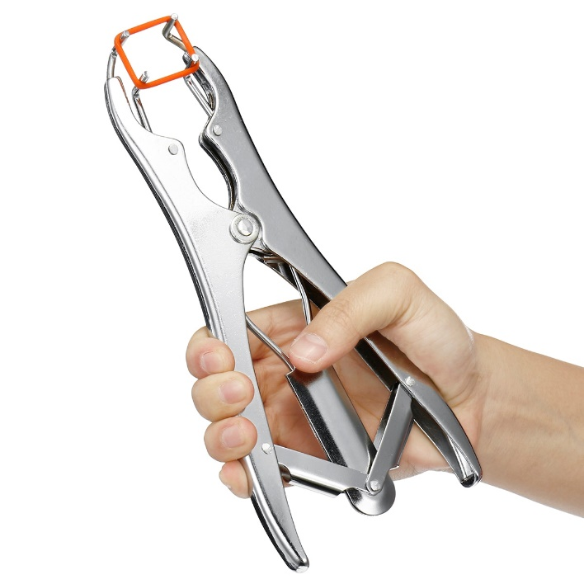

1. Hold the handles with the prongs pointed up. Close the handles to open the elastrator band.
2. Pass the band up and over the scrotum.

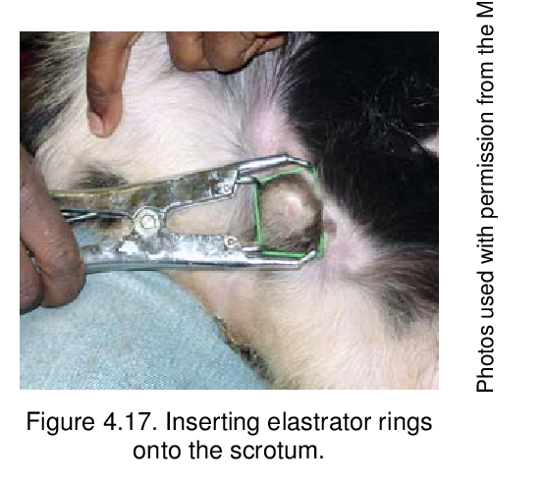

1. Pull the scrotum down and make sure both testicles are completely below the band.

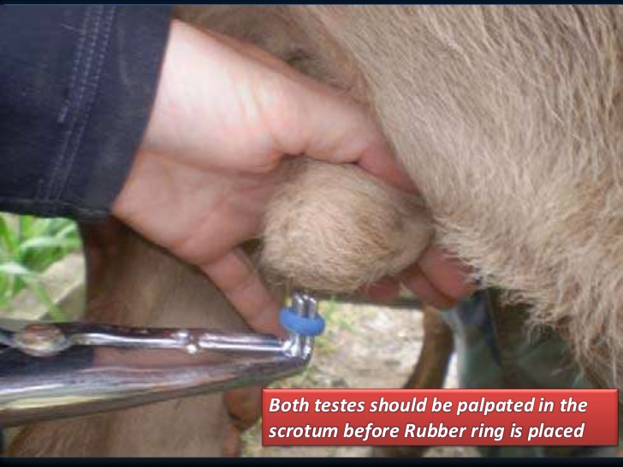

1. Open the handles, allowing the band to close on the neck of the scrotum.
2. Pull the instrument off the band. Always recheck to make sure both testicles are completely below the band.

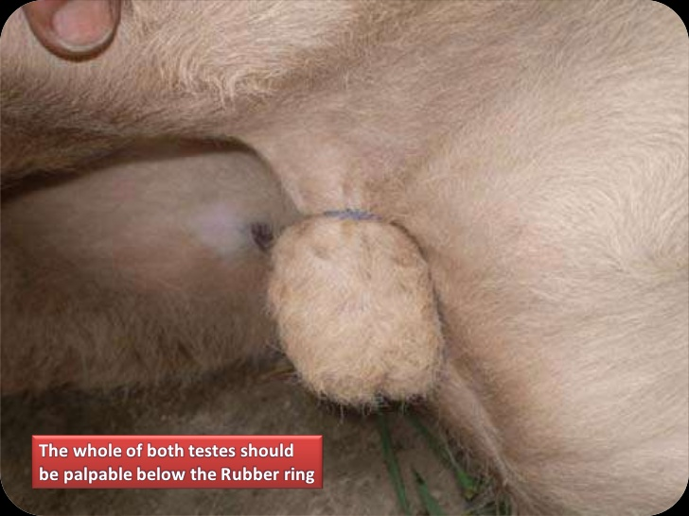

1. If a mistake has been made, use a sharp knife to cut off the band and repeat the procedure.
2. After banding, calves will often show discomfort by rolling on the ground or kicking at their belly for up to 30 minutes.

1. The calf’s scrotum should dry up and fall off in two to four weeks.