**Emasculator**

Technique:

**\*Put local anaesthetic into the spermatic cord so they feel no pain.**

1. Remove bottom 1/3 to ½ of the scrotum or make a vertical incision on the side of the scrotum next to the leg (to the end of the scrotum) using a sharp knife or scalpel. The bottom of the scrotum is pulled down and back with one hand (using surgical clamps or pliers is safer), while the other hand cuts off the bottom of the scrotum from side to side. Be careful not to cut the testicles, your other hand or the big vein inside the calf’s leg.

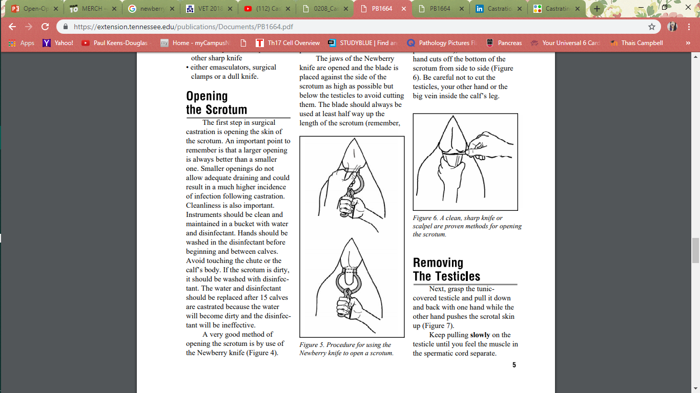 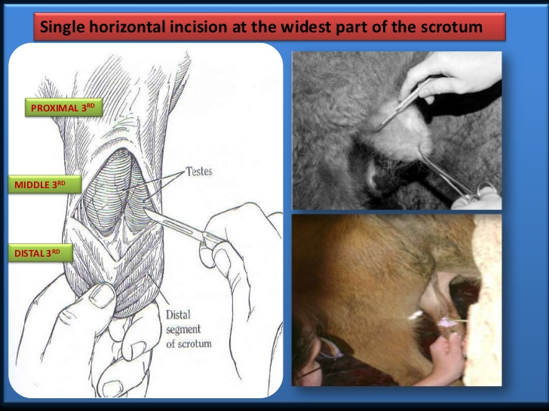

1. Strip fascia from skin (testicles still in common vaginal tunic)
2. Expose the testis by grasping the tunic covered testicle and pull it down and back with one hand while the other hand pushes the scrotal skin up. Keep pulling slowly on the testicle until you feel the muscle in the spermatic cord separate.

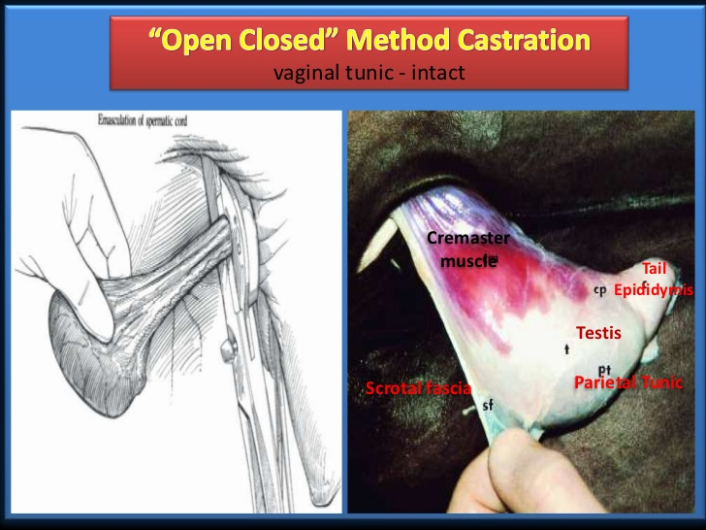

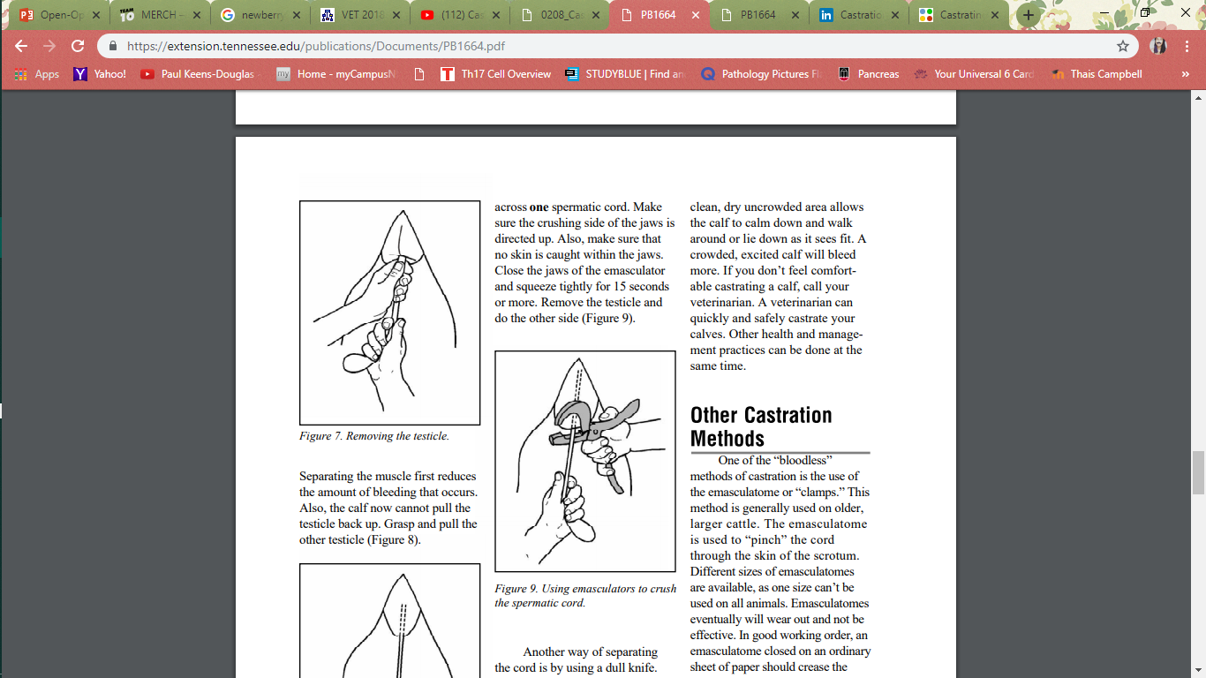

Separating the muscle first reduces the amount of bleeding that occurs. Also, the calf now cannot pull the testicle back up. Grasp and pull the other testicle

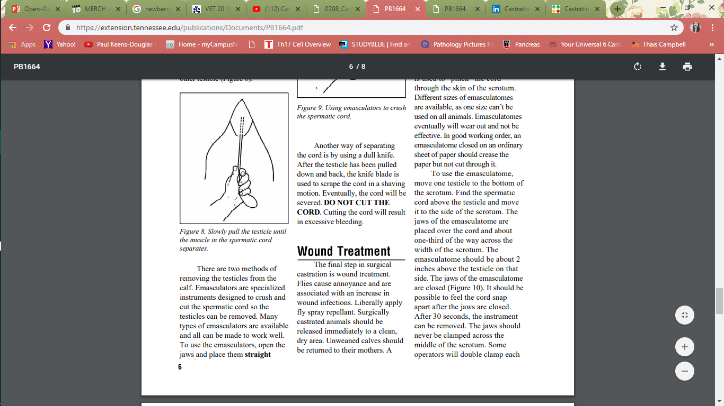

1. Open the Emasculator jaws and place them straight across one spermatic cord. Make sure the crushing side of the jaws is directed up ***“nut to nut”***. Also, make sure that no skin is caught within the jaws. Close the jaws of the emasculator and squeeze tightly for 15 seconds or more. Remove the testicle and do the other side

