**Newberry Castrating knife**

**Technique:**

**\*Ensure to Administer local anaesthetic into the spermatic cord so the patient feels no pain.**

1. One hand is used to pull the scrotum down and back

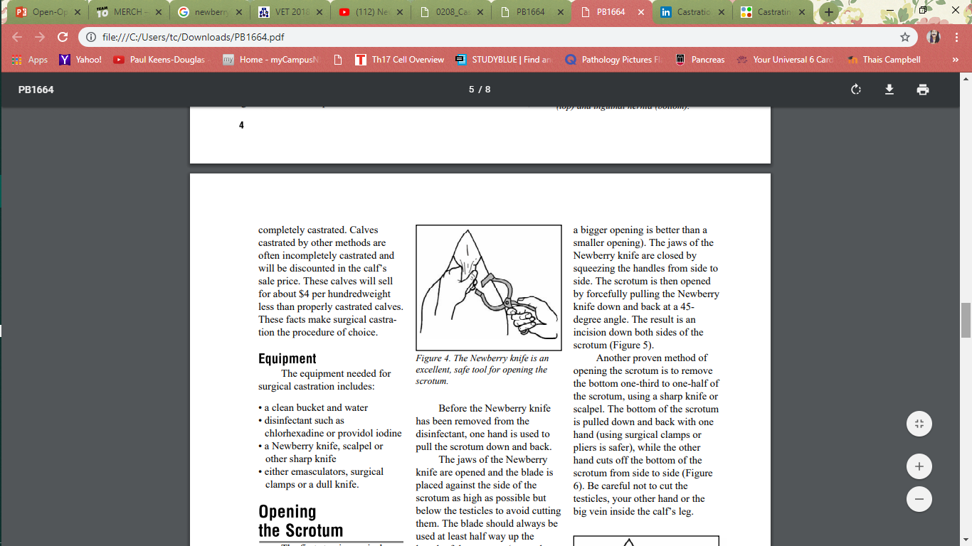

1. The jaws of the Newberry knife are opened, and the blade is placed against the side of the scrotum as high as possible but below the testicles to avoid cutting them.
2. The blade should always be used at least half way up the length of the scrotum (remember a bigger opening is better than a smaller opening).

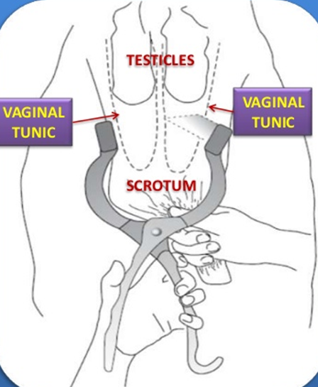

1. The jaws of the Newberry knife are closed by squeezing the handles from side to side.

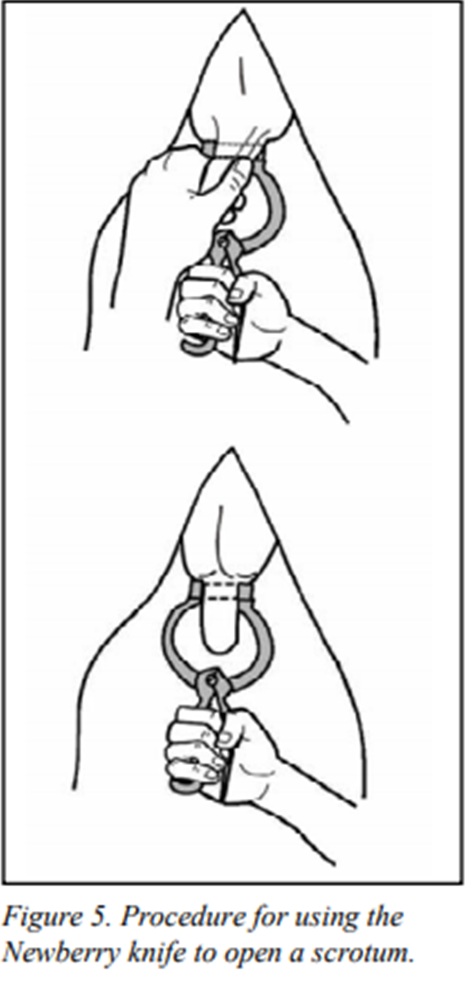

1. The scrotum is then opened by forcefully pulling the Newberry knife down and back at a 45- degree angle. The result is an incision down both sides of the scrotum