**Emasculatome (Burdizzo)**

**Procedure:**

1. Move one testicle to the bottom of the scrotum. Find the spermatic cord above the testicle and move the spermatic cord laterally so one doesn’t cut off scrotum blood supply by mistake. You do not want to clamp epididymis or too close to body wall (urethra).

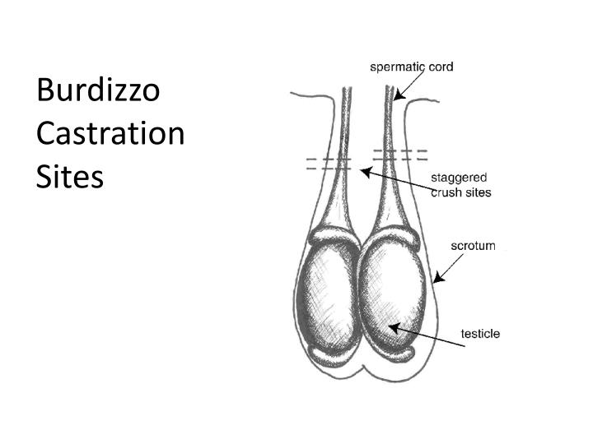

1. The jaws of the emasculatome are placed over the cord and about one-third of the way across the width of the scrotum.
2. Ask an assistant to make sure the cord is still in the correct place. Make sure not to clamp skin. Make sure to get blood supply to testes not to the scrotum.

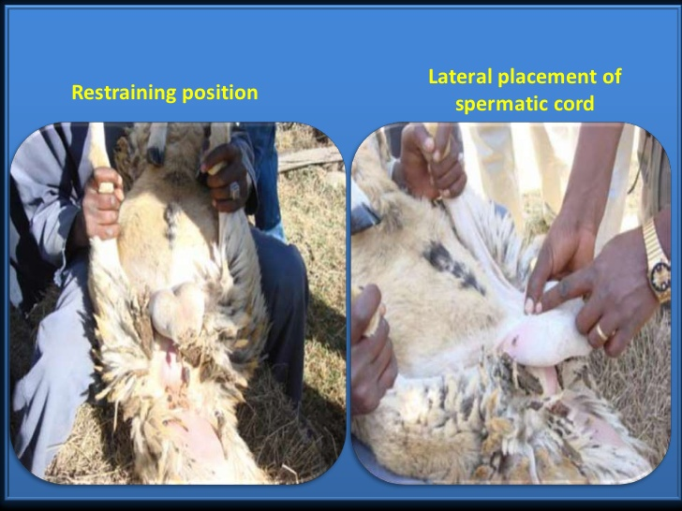

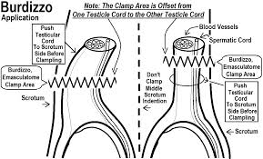

1. Stagger the clamps as a safeguard not to damage blood supply. Pull one side and try to go as transverse as possible along the cord.
2. The emasculatome should be about 2 inches above the testicle on that side. The jaws of the emasculatome are closed It should be possible to feel the cord snap apart after the jaws are closed.

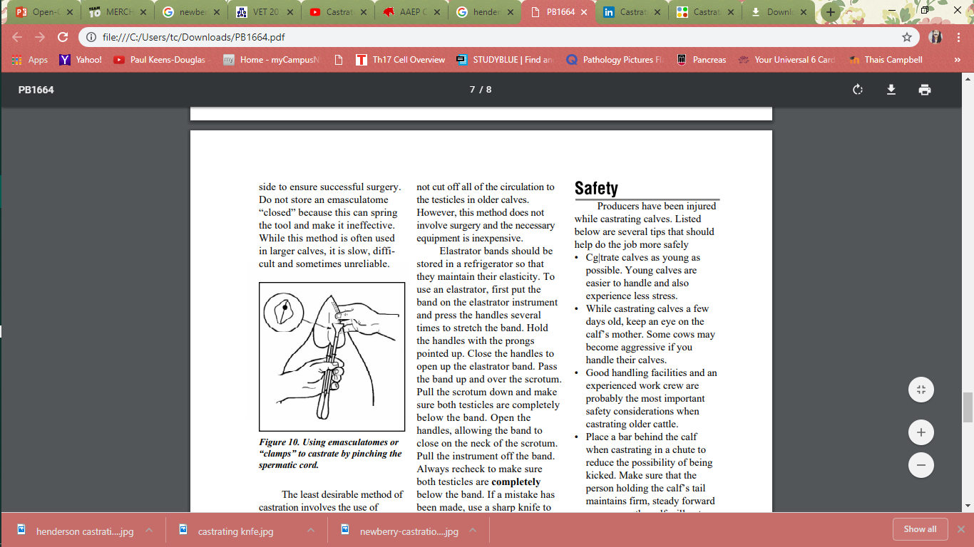

1. After 30 seconds, the instrument can be removed
2. Repeat steps on the other testicle but starting at a different level (either above or below the first crush site)
3. After you finish - If you pass your hand you will feel an indentation in the cord not skin. Palpate again to make sure cord did not slip to make the final crunch. If it did slip, then try to find the same groove and do it again. Larger animals have more tendencies to slip medially.

*thrombus formation in the spermatic vessels arrest blood supply gradual atrophy of the testicles

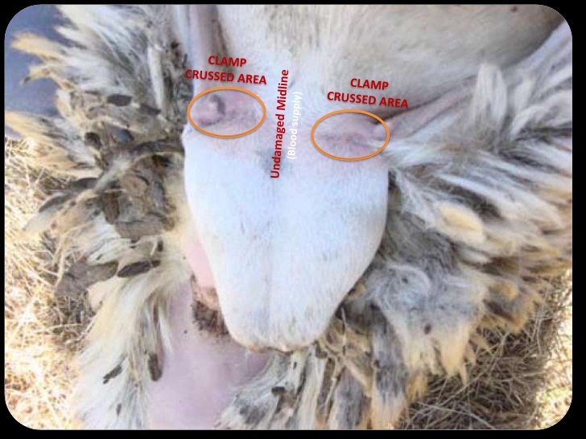

After you finish - If you pass your hand you will feel an indentation in the cord not skin. Palpate again to make sure cord did not slip to make the final crunch. If it did slip, then try to find the same groove and do it again. Larger animals have more tendencies to slip medially.

*Smaller the animal = higher success rate.

\***Do not crush across entire neck of scrotum as scrotal sac needs to receive blood otherwise it will become gangrenous and necrotizes resulting in complications**