**Open method (open scrotum)– surgical technique – emasculator (did in Lab)**

**Open Uncovered or Open Open (vaginal tunic) method**

**NOTE:**

|  |
| --- |
| * Be clean - Wash hands before doing surgery.   • Control haemorrhage  • Keep flies away from incisions.  • Restrain the animal properly during the procedure. Especially older calves |

*Ensure to Administer local anaesthetic into the spermatic cord so the patient feels no pain.

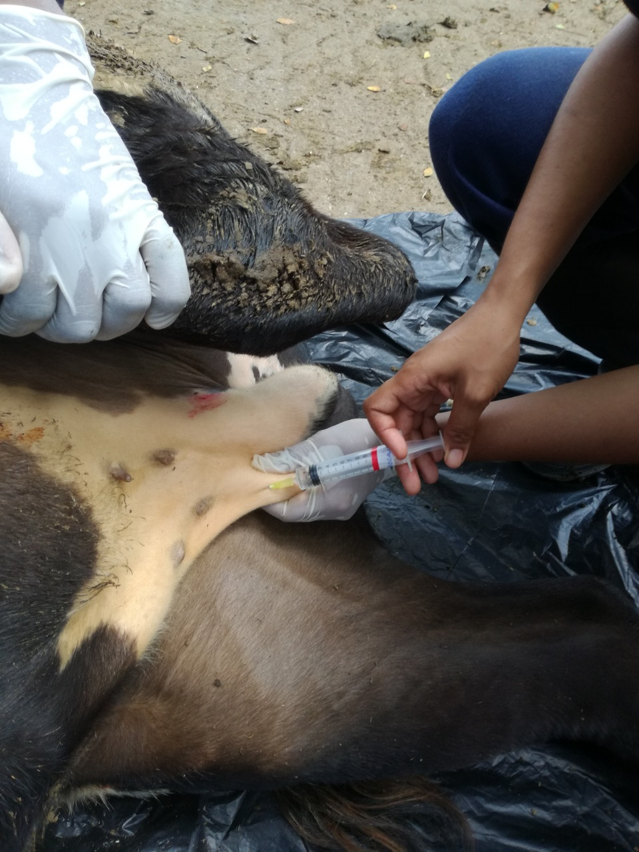

1. Remove bottom 1/3 to ½ of the scrotum or make a vertical incision on the side of the scrotum next to the leg (to the end of the scrotum) using a scalpel.The bottom of the scrotum is pulled down and back with one hand (using surgical clamps or pliers is safer), while the other hand cuts off the bottom of the scrotum from side to side (Figure 6). Be careful not to cut the testicles, your other hand or the big vein inside the calf’s leg.

Horizontal incision Vertical incision

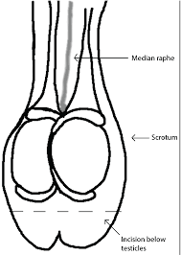 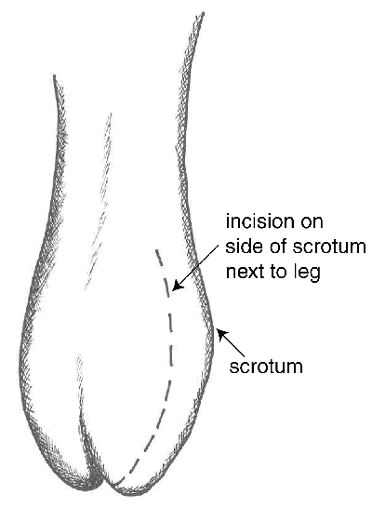

1. Strip the fascia from the skin (the testicles would still be in the common vaginal tunic)
2. Expose the testis by grasping the tunic covered testicle and pull it down and back with one hand while the other hand pushes the scrotal skin up. Keep pulling slowly on the testicle until you feel the muscle in the spermatic cord separate.

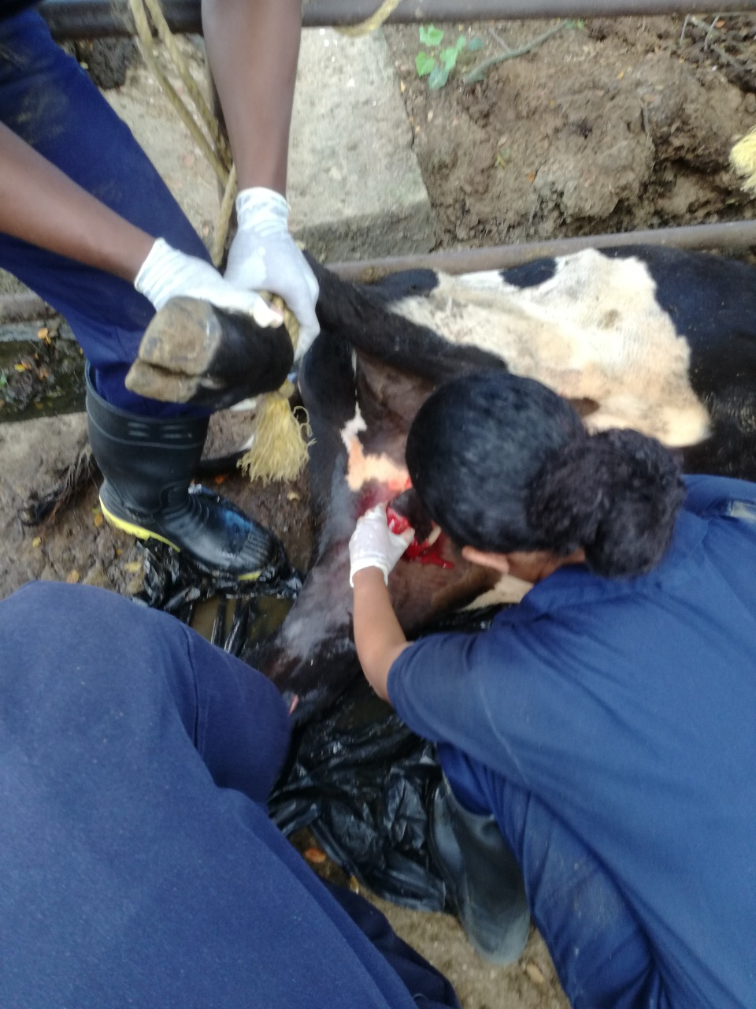

1. Isolate one testicle and vertically incise the vaginal tunic. Once incised, the testicle will easily extrude from the vaginal tunic but remains attached at the level of the epididymis
2. Using fingers gently separate the ligament of the tail of the epididymis from the testicle ensuring that in the region of separation there’s no blood vessels present
3. The tunic is reflected towards the patient, and the testicular, arteries, venous pampiniform plexus and ductus deferens (spermatic chord) are visible
4. Pull down the testicle ensuring that the entire spermatic chord is visible and using a haemostat clamp the spermatic chord in the region that is closer to the patient (about the upper 1/3 of the spermatic chord)
5. Using the emasculator, emasculate below the haemostat with the knot of the tool facing the testicle (nut to nut) and squeeze, holding it there for a minute. Using the emasculator, the opposite way will cause haemorrhage as the blood vessels will be left wide open rather than crushed

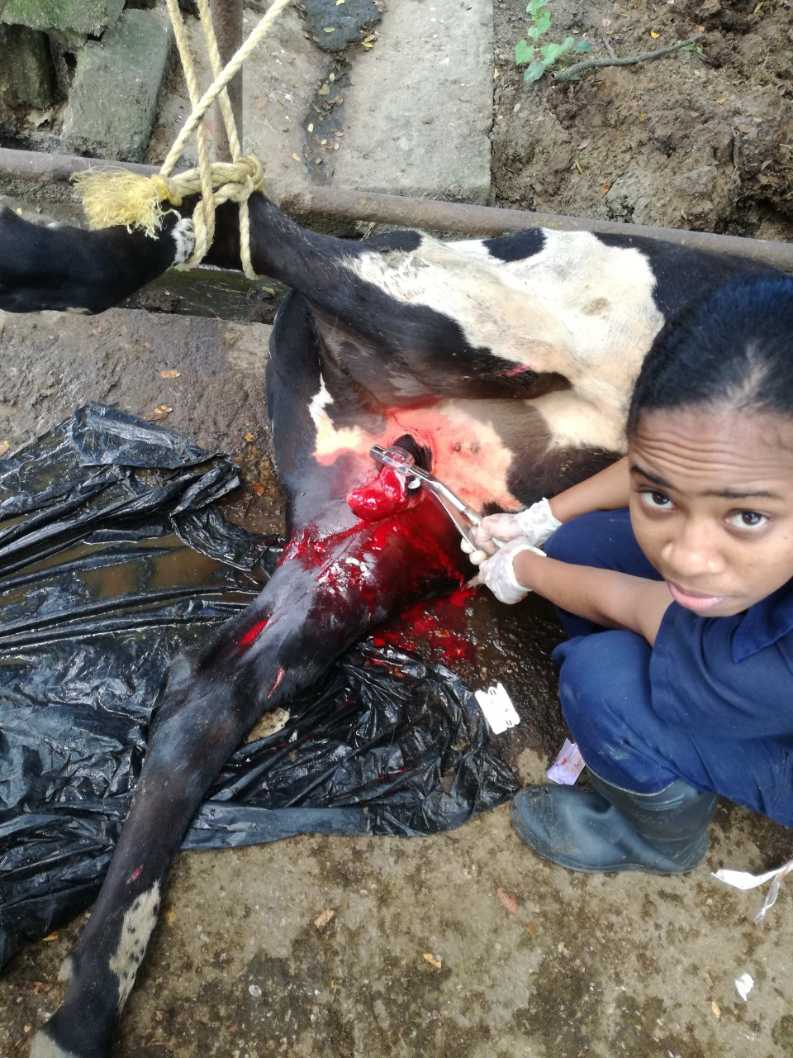

1. Ligate above the haemostat using the Strangle knot and Aberdeen knot to occlude the blood vessels
2. Remove haemostat and observe for bleeding
3. Repeat steps 4- 10 on the next testicle.