**Anatomy of the Scrotum**

The scrotum/scrotal sac is the pouch that contain the testicles and the epididymides, parts of the male reproductive system. It is located just under the anus in cats and the pig. In other domestic species, the scrotum is pendulous and hangs a short distance from the anus. The sac itself is composed of several layers that covers the gonads and protect it from adverse temperatures, trauma and infection.

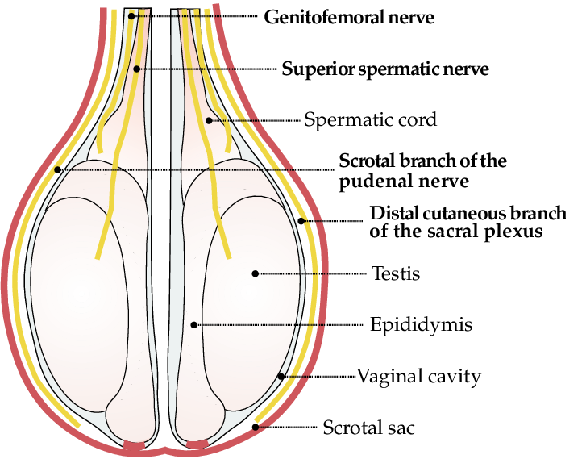

**Skin** – the integument that forms the scrotum

**Dartos** – the layer of fibromuscular tissue that lies just under the skin and also in the scrotal septum. It contracts in lower temperatures to maintain the proper functioning of the testicles and protects the viability of the sperm being produced.

**Spermatic fascia** – is mainly composed of the fascia that continues from the inner and outer abdominal fascia around the testicle and spermatic cord

**Vaginal tunic** – an envagination of the peritoneum through the inguinal canal, it is split into two layers. These are the visceral layer which covers the spermatic cord and the testicles and the parietal layer, which lines the inside of the scrotum.

**Scrotal septum** – the division between the two compartments of the scrotum that holds each of the testicles.

**Median raphe** – holds several essential blood vessels that supplies the scrotal sac and its associated layers

**Epididymis** – a structure that is closely attached to the testicle and is broken up into the head, body and tail. It serves very important functions pertaining to the sperm produced in the testicle, namely:

* Transport of the developing sperm cells to the vas deferens to the testicle.
* Concentration of the sperm by absorption of excess fluids
* Maturation of the developing spermatozoa
* Storage of viable sperm cell in the epididymis tail

**Deferent duct (vas deferens)** – this structure emerges from the tail of epididymis as a straight tubule that directs upward as part of the spermatic cord and through the inguinal canal and into the body cavity. Smooth muscle in this tubule channel mature sperm through the pelvic region to the rest of the reproductive tract, achieving ejaculation.