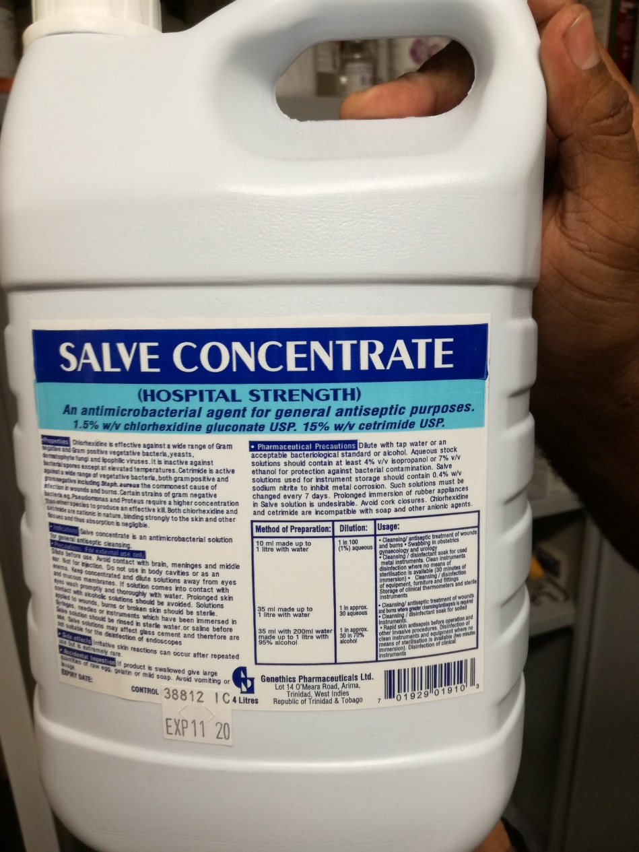**Sanitization of Instruments**

**Chlorhexidine**

Chlorhexidine gluconate is the ideal choice of antiseptic/disinfectant for use in the sanitization of the instruments to be used in this procedure, along with many others. It is of paramount importance that asepsis is established and maintained as best as possible in order to prevent or, at least, minimize the risk of infection of the patient with microorganisms that can cause post-op pathologies. This is still to be considered despite the fact that castration typically doesn’t occur in a surgical theatre setting, but in the calf pens which are typically not the best environment to conduct an open-wound surgery. Therefore, even the instruments to be used must be adequately sanitized.

Chlorhexidine has a wide spectrum of activity, both bactericidal and bacteriostatic, affecting Gram-positive and Gram-negative microorganisms.

It must be noted that it doesn’t full effect on certain species off *Proteus* and *Pseudomonas*. Furthermore, it has virtually no effect on mycobacteria and bacterial spores.

In order to formulate our solution for the instruments to be used, we implemented the dilution equation, which is as follows:

$V_{1}C_{1}=V_{2}C_{2}$

Where **V1** = Volume of original solution

**C1** = concentration of original solution

**V2** = volume of diluted solution

**C2** = concentration of diluted solution

The recommended ratio for the solution was 10mL chlorhexidine gluconate to 1L of water. Therefore, we used 40mL of chlorhexidine gluconate which was added to 4L of water in an 8mL bucket. This would make for a 0.05% chlorhexidine wash.

It is best to leave the instruments immersed in the solution for at least 30 minutes.