TABLE SHOWING TOPICAL DRUGS USED
DRUGS | DETAILS
Tetravet  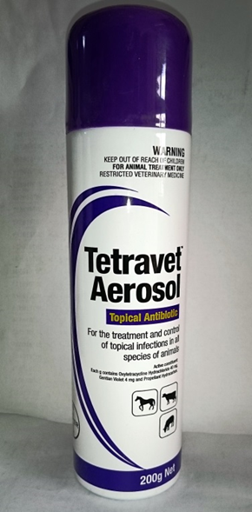  Agropharm screw worm aerosol  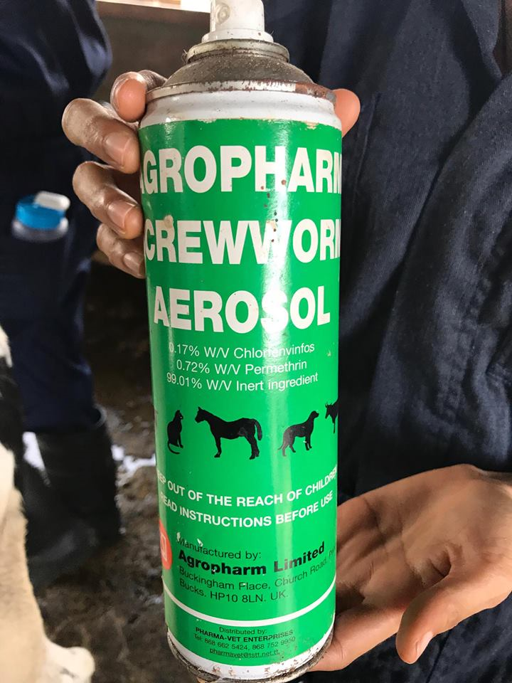 | - Active constituent- Oxytetracycline hydrochloride  - Indications- topical antibiotic for all species of animals  - Dosage- once or twice daily and repeat for 3–5 days, or as required  - Withholding time- None  - Active constituent- Permethrin (primarily)  - Indications- topical anti-myiasis sprays for food animals  - For more information- https://www.drugs.com/vet/screw-worm-aerosol.html

