**Wound Care and Management**

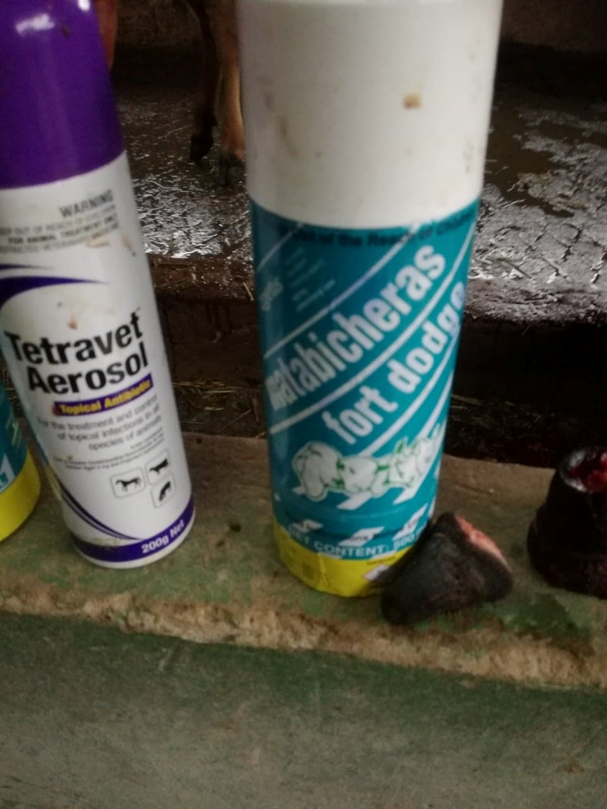The area must also be kept clean and dry.

Tetravet is sprayed unto the open wound at the site of the castration because it is used as an antibiotic. It has two important active ingredients; gentian violet and oxytetracycline hydrochloride.

Gentian violent is used as a topical antiseptic, antibacterial and antifungal. Oxytetracycline hydrochloride is a broad-spectrum antibiotic that diffuses through the cell and binds to the 30s ribosomal subunit preventing peptide elongation and ultimately inhibiting protein synthesis.

Fort Dodge Aerosol is classed as an ectoparasitic agent used in the prevention of myiasis. Myiasis is the invasion of the larval stages of flies in open wounds which feed on living tissue.

These should be applied daily for seven weeks. By spraying Tetravet first followed by the Fort Dodge aerosol. Tetravet must be sprayed within the wound and the Fort Dodge sprayed around the wound. For the best protection against infection.