Auriculo-Palpebral and Cornual Nerve Block in Large Ruminants

The horn and the skin around the base of the horn are innervated by the corneal branch of the lacrimal or zygomatoaticotemporal nerve, which is part of the ophthalmic division of the trigeminal nerve. The cornual nerve passes through the periorbital tissues dorsally and runs along the frontal crest to the base of the horns. Approximately 5 to 10 mL of a local anesthetic agent is deposited subcutaneously and relatively superficially midway between the lateral canthus of the eye and the base of the horn along the zygomatic process. Complete anesthesia may take 10 minutes. Larger cattle with well-developed horns require additional anesthetic infiltration along thecaudal aspect of the horn, in the form of a partial ring block, to desensitize subcutaneous branches of the second cervical nerve.

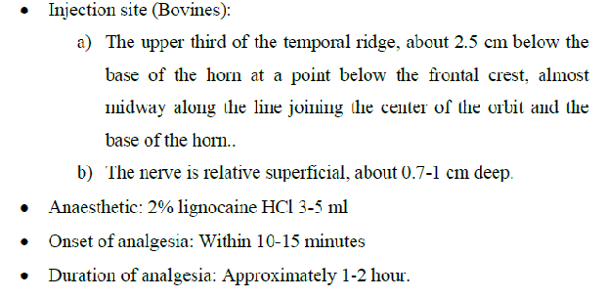

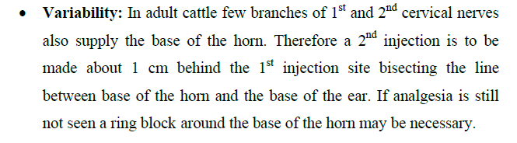



**Needle placement for desensitizing the cornual branch of the zygomaticotemporal nerve**

**in cattle.**

**Auriculo-Palpebral Nerve Block**

Anesthesia of the eyelid is accomplished by performing a line block of the eyelid or by blocking the auriculopalpebral branch of the facial nerve. The auriculopalpebral nerve block is performed by using an 18- or 20-gauge 2.5-cm needle placed subcutaneously approximately 5 to 7.5 cm lateral to the zygomatic arch. A total of 5 to 10 mL of local anesthetic is then injected. Because the auriculopalpebral nerve block only blocks the lower eyelid, if the surgical procedure to be performed also requires desensitization of the upper eyelid, a line block may be performed

