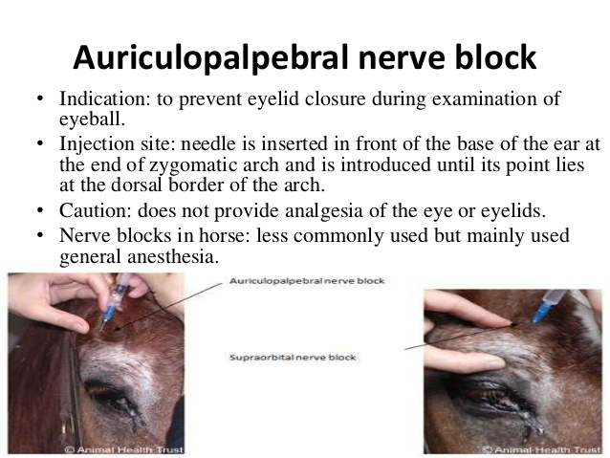Auriculo-Palpebral and Cornual Nerve Block in Horses

* Routine skin preparation.
* 25gauge ⅝ inch needle and 5ml local anaesthetic.
* An auriculopalpebral nerve block can be performed at the dorsal edge of the most dorsal point of the zygomatic arch by injecting about 5 ml of local anaesthetic subcutaneously.
* This block produces no loss of sensation but makes the examination of the eye much easier.
* If placed correctly, a dose of 1–2 mL of lidocaine is usually sufficient to block either the auriculopalpebral or supraorbital nerve. The block is usually effective within 3–5 min and can last up to 2–3 hr.

