Auriculo-Palpebral and Cornual Nerve Block in Small Ruminants

The nerve supply to the horn region in the goat and sheep is from the cornual branches of the lachrymal (zygomaticotemporal) and infratrochlear nerves. Both of these must be blocked prior to dehorning.

There are two sites to block the corneal branches of the lacrimal and infratrochlear nerves:

**1.** Behind the root of the supra orbital process to block the lacrimal branch

**2.** Close to the dorsomedial margin of the orbit to block the infratrochlear branch

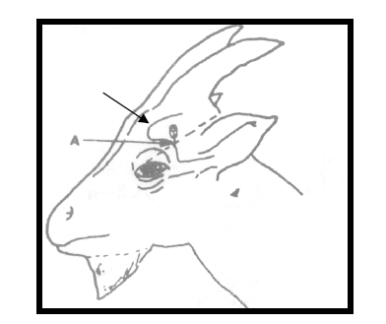

**For the corneal branch of the lachrymal (zygomaticotemporal) nerve:**

The cornual branch of the lachrymal nerve is blocked as it crosses the lateral ridge of the frontal bone (the frontal crest) lateral to the eye (only this nerve needs to be blocked for sheep).

A 23-gauge needle and 2 to 3 ml of 2% lidocaine are used in adults. For kids 0.5 to 1ml of 0.5% lidocaine is generally sufficient.

**For the corneal branch of the infratrochlear nerve three options have been suggested for blocking this nerve:**

**a)** Block at the dorsomedial margin of the orbit; the nerve may be palpable in larger animals. Insert the 22 G needle as close as possible to the orbit margin, to 0.5 cm deep, inject 2.0 ml 2% procaine. Block the infratrochlear nerve as it emerges dorsomedial to the orbit, where it may be palpable under the skin. Insert the needle as close as possible to the margin of the orbit, dorsomedial to the eye. Insert to a depth of about 0.5cm 0.5-1.0 cm. Inject 2-3 ml of 2% lidocaine (in adults). Palpate the nerve as it emerges across the dorsomedial edge of the bony orbit. Introduce a short, 25 gauge needle to about 0.5- 1.0 cm. Inject 1.0 ml of 1% lidocaine or mepivacaine.

**b)** Half way between the medial canthus of the eye and the medial base of the horn using a 2.5 cm 22G needle, inserted dorsal and parallel to the dorsomedian margin of the orbit, 1-1.5 cm deep, inject 2-3ml of 2% lidocaine. 1 ml of 2% lidocaine should be sufficient at each site.

**c)** The cornual branch of the infratrochlear nerve is blocked using a short subcutaneous line block across the forehead immediately above the supraorbital foramen. A 23-gauge needle and 2-3 ml of 2% lidocaine are used in adults. For kids 0.5-1ml of 0.5% lidocaine is generally sufficient.

