EQUIPMENT USED FOR DISBUDDING AND DEHORNING SMALL AND LARGE RUMINANTS

Name | Picture | Used for
Disbudding iron | 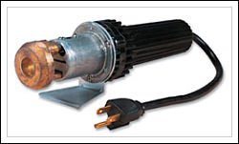 | Disbudding: Destroys horn-producing cells in the horn buds and surrounding skin which are free-floating and not yet attached to the frontal bone of the skull.
Tube, Cup or Spoon Dehorner | 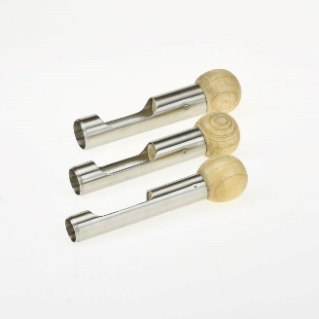 | Disbudding: The circular blade is pushed into the skin around the horn bud, then rotated and tilted to gouge out the horn bud.
Gigli Wire/ Obstetrical or Embryotomy Wire | 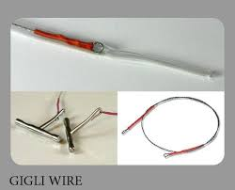 | Dehorning: A long piece of wire is attached to two handles, then moved back and forth rapidly to saw through the horn base plus a ½-inch circle of skin.
Barnes or “Gouger” Dehorner | 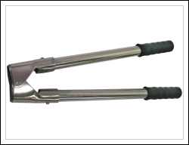 | Disbudding/Dehorning: hinged, closed set of sharp scoops. Opening the handles with the tool at the base of the horn and surrounding skin forces the cutting edges together slicing through the skin and under the horn.
Knife Dehorning | 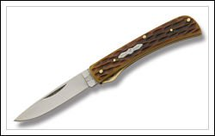 | Disbudding/Dehorning: A knife is used to cut away skin around and under the horn bud, surgically removing the horn from the base tissue. Cauterization is need after to control haemorrhage.
Caustic paste | 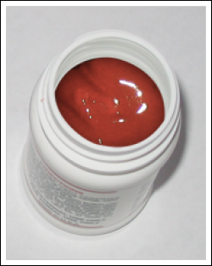 | Disbudding: Caustic substances in dehorning paste cauterizes tissue and prevents horn growth by killing the horn-producing cells which are free-floating and not yet attached to the frontal bone of the skull.
Keystone or “Guillotine” Dehorner | 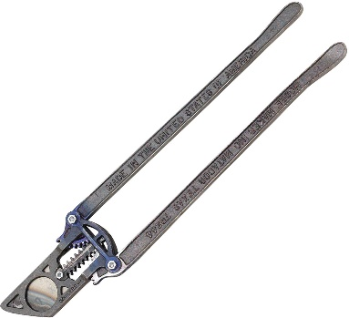 | Dehorning: Uses the two handles that move a blade downward against a plate or another blade, slicing through the base of the horn and surrounding skin.
Hand Saw Dehorner | 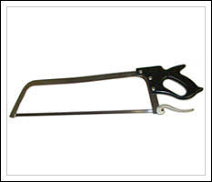 | Dehorning: a hand saw is used to remove the horn along with a ½-inch ring of skin around the horn base.

References
- Inc. H. Dehorning Methods [Internet]. Dehorning.com. 2018 [cited 30 September 2018]. Available from: http://www.dehorning.com/dehorning-methods

