Mechanical Technique for disbudding a calf/kid using a disbudder
- Clip the surrounding hairs around the horns an approximately 1inch from the horn
- Apply the pre-heated disbudder onto the bud using moderate pressure for 10secounds
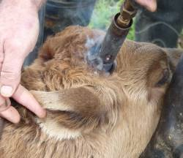
*tip- test the disbudder on a piece of wood to ensure it makes a complete dark brown ring
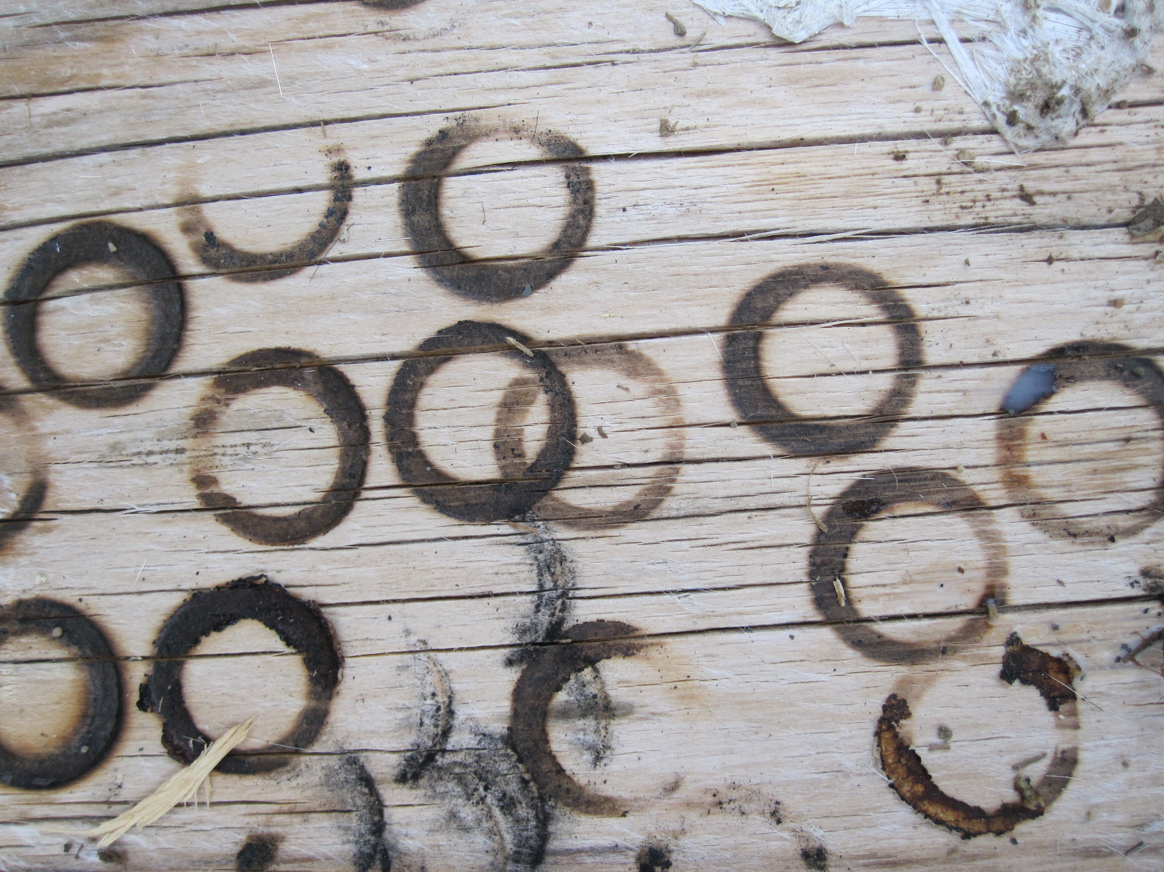
- Upon removal of the disbudder a complete brown ring should surround the horn bud to ensure the destruction of the horn producing cells (corium).
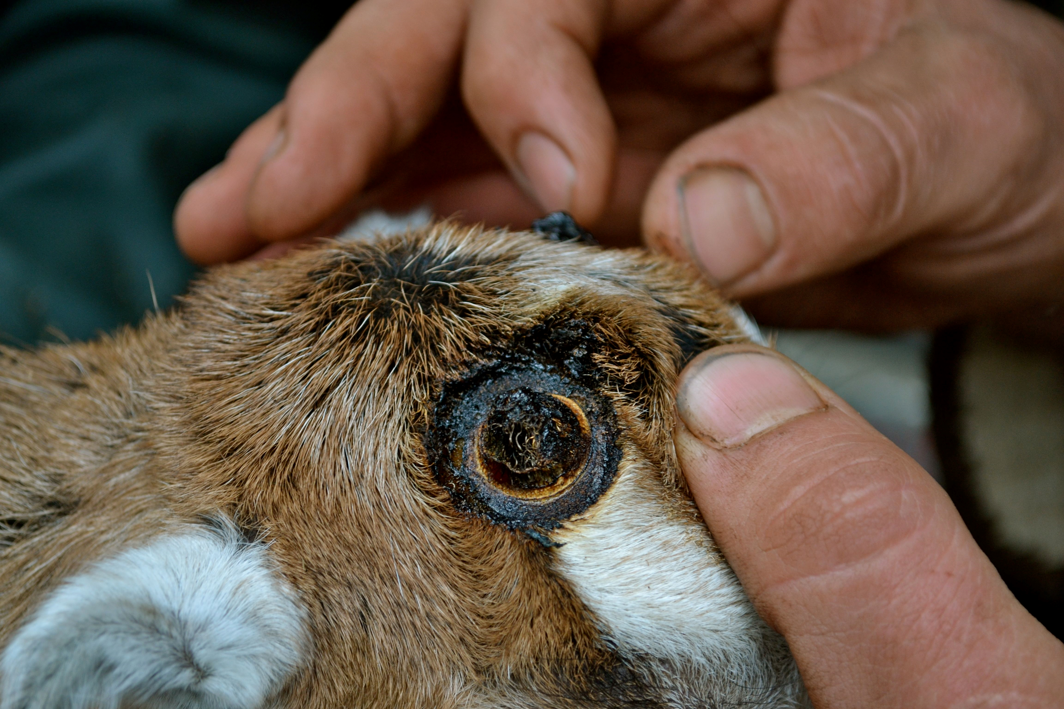

- Repeat steps for the other horn bud

*precaution- do not exceed more than 10seconds especially in goat as this can lead to thermal meningitis

