Post Operative Care for Disbudding

* This procedure can cause thermal brain damage if the hot iron is left on for too long. Therefore the calf must be carefully observed for any neurological signs immediately following the procedure and for the following week.
* The animal should also be observed daily following the procedure for the presence of any infection, myiasis, bleeding/hemmorhage, hematoma formation, lethargy or recumbency.
* Application of topical antibiotic spray for the treatment and control of topical infections: Oxytetracycline Hydrochloride Spray. This should be done immediately after the procedure as well as every day for the following week.

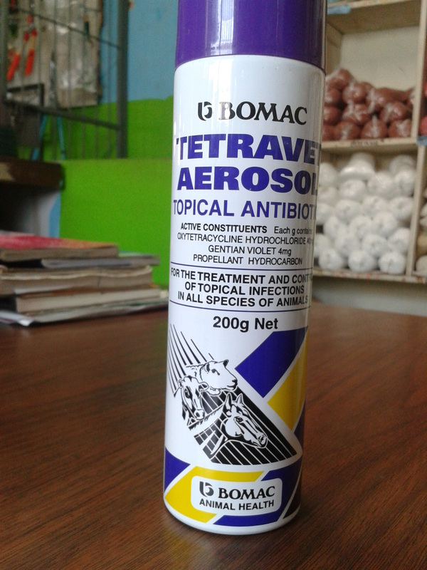

* Application of fly repellent / anti-myiasis topical spray to prevent the occurrence of myiasis.
* A dose of Ivermectin can be given post operatively for the prevention of parasitic loads.