Post Operative Care for Dehorning

* The animal should be observed daily following the procedure for the presence of any infection, myiasis, bleeding/hemmorhage, hematoma formation, lethargy or recumbency.
* A hot iron cauterizer should be used in the event that excessive bleeding continues post operatively.
* Application of topical antibiotic spray for the treatment and control of topical infections: Oxytetracycline Hydrochloride Spray. This should be done immediately after the procedure as well as every day for the following week.

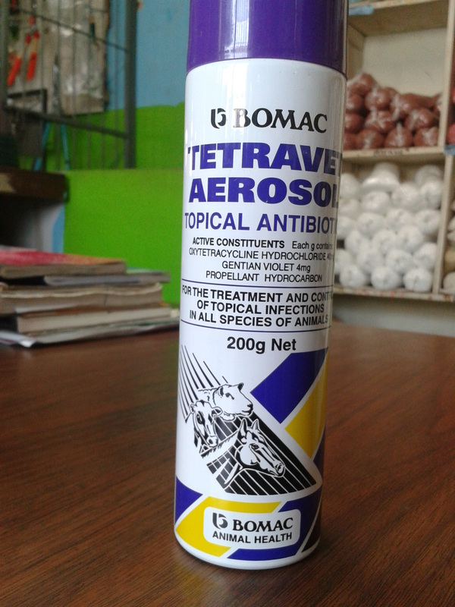

* Application of fly repellent / anti-myiasis topical spray to prevent the occurrence of myiasis.
* In the event that a sinus is left open after removal of the horn, it must be filled in with a gauze sheet soaked in oxytetracycline spray. In addition to this, a second dose of Penicillin-Streptomycin should be given for the prevention of infection to the open sinus and subsequent spread through the system of the animal.
* Repeated application of nitrofurazone antibacterial ointment to the open sinus for the next few days for prevention and control of infection.
* A dose of Ivermectin can be given post operatively for the prevention of parasitic loads.