Advantages of Chemical Disbudding:

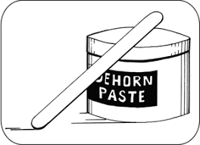

* Performed at a young age with less stress than some other techniques
* Bloodless
* Can be used in any season

