Chemical disbudding

Safety:

* To protect oneself, wear gloves when applying the chemicals
* To protect the calf; avoid application near its eyes, do not use caustics in rainy weather

Technique:

1. Restrain and administer sedation, analgesia and local anaesthetic
2. Expose the horn bud by pushing the hair back/clipping
3. Apply petroleum jelly (this prevents the skin from burning)
4. Apply a thin layer of the caustic to the horn button using a wooden applicator
5. Re-position the hair over the paste and horn bud, cover the horn bud

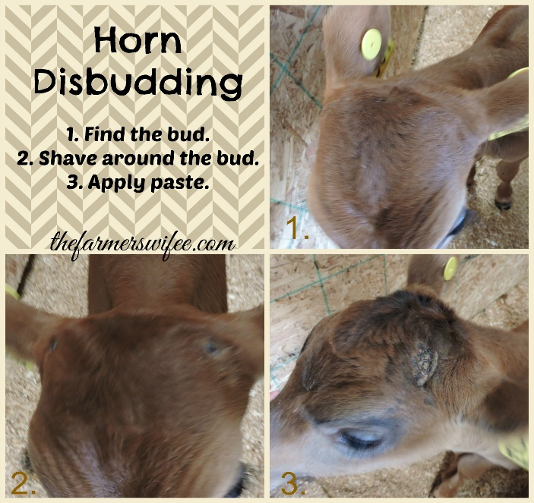

* Though some packages suggest clipping the hair around the horn bud, it has been proven by experience that keeping the hair keeps the caustic in place, reduces the risk of irritation to cow udders and flanks and reduces irritation to other facial skin of the calf

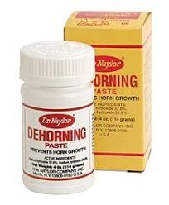

* Another method to protect cow and calf from caustic burns by placing a patch of duct tape over each bud though it may fall off in a few days

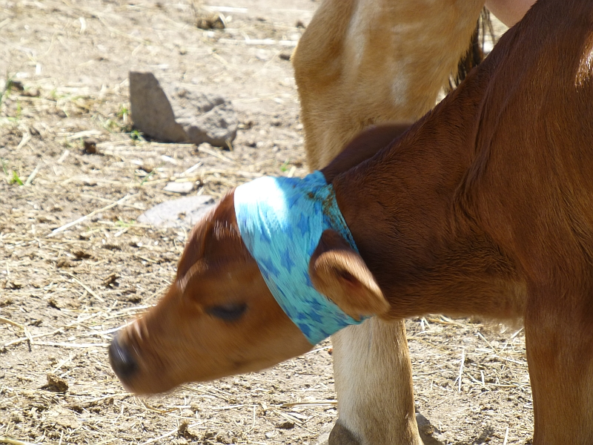

* Dairy cows should be kept in separate pens

