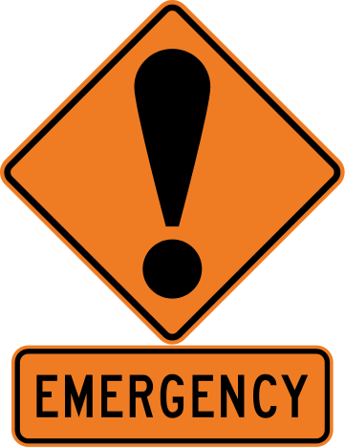

Atropine is used to reverse any signs of bradycardia

Epinephrine is used in case the animal develops an anaphylactic reaction.

Tolazoline is used to reverse Xylazin.

To administer Atropine:

* Dose: 0.04 mg/kg
$$Volume=\frac{Weight ×Dse}{Concentration}$$

* Concentration: 0.54 mg/mL
* Weight of Cow #258: 100kg

$$Volume=\frac{100 kg ×0.04 mg/kg}{0.54 mg/ml}$$

$$Volume= 7.4 ml$$

To administer Epinephrine:

* Dose: 0.02 mg/kg
$$Volume=\frac{Weight ×Dose}{Concentration}$$

* Concentration: 1 mg/mL
* Weight of Cow #258: 100kg

$$Volume=\frac{100 kg ×0.02 mg/kg}{1 mg/ml}$$

$$Volume=2 ml$$

$$Volume=\frac{Weight ×Dose}{Concentration}$$

To administer 10% Tolazoline:

* Volume of Xylazine used: 0.1 mL at concentration 20mg/mL
* Concentration of Tolazoline: 100mg/mL

For mildly depressed animals: **2** times xylazine dose: 0.025 mg/kg x 2= *0.05mg/kg*

For severely depressed animals: **4** times xylazine dose: 0.025 mg/kg x 4= *0.1mg/kg*

$$Volume=\frac{100 kg ×0.05 mg/kg}{100 mg/ml} Volume=\frac{100 kg ×0.1 mg/kg}{100 mg/ml}$$

*Volume= 0.05 ml Volume= 0.1 ml*