Barnes-Type Dehorner:

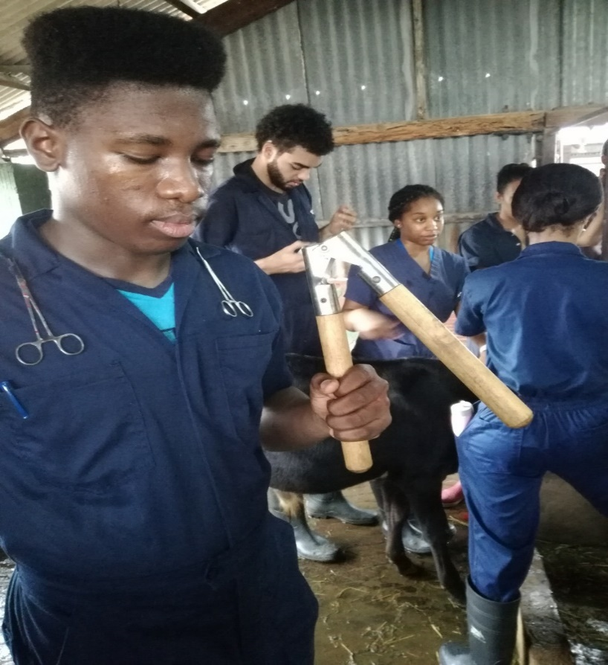

They come in two sizes:

* Smaller for six to eight-month-old calves
* Larger for dehorning yearlings or older cattle

Technique:

1. Restrain and administer sedation, analgesia and local anaesthetic
2. Close the handles together
3. Press the gouger the head maintain the pressure
4. Place gently the jaws of the dehorner over the horn bud. The objective is to completely remove a ring of skin surrounding the horn base therefore adjust the opening as needed
5. Quickly spread the handles apart, bringing the blades together to remove skin and the horn bud and rotate clockwise (180ᴼ) to ensure an half inch of skin is also removed.

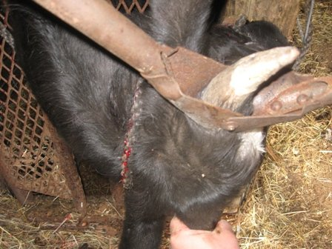

1. Control the bleeding by clamping the cornual artery with a haemostat or cauterizing it with a hot iron
2. Clean and disinfect the jaws of the gouger between calves

